# Future climate warming may unprecedently alter the Baltic ecosystem compared to the past 150 yrs

H. E. M. Meier1,2, H. C. Andersson1, B. Arheimer1, T. Blenckner3, B. Chubarenko4, C. Donnelly1, K. Eilola1, B.G. Gustafsson3, J. Havenhand5, A. Höglund1, I. Kuznetsov1, B. MacKenzie6, B. Müller-Karulis3, T. Neumann4, S. Niiranen3, J. Piwowarczyk7, U. Raudsepp8, M. Reckermann9, T. Ruoho-Airola10,O.P. Savchuk3, F. Schenk9, S. Schimanke1, G. Väli1, J.M. Weslawski7 and E. Zorita9

1Swedish Meteorological and Hydrological Institute, 60176 Norrköping, Sweden

2Stockholm University, Department of Meteorology, 10691 Stockholm, Sweden

3Stockholm Resilience Centre, Baltic Nest Institute, Stockholm University, 10691 Stockholm, Sweden

4Leibniz-Institut fürOstseeforschungWarnemünde, 18119 Rostock, Germany

5Dept. Marine Ecology – Tjärnö, University of Gothenburg, 452 96 Strömstad, Sweden

6Technical University of Denmark, 2920 Charlottenlund, Denmark

7Marine Ecology Department, Institute of Oceanology, Polish Academy of Sciences, 81-712 Sopot, Poland

8Marine Systems Institute, Tallinn University of Technology, 12618 Tallinn, Estonia

9Helmholtz-Zentrum Geesthacht, Centre for Materials and Coastal Research, 21502 Geesthacht, Germany

10Finnish Meteorological Institute, 00101 Helsinki, Finland

**Corresponding author:** Markus Meier, E-mail: [markus.meier@smhi.se](mailto:markus.meier@smhi.se)

**Abstract**

Multi-model ensemble simulations for the marine biogeochemistry and food web of the Baltic Sea for 1850-2098are performed and projected changes of future climate are compared with past climate variability. For 1850-2006 atmospheric, hydrological and nutrient forcing are reconstructed based upon historical measurements. For 1961-2098scenario simulations driven by regionalized global General Circulation Model (GCM) data are performed. To estimate uncertaintiesdifferent models for the various parts of the Earth system and several nutrient load scenarios are applied.Assuming IPCC greenhouse gas emission scenarios A1B or A2 we found that water temperatures at the end of this century may be higherand salinities and oxygen concentrations may be lower than ever before since 1850. There is also a tendency of increased eutrophication in the future. Although cod biomass is mainly controlled by fish mortality, climate change may have a significant impact on cod biomass as well and may cause a decline of cod biomass under present fishing pressure. Despite considerable shortcomings of state-of-the-art models this study suggests that the future Baltic Sea ecosystem may unprecedently change compared to the past 150 years. As stakeholders pay todayonly little attention to adaptation and mitigation strategies, more information is needed helping to raise public awareness of the possible impact ofclimate change on the marine ecosystem.

**Keywords:** Baltic Sea, numerical modeling, Climate Change, eutrophication, scenarios, ensemble modeling, marine biogeochemical cycles, marine food web, Baltic Sea Action Plan, decision support system

**1 Introduction**

The Baltic Sea is a semi-enclosed sea with a positive freshwater balance due to the runoff from a catchment area which is four times larger compared to the sea surface (e.g., Leppäranta and Myrberg 2009). Mainly due to intensive agriculture in the catchment, where 85 million people are living, nutrients are released into the water shed and transported towards the sea. As a consequence the Baltic Sea suffers today from severe environmental problems due to eutrophication, e.g. large cyanobacteria bloomsand dead bottoms (e.g.,Elmgren 2001, Conley et al 2009,Savchuk 2010). To overcome these problems it is of vital importance to reduce nutrient loads from the atmosphere, point sources and rivers with the help of international policies, e.g. the Helsinki Commission’s (HELCOM’s) Baltic Sea Action Plan (BSAP) which is a unique collaboration aiming for a healthy Baltic Sea with good water quality (HELCOM 2007).

Tounderstandwhat effects different measures will have on the marine ecosystem, we developed a multi‐model system toolto support decision makers (Fig. 1). The advanced modelling tool produces scenario simulations of the whole marine ecosystem that can underpin and inform design strategies to ensure water quality standards, biodiversity and fish stocks.

As the response of the Baltic Sea system to changing nutrient loads from land occurs on a 30-year time scale, long scenario simulations are needed that take the combined effects of changing climate and nutrient loads into account (e.g.,Meier et al 2011). To estimate uncertainties caused by model biases we use a multi-model ensemble approach (Fig. 1).

Future projectionsare compared with variations during the past 150 years.Further, to evaluate the models’ sensitivity to changing drivers on long time scales we reconstructed atmospheric surface fields, runoff, nutrient loads from land and atmospheric deposition for the period 1850-2006. From the reconstruction of the past 150 years we learned about eutrophication, warming trends due to anthropogenic influences, and decadal variations (such as stagnation periods) helping to understand expected future changes.

For coupled climate-environmental modeling the ensemble approach is novel and to our knowledge a comprehensive downscaling approach as in this study[1] has never been applied before.

**2 Methods**

**2.1 Future climate forcing**

Following Meier et al (2011) four climate scenariosimulations using regionalized data from two General Circulation Models (GCMs) and two greenhouse gas emission scenarios (A2, A1B)have been used to force three state-of-the-art coupled physical-biogeochemical models for 1961-2098.For the dynamical downscaling a regional, high-resolution coupled atmosphere-ice-ocean-land surface model (the Rossby Centre Atmosphere Ocean model, RCAO;Döscher et al 2002) with lateral boundary data from GCMs was applied.Runoff is calculated using a statistical model (Meier et al 2012).

Three nutrient load scenarios ranging from a pessimistic business-as-usual to a more optimistic case have been investigated with the models: a reference with a continuation of present loads (REF), implementation of abatements according to the BSAP and “business-as-usual” with increasing loads due to increased use of fertilizers in transitional Baltic Sea countries (BAU) (Gustafsson et al 2011). Atmospheric deposition changes vary between a 50% reduction in BSAP and no change in BAU compared to present conditions.

**2.2 Past climate forcing**

For 1850-2006 multivariate HIghRESolution Atmospheric Forcing Fields (HiResAFF) were reconstructed (Schenk and Zorita 2012). The daily fields are homogenous and physically consistent by making use of both long European historical station data since 1850 and simulated atmospheric fields from RCAO over Northern Europe in the period 1958 – 2006 driven at the lateral boundaries by ERA40 (Samuelsson et al 2011).

The reconstruction of basin-wise,monthlynutrientloadsfromrivers and pointsources and of atmosphericnitrogen deposition for 1850-2006 is baseduponavailablehistorical data.

**2.3 Biogeochemical and food web models**

Three coupled physical-biogeochemical models are used to calculate either historical climate variations 1850-2006 driven with reconstructed data or changing climate 1961-2098 driven with regionalized GCM data: the BAltic sea Long-Term large-Scale Eutrophication Model (BALTSEM) (Gustafsson 2003,Savchuk 2002), the Ecological Regional Ocean Model (ERGOM) (Neumann et al 2002), and the Swedish Coastaland Ocean Biogeochemical model coupled to the RossbyCentre Ocean circulation model (RCO-SCOBI) (Meier et al 2012). To calculate appropriate initial conditions customized spin-up strategies for each of the models were developed.

A new Central Baltic Proper Ecopath with Ecosim food web model (BaltProWeb) is used to analyze climate-induced changes in marine food webs and the implications on ecosystem services.The model contains 22 functional groups from primary producers to seals and fishery and was parameterized with a focus onthe functional groups cod, sprat, macrozoobenthos, *Pseudocalanus* sp. and other mesozooplankton. In addition, statistical single- and multi-species models are used to link climatic forcing and lower trophic level processes to fish dynamics.An assessment of plausible impacts of ocean acidification on key functional groups using available food web data is carried out to better understand the response of Baltic Sea organisms.

**2.4 Socio-economic impact assessment**

Assessments of the impact of climate change on regional and local developments anda cross-country analysis of stakeholder perceptions in eight Baltic Sea countries are performed. As the awareness of stakeholders will ultimately affect their actions, the results of the questionnaires are important for the implementation of climate change in long-term coastal management.

**3 Results**

**3.1 Evaluation 1850-2006**

Simulated water temperature, salinity, oxygen and nutrients are evaluated using long observational records from the central Gotland Basin (Gotland Deep) (Fig. 2).As it is impossible to calculate annual mean sea surface temperature (SST) based upon available observations at Gotland Deep, we compare instead model results and measurements at the light ship SvenskaBjörn (1902-1968) which was located in the northern Gotland Basin south of the Åland Islands (Fig. 2a). Hence, the apparent warm bias of the reconstructed SST is mainly explained just by the different locationsof simulated and observed SSTs. Although during 1961-2006 SST trends in GCM driven simulations are underestimated compared to observations (in accordance with air temperature trends, see van Oldenborgh et al., 2009), SSTs in the reconstruction and in GCM driven simulations are relatively close around year 2000. Observations of water temperature in 200 m depth at Gotland Deep suggest that all models have a cold bias (Fig. 2b). However, temperature variations in the reconstruction and in observations are similar. We found also good results for temperatures in 200 m depth in GCM driven simulations.

Reconstructed sea surface salinities (SSSs) are slightly underestimated, in particular prior to 1930, whereas SSSs in GCM driven simulations are in good agreement with the observed mean SSS value of 1961-2006 (Fig. 2c).Although many of the saltwater inflows are reproduced using the reconstructed atmospheric forcing, salinities in 200 m depthare in two out of three models considerably underestimated(not shown) whereas deepwater salinities in GCM driven simulationsare close to observations(Fig. 2d). However, the chronologies of natural variationsdiffer among the climate realizations due to the chaotic behavior of the Earth system. Hence, the temporal evolution of the ensemble mean of the GCM driven simulations does not include observed decadal variations, like the stagnation period 1983-1992.

Although in the reconstructions oxygen concentrations in 200 m depth are overestimated compared to observations, in particular prior to 1930, the negative trend since the 1950s caused by eutrophication is well captured (Fig. 2e). The too high oxygen concentrations during the early period might be caused partly by a too weak vertical stratification and partly by shortcomings in simulated oxygen consumption in oligotrophic ecosystems. On the other hand, oxygen concentrations in GCM driven simulations are relatively close to observations during 1961-2006.

Further, in the reconstructions surface phosphate concentrationsreflect the history of eutrophication since the 1950s satisfactorily (Fig. 2f). However,in GCM driven simulationsthe positive trend in phosphate concentrations is too small. This might be explained by the fact that at least in one out of three models external nutrient loads do not represent the observed temporal evolution correctly (not shown). In this case riverine nutrient load concentrations are assumed to be constant during 1961-2006.

For surface nitrate concentrations the discrepancies among the models during 1961-2006 are even larger than for surface phosphate concentrations (Fig. 2g). In two out of three models the surface nitrate concentrations in the reconstructions are too low (not shown). In GCM driven simulations none of the models reproduces the high nitrate concentration values of the 1980s.

**3.2 Changing climate 2007-2098**

Figure 2 shows also results from scenario simulations of future climate in the central Gotland Basin. In the investigated four scenario simulations annual mean air temperature in the Baltic Sea region is projected to increase between2.7 and 3.8 K in 2070-2099 relative to 1969-1998 (Meier et al 2012). Due to an increase of net precipitation over the Baltic catchment area river runoff is projected to increase between 4 and 22% depending on the scenario and hydrological model used. In this study, only model results driven with runoff changes from a statistical approach are shown (Figs 2 and 3)which are in the range 15 - 22% (Meier et al 2012).

As a consequence of increased air temperature and freshwater supply water temperatures are projected to increase and salinities to decrease (Figs. 2a-d). At the end of the 21st century both surface and deep water temperature and salinity changes in the A1B/A2 scenarios are larger than all decadal variations ever observed since 1850.

Warmer water changes the oxygen saturation concentrations and turnover rates of biogeochemical processes, enhancing eutrophication (Meier et al 2011). Hence, depending on the nutrient load scenario oxygen concentrations in the Baltic deep water are projected to decrease compared to the 2000s (Fig. 2e). Only in BSAP oxygen concentrations during the 21st century do not change approximately.

Surface phosphate concentrations will continue to increase in REF and BAU but decrease in BSAP compared to the 2000s (Fig. 2f). Also surface nitrate concentrations will increase in REF and BAU but will remain approximately constant in BSAP (Fig. 2g). Unfortunately, changing surface nutrient concentrations cannot be compared directly with either observed or reconstructed historical values because in particular nitrate concentrations in GCM driven simulations are too low during the past 30 years. However, taking a bias correction of contemporary nutrient concentrations in GCM driven simulations into account would suggest that with none of the studied nutrient load scenarios the environmental status of the 1960s could be restored. Instead, climate induced changes together with present external nutrient loads (REF) will very likely affect the marine environment inter alia with enhanced eutrophication (Figs. 2f and 2g), increased oxygen depletion (Fig. 2e), reduced water transparency (due to increased organic material in the sea, not shown), reduced biodiversity (due to decreased salinity) and increased risk for acidification (due to increased atmospheric CO2 concentrations).

Note that for biogeochemical variables the spread among ensemble members increases with time. Despite these uncertaintiesthe scenario simulations suggest that climate induced changes are considerable and may not easily be counteracted by future nutrient loads.

**3.3 Changing marine ecosystems 2007-2098**

Although fish population/food web models have very different parameterizations, assumptions and sensitivities to environmental forcing, all applied models indicate an initial decline in sprat biomass followed by a rise (not shown). Based on these calculations, it is likely that the sprat spawner biomass will increase in the Baltic Sea during the 21st century.BaltProWeb has been run for the most extensive combination of climate, nutrient loading and fishery scenarios using output from all three biogeochemical models (Fig. 3). These simulations demonstrate the dominant impact of fishing on cod. However, worsening of reproduction conditions, due to climate change in combination with high nutrient loading (the cod reproductive habitat based on oxygen concentration and salinity is projected to decrease), seems to limit the cod stock even at low fishing levels. Nutrient loading had a larger effect on lower trophic level groups (not shown). Other simulations showed that a recovery of the population of grey seals (which prey on cod) is also likely to have a smaller impact than exploitation and climate change on the development of cod biomass in the Baltic Sea during the 21st century (MacKenzie et al 2011).

Climate scenario simulations showed a continuous acidification of the Baltic Sea which is mainly controlled by the increasing atmospheric pCO2. Changes in pH due to other factors like increasing temperature and primary production are less important and differ between the regions (not shown). Future acidification may also impact Baltic biota. Althoughavailable data suggest that most species and ecologically important groups in the Baltic food web (zooplankton, macrozoobenthos, cod and sprat) will be robust to the expected changes in pH, a general conclusion cannot be drawn because mostly single-species and single-factor studies are available. A preliminary sensitivity analysis of the consequences of ocean acidification on the Baltic ecosystem assuming some kind of ``worst case´´ suggests that ocean acidification may cause substantial (> 50%) declines in some key fish populations of the Baltic Sea (herring, cod) and in biomass of other taxa (zooplankton, benthic filter-feeders).

**3.4 Socio-economic impacts and stakeholder perceptions**

The problems related to climate change are widely acknowledged if directly approached by survey questions.Climate change was, with a few exceptions, considered to have a negative impact on most sectors of human activity. However, the importance of issues related to climate change is often overshadowed by other problems: social, economic, and environmental.At the same time, climate change was perceived as distant in space and time. Therefore, only the need for soft actions, mainly related to education was acknowledged. Adaptation and mitigation were of secondary importance, although a high degree of self-rated knowledge was declared on these topics.The understanding of the consequences of climate change remains abstract, vague and not region-based. There is still a need for information and knowledge that would enable a shift in thinking that could bring forward more adequate adaptation and mitigation actions.

**4 Discussion**

A diverse set of climate-oceanographic-biogeochemical, population and food web models has been linked to simulate various combinations of ecosystem drivers (fishing, climate change, nutrient loading, marine mammal predation) on ecosystem dynamics. This framework will facilitate future studies of the consequences of potential ecosystem and fishery management decisions and should be a valuable tool for both marine scientists and policymakers.For instance, we showed that in the case of cod dynamical downscaling from GCMs to food web models is a feasible approach. However, there are considerable uncertainties caused by model biases (1), unknown initial conditions(2), andunknown greenhouse gas emission and nutrient load scenarios (3).

Concerning model biases (1), temperature and salinity dependencies of some key biogeochemical processes are not well understood. For instance, higher temperatures accelerate phosphorus mineralization in the bottom sediments. Hence, the release of phosphorus is increased which was during previous decades with higher external nutrient supply stored in the sediments.

Another uncertainty is related to nutrient concentration changes in rivers. According to process oriented, hydrological modelingphosphorus will more intensively flushed out from the soils due to the projectedincrease of heavy rainfall intensity causing increased phosphorus concentrations in rivers. However, model results also suggest that nitrogen loads may decrease due to increased denitrification in warmer soils. Due to the uncertainties involved the latter impacts are not considered in this study. However, one should keep in mind that the impact of climate change could be in the same order of magnitude as anthropogenic induced nutrient concentration changes like BSAP.

Further, in the simulations initial conditions of nutrients in the sedimentsmight be biasedbecause they cannot be measured (2).The scenario simulations start from 1961 after the onset of historical eutrophicationfrom unknown nutrient pools in the sediments.As the two records of reconstructed past and projected future climates for temperature, salinity and oxygen concentration fit well together, we conclude that in each of the models the spin-up simulations of initial conditions for these variables were successful. However, the two nitrate records do not fit well together and surface nitrate concentrations are in all control simulations too low compared to observations. To a minor extent this problem is also evident for surface phosphate concentrations. We assume that these results are mainly explained by unknown initial concentrations of nutrients in the sediments and model shortcomings of the nutrient cycling. One possibility to improve the results would be to perform a long spin-up starting before the onset of historical eutrophication using homogeneous and realistic forcing data. However, consistent forcing data sets for the entire period 1850-2098 are not available.Nevertheless, in this study a first attempt to simulate the entire period was made.

Finally, another considerable source of uncertainty is caused by missing plausible and consistent nutrient load scenarios for the Baltic Sea region (3). For instance, we studied a rather wide range of riverine and atmospheric nutrient load scenarios (REF, BAU, BSAP) which are rather simple and which do not take detailed assessments of future population growth, agricultural development, life style changes, etc. into account.

**5 Conclusions**

* A unique, publicly available climate and environmental database of simulation results from a multi-model ensemble and observations is built describing past and future climates of the Baltic Sea region for 1850-2098. A decision support system based upon “Google Earth Maps” informs about the Baltic Sea status under various nutrient load and climate change scenarios (see <http://www.baltex-research.eu/ecosupport>).
* State-of-the-art Baltic Sea models are capable to simulate past climate variations and eutrophication since 1850. In particular, climate variability of water temperature, salinity and oxygen concentrations are in good agreement with available observations building confidence that the models are able to simulate future changes provided that projected forcing from GCMs is realistic. However, some shortcomings of simulated nutrient dynamics are identified emphasizing the need of consistent spin-up simulations since 1850 even for future projections.
* Climate change mayhave considerable impact on the Baltic Sea ecosystem. Assuming the greenhouse gas emission scenario A1B or A2, at the end of the 21st century water temperature will be higher and salinity and oxygen concentrations will be lower than ever before since 1850. These changes will affect the marine food web. For instance, irrespective of the assumed nutrient load scenario cod biomass will decline assuming present day fish mortality.
* These effects need to be taken into consideration in management plans. Our results give a scientific basis for marine management and policy support. To reach HELCOM targets for a Baltic Sea unaffected by eutrophication and human impact, nutrient load reductions and sustainable fishery are of even higher importance in future than in present climate.Although our results will partly be considered for the revision of the BSAP, climate change was perceived by coastal stakeholders as distant in space and time. Today overall only little attention is paid to adaptation and mitigation strategies.

# Acknowledgement

The research presented in this study is part of the project ECOSUPPORT (Advanced modeling tool for scenarios of the Baltic Sea ECOsystem to SUPPORT decision making) and has received funding from the European Community's Seventh Framework Program(FP/2007-2013) under grant agreement no. 217246 made with BONUS, the joint Baltic Sea research and development program, from the Swedish Environmental Protection Agency (08/381), the German Federal Ministry of Education and Research (03F0492A),from the Russian Fund of Basic Researches (08-05-92421), the Polish Ministry of Science and Higher Education (06/BONUS/2009), the Finnish Academy of Sciences, the Danish National Science Foundation, and the Estonian Science Foundation (7467, 7581).

# References

Conley, D.J., S. Björck, E. Bonsdorff, J. Carstensen, G. Destouni, B.G. Gustafsson, S. Hietanen, M. Kortekaas, H. Kuosa, H.E.M. Meier, B. Műller-Karulis, K. Nordberg, A. Norkko, G. Nűrnberg, H. Pitkänen, N.N. Rabalais, R. Rosenberg, O.P. Savchuk, C.P. Slomp, M. Voss, F. Wulff, and L. Zillén, 2009: Hypoxia-related processes in the Baltic Sea. Critical Review. Environ. Sci. Technol., 2009, 43 (10), 3412-3420

Döscher, R., U. Willén, C. Jones, A. Rutgersson, H.E.M. Meier, U. Hansson, and L.P. Graham, 2002: The development of the regional coupled ocean-atmosphere model RCAO. Boreal Environ. Res., 7, 183–192.

Elmgren, R., 2001: Understanding human impact on the Baltic Sea ecosystem: changing viewsin recent decades, Ambio, 30, 222–231.

Gustafsson, B.G. 2003. A time-dependent coupled-basin model for the Baltic Sea, Report C47, Earth Sciences Centre, Göteborg University, Göteborg, 61 pp.

Gustafsson, B.G., O.P. Savchuk, and H.E.M. Meier, 2011. Load scenarios for ECOSUPPORT. Technical Report 4, Baltic Nest Institute, Stockholm, Sweden, ISSN 978-91-86655-03-7.

HELCOM, 2007. Toward a Baltic Sea unaffected by eutrophication. Background document to Helcom Ministerial Meeting, Krakow, Poland, Tech. rep., Helsinki Commission, Helsinki, Finland.

Leppäranta, M. and K. Myrberg, 2009. Physical oceanography of the Baltic Sea. Praxis publishing Ltd, Chiester, UK, Springer-Verlag Berlin Heidelberg New York ISBN 978-3-540-79702-9.

Meier, H.E.M., H.C. Andersson, K. Eilola, B.G. Gustafsson, I. Kuznetsov, B. Müller-Karulis, T. Neumann, O.P. Savchuk, 2011. Hypoxia in future climates - a model ensemblestudy for the Baltic Sea Geophys. Res. Lett.,38, L24608.

Meier, H.E.M., R. Hordoir, H.C. Andersson, C. Dieterich, K. Eilola, B.G. Gustafsson, A. Höglund, and S. Schimanke, 2012. Modeling the combined impact of changing climate and changing nutrient loads on the Baltic Sea environment in an ensemble of transient simulations for 1961-2099. Clim. Dynam., in press.

Neumann, T., W. Fennel, and C. Kremp. 2002. Experimental simulations with an ecosystemmodel of the Baltic Sea: a nutrient load reduction experiment, Global Biogeochemical Cycles, 16 , 1033.

Samuelsson, P., C.G. Jones, U. Willén, A. Ullerstig, S. Golvik, U. Hansson, C. Jansson, E. Kjellström, G. Nikulin, K. Wyser, 2011: The Rossby Centre Regional Climate model RCA3: modeldescription and performance. Tellus 63A, 4–23.

Savchuk, O. P. 2002. Nutrient biogeochemical cycles in the Gulf of Riga: scaling up field studies with a mathematical model, J. Mar. Sys., 32, 235–280.

Savchuk, O.P., 2010. Large-scale dynamics of hypoxia in the Baltic Sea. In: Yakushev, E., (Ed.), Chemical structure of pelagic redox interfaces: observation and modelling. Hdb. Env. Chem., doi:10.1007/698_2010_53, Springer-Verlag, Berlin Heidelberg.

Schenk, F., and E. Zorita, 2012: Reconstruction of high resolution atmospheric fields for Northern Europe using analog-upscaling. Clim. Past Discuss., 8, 819–868, doi:10.5194/cpd-8-819-2012.

Van Oldenborgh, G.J., S. Drijfhout, A. van Ulden, R. Haarsma, A. Sterl, C. Severijns, W. Hazeleger, and H. Dijkstra, 2009: Western Europé is warming much faster than expected. Clim. Past, 5, 1-12.

# Figure captions

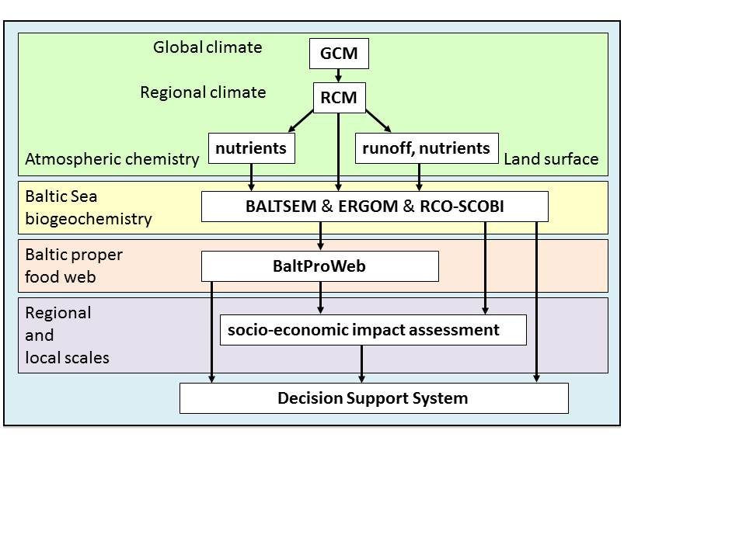

**Figure 1:**The ECOSUPPORT decision support system is based upon information from scenario simulations from a Regional Climate Model (RCM) forced with lateral boundary data from GCMs, hydrological models to calculate river flow and nutrient loadings, atmospheric deposition data, three marine physical-biogeochemical models of differing complexity (BALTSEM, ERGOM, RCO-SCOBI), food web (BaltProWeb)and statistical fish population models, regional case studies and socio-economic impact studies.

g

f

e

d

c

b

a



**Figure 2:**Simulated ensemble mean and observed (green symbols) annual mean water temperature (a, b) and salinity(c, d)at Gotland Deep in 1.5 and 200 m depth, annual mean oxygen concentration in 200 m depth (e) and winter (January-March) mean surface phosphate (f) and nitrate (g) concentrations. Shaded areas denote the ranges of plus/minus one standard deviation around the ensemble means. The various nutrient load scenarios (1961-2098) are shown by colored lines (REF - yellow, BSAP - blue, BAU - red) and the reconstruction (1850-2006) by the black line.

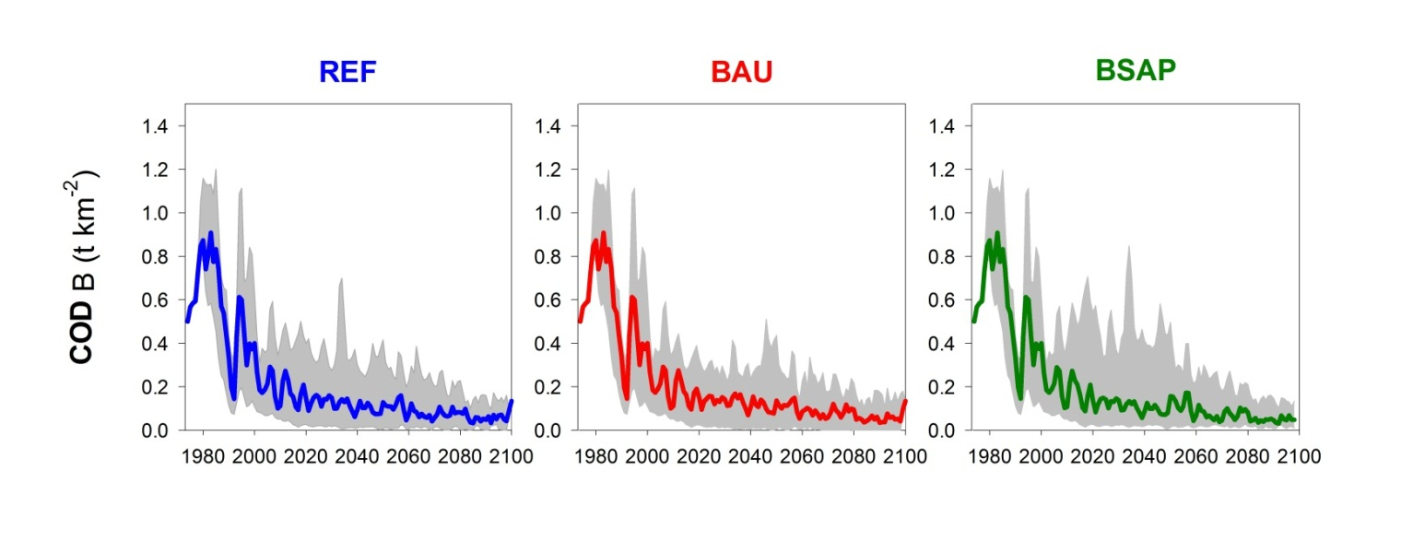

**Figure 3:**Ensemble mean spawnerbiomass of cod (in t km-2) 1970-2100 in the Baltic Sea (ICES Subdivisions 25-32) as simulated using BaltProWeb coupled to three oceanographic-biogeochemical models assuming a business-as-usual cod fishery scenario and three nutrient load scenarios corresponding to REF, BAU and BSAP.The grey shaded area represents the range (minimum to maximum) among the three biogeochemical models.

1. The present study summarizes selected research highlights of the ECOSUPPORT project (Advanced modeling tool for scenarios of the Baltic Sea ECOsystem to SUPPORT decision making, see www.baltex-research.eu/ecosupport) lasting 2009-2011. More detailed resultsof this project will be published elsewhere.