4.3 Projections of future climate change
This section deals with model-based projections of anthropogenic climate change in the Baltic Sea Basin. The range of subjects includes results from numerical climate models as well as other kinds of models regarding changes in atmosphere and ocean, and goes on to cover resulting consequences for the hydrological situation in the Baltic Sea Basin. The time scale of such projections is normally around 100 years, usually a comparison of projections for the middle or the end of the current century, compared to the state in the end of the 20th century. This is a choice mostly resulting from the fact that anthropogenic climate change on this time horizon is expected to be beyond the uncertainty range of natural variability.
Since the first Baltic Sea Assessment (BACC, 2008), a large number of projects and simulations have contributed to to the advancement of information on expected climate change in the Baltic Sea Region. The fourth IPCC assessment report (IPCC, 2007) has summarised many of the relevant studies, and many more analyses have come forth since then, particularly based on the simulations of the EU FP6 ENSEMBLES project (van der Linden and Mitchell, 2007).

4.3.1. Atmospheric change in the Baltic Sea region
Ole Bøssing Christensen, Erik Kjellström and Eduardo Zorita

4.3.1.1 Introduction
A comprehensive summary of existing scenarios for the Baltic Sea Region up to 2006 was published in the first Assessment of climate change for the Baltic Sea Basin (BACC, 2008). Since the first BACC report, several large systematic efforts have been undertaken to perform numerical model simulations and extract knowledge about anthropogenic climate change. At the international level, a large number of global climate change scenarios have been produced over the last decades in climate model intercomparison projects (CMIP), often in connection with the work on the latest IPCC assessment reports (IPCC, 2001; IPCC, 2007). Most recently, the fourth IPCC report (IPCC, 2007) built on the World Climate Research Programme's (WCRP's) Coupled Model Intercomparison Project phase 3 (CMIP3) multi-model dataset (Meehl et al., 2007a) with the participation of many global climate models, and use of several SRES scenarios (previous section; Nakićenović et al., 2000).
At the European level, some of these scenarios have been dynamically or statistically downscaled to a higher horizontal resolution allowing for detailed analysis of climate change on local to regional scale. Regional climate model (RCM) simulations in the PRUDENCE project (Christensen and Christensen, 2007) have been analysed, and simulations from the ENSEMBLES project (van der Linden and Mitchell, 2009) have been made publicly available and analysed (e.g. Déqué et al., 2011; Hanel and Buishand, 2011; Kyselý et al., 2011; Räisänen and Eklund, 2011) and used for impact studies (e.g. Wetterhall et al., 2011). Finally, at the Baltic level, several national initiatives have resulted in extensive analyses of possible climatic futures for areas including the Baltic Basin (e.g. Lind and Kjellström, 2008; Kjellström and Lind, 2009; Kjellström et al., 2011; Nikulin et al., 2011; Benestad, 2011).
Probabilistic climate change information has been derived from the global climate model (GCM) scenarios (Räisänen, 2010) and the regional climate model scenarios (Buser et al., 2010; Donat et al., 2011). In addition, the wider range of GCM scenarios has been used to set regional scenarios in a broader context (Lind and Kjellström, 2008).
This chapter relies on existing literature on climate change scenarios with focus on northern Europe and in particular the Baltic Sea region. Some original summarizing plots of public data from the ENSEMBLES project have been added. This has been decided, since not all of the expected analysis of the ENSEMBLES archive has yet been published; at the same time this collection of RCM data is an essential improvement on the state of the science since the first BACC report. For a more elaborate description of global climate models (GCMs) and downscaling techniques see IPCC (2007) and BACC (2008) and references therein. Much literature exists related to past and present climate change in the Baltic, and conversely about future climate at the European scale, but there is not much targeted research on expected future climate change in the Baltic area.

4.3.1.2 Emission scenarios
The SRES emission scenarios (Nakićenović et al., 2000) were used in simulations for IPCC (2007). Hence, most existing climate change scenarios build on these emission scenarios that are based on different storylines for the future development of world population and economy. All SRES scenarios show increasing amounts of greenhouse gases in the atmosphere leading to increasing global temperatures. Depending on scenario, the amplitude of climate change differs, implying a notable impact of mitigation actions even if such actions are not explicitly taken into account in the SRES scenarios. The differences in emissions between high and low emission scenarios lead to different climate change most notably in the latter half of the 21st century. In the nearest few decades much of the expected warming is already accounted for by historical and current emissions.
Most downscaling experiments build on the SRES scenarios A2, A1B and B2, implying that the more extreme scenarios (A1FI on the high side and B1 on the lower side) have not been studied as extensively. Pattern-scaling techniques have been used in order to “translate” information between scenarios including also the more extreme scenarios (e.g. Ruosteenoja et al., 2007; Kendon et al., 2010). Regional simulations for Europe with low-emission stabilization scenarios exist with the ENSEMBLES E1 stabilisation scenario, see ???. Also a very high emission scenario downscaling has been performed (RCP 8.5, see Christensen (2011)). However, none of these simulations have been analysed in the literature ((OBC: This needs to be checked/updated)), and no studies with specific focus on the Baltic Sea Basin have been performed.
The upcoming IPCC Fifth Assessment Report will correspondingly receive data from the CMIP5 project, which will contain output from many more models, according to the new family of RCP emission scenarios (van Vuuren et al., 2011). Simulations for this archive have only started to come in at the time of writing, the end of 2011, and no publications have at this time made use of any CMIP5 data.

4.3.1.3 Global climate model simulations
Most regional climate change information from global models in the last few years originate from the CMIP3 project underlying IPCC (2007). In that project about 20 different coupled atmosphere-ocean general circulation models were used in a number of different experiments including simulations of the 20th century with observed forcing and a number of SRES emission scenarios for the 21st century. In addition to GCM and scenario uncertainty, also uncertainty due to natural variability was considered in CMIP3. This was accomplished by multiple simulations with individual GCMs differing only in initial conditions. Extensive documentation of model performance and climate change projections are given in IPCC (2007).

4.3.1.4 Regional climate models
Downscaling of global climate model results to the regional scale have been pursued with a number of regional climate models in the context of EU-projects (like PRUDENCE and ENSEMBLES), other international projects (Climate and Energy Systems in the Nordic region; Kjellström et al., 2012) and as national efforts (e.g. Iversen, 2008; Kjellström et al., 2011). Most of the existing scenarios are at 50 or 25 km horizontal resolution but attempts have been made at even higher resolution (around 12 km in Larsen et al., 2009; 10km in Jacob et al. (2008). In addition to downscaling of climate change scenarios, also so-called reanalysis data sets have been extensively downscaled in recent years (e.g. Christensen et al., 2010; Samuelsson et al., 2011). These experiments facilitate a comparison of RCM results to observational data in the most recent decades and thereby an evaluation of the RCMs.

4.3.1.5 Temperature climate
Temperatures in the Baltic Sea area are expected to increase with time and the increase is generally larger than the corresponding increase in the global mean temperature. This is to a large degree a result of a strong wintertime increase (Figs 4.3.1, 4.3.3) that is a result of feedback mechanisms involving retreating snow and sea ice cover thereby leading to even higher temperatures. –A reduced snow and ice cover will enhance absorption of sunlight, and enable heat to be stored in the soil.
The strong increase in wintertime daily mean temperatures are most pronounced for the coldest episodes (Kjellström, 2004) and this is also the case for the more extreme daily maximum and minimum temperatures (Kjellström et al., 2007; Nikulin et al., 2011) with significant decrease in probabilities of cold temperatures (e.g. Benestad, 2011). In summer, warm extremes become more pronounced than they are in today’s climate. As an example, Nikulin et al. (2011) show that the recurrence time for warm extremes as defined in today’s climate are reduced from 20 years to around 5 years in Scandinavia comparing 2071-2100 with 1961-1990 in an ensemble of six RCM simulations, all downscaling GCMs under the A1B emission scenario.
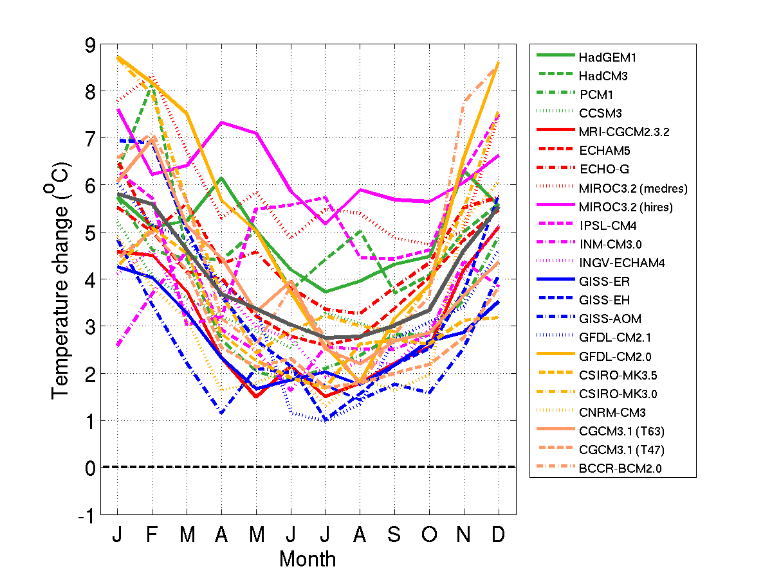
Figure 4.3.1. Projected temperature change in northern Sweden as calculated in 23 CMIP3 AOGCM-simulations under the SRES A1B scenario (Lind and Kjellström, 2008). 30-year averages of monthly mean data has been compared between 1961-1990 and 2071-2100. The thick grey line is an average of all individual model results while the dashed line indicates no change.
In Fig. 4.3.1 we show the annual cycle of temperature change for northern Sweden according to 23 different CMIP3 GCM simulations. The increase in temperature is evident in all seasons. We note that there is a large spread between different GCMs in their response to the changing forcing. This large spread is directly reflected in downscaling studies. Figure 4.3.2 shows an example results from 16 regional climate change simulations with the Rossby Centre regional climate model (Kjellström et al., 2011). These simulations include different emission scenarios, different forcing global climate models and also different ensemble members allowing an illustration of the uncertainties related to climate change discussed in Section 4.1.???. It is clear that the spread due to different GCMs contributes strongly to the overall uncertainty in this area. We also note that the overall uncertainty increases with time, as the spread between all 16 scenarios gets larger in the third period compared to the first. Further, the impact of different emission scenarios increase over time as can be seen by comparing the three scenarios A2, A1B and B1 simulated by the same ensemble member of ECHAM5 (denoted M, A and P in the figure). Finally, the three ECHAM5 A1B simulations with different ensemble members differing only in initial conditions (A, B and C) show a large spread illustrating the fact that natural variability contributes to the uncertainty also on longer time scales such as the 30-year time used here.
Figure 4.3.2. Change in annual mean precipitation (%) versus T_{2m} (°C) over all land grid points in the Baltic Sea runoff region. Emission scenarios and forcing AOGCM for each RCA3-simulation are given in the legend (A-P). Simulated changes are shown for three different time periods; (1) 2011-2040, (2) 2041-2070 and (3) 2071-2100. The grey line is a least-square fit to the data (the slope k is 5.0% per °C and the correlation coefficient r is 0.93).
An ensemble of 11 RCM simulations from the ENSEMBLES project has been analysed here, resulting in the maps of Fig. 4.3.3. They are summarised in Table 4.3.1. The criteria for selection has been that they extended to the end of the 21st century, and that they were not driven by the low-and high-sensitivity GCM simulations from the Hadley Centre (Collins et al., 2011). For each point and each of the 11 simulations, there is a value of the quantity in question, e.g. the change in summer temperature between 1961-1990 and 2070-2099. As an estimate of the spread, the 11 numbers are sorted, resulting in an approximate 5th percentile corresponding to the lowest value, a median, and an approximate 95th percentile.
Table 4.3.1 Selection of ENSEMBLES RCM simulation used in this section. All simulations follow the SRES A1B scenario. For documentation on the individual models, see http://ensemblesrt3.dmi.dk/.
Acronym | GCM | RCM
ICTP-REGCM3_ECHAM5 | ECHAM5 | RegCM3
MPI-M-REMO_ECHAM5 | ECHAM5 | REMO
SMHIRCA_ECHAM5-r3 | ECHAM5 | RCA
KNMI-RACMO2_ECHAM5 | ECHAM5 | RACMO2
DMI-HIRHAM5_ECHAM5 | ECHAM5 | HIRHAM5
SMHIRCA_BCM | BCM | RCA
DMI-HIRHAM5_BCM | BCM | HIRHAM5
DMI-HIRHAM5_ARPEGE | ARPEGE | HIRHAM5
CNRM-RM5.1_ARPEGE | ARPEGE | Aladin
ETHZ-CLM_HadCM3Q0 | HadCM3 | CLM
METO-HC_HadRM3Q0_HadCM3Q0 | HadCM3 | HadRM3

An inter-model spread similar to that in Figs 4.3.1 and 4.3.2 is seen again in Fig. 4.3.3 reflecting also an uncertainty related to the choice of RCM-GCM combination. The north-south trend of highest warming in the north in winter is general, but there is a spread in the magnitude of the change. This spread is much smaller compared to that shown in Figure 4.3.1 and we stress the fact that an RCM ensemble sampling more of the GCM uncertainty would likely result in a larger spread. Summer warming in the Baltic Basin is smaller than winter warming, and it is comparatively homogeneous across the area. The highest warming in the ensemble is largest in the southeast, however. This is related to the large-scale pattern of warming in Europe with strongest summertime warming in southern Europe. Similar results also exist for other GCM/RCM-combinations (e.g. Christensen and Christensen, 2007; Kjellström et al., 2011). The results shown in Fig. 4.3.3 are consistent with the results for an earlier time period (2021-2050) based on a larger ensemble of RCM-GCMs as presented by Déqué et al. (2011). They find that even though the total uncertainty related to choice of model combination (GCM/RCM) and sampling (natural variability) is considerable, it is not large enough to mask the temperature response, not even at the 2021-2050 time frame.
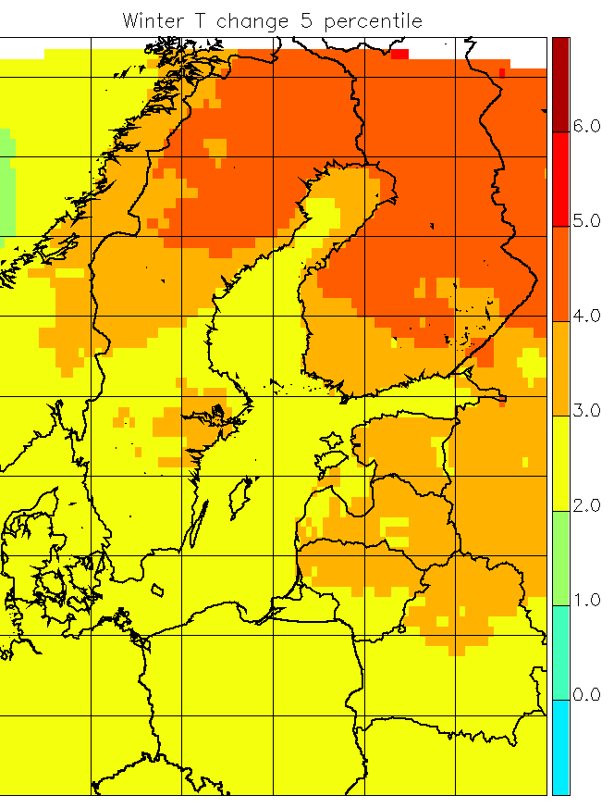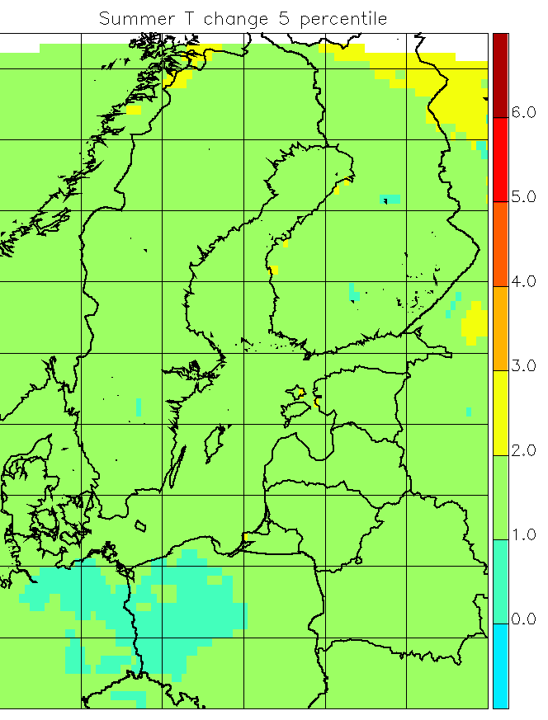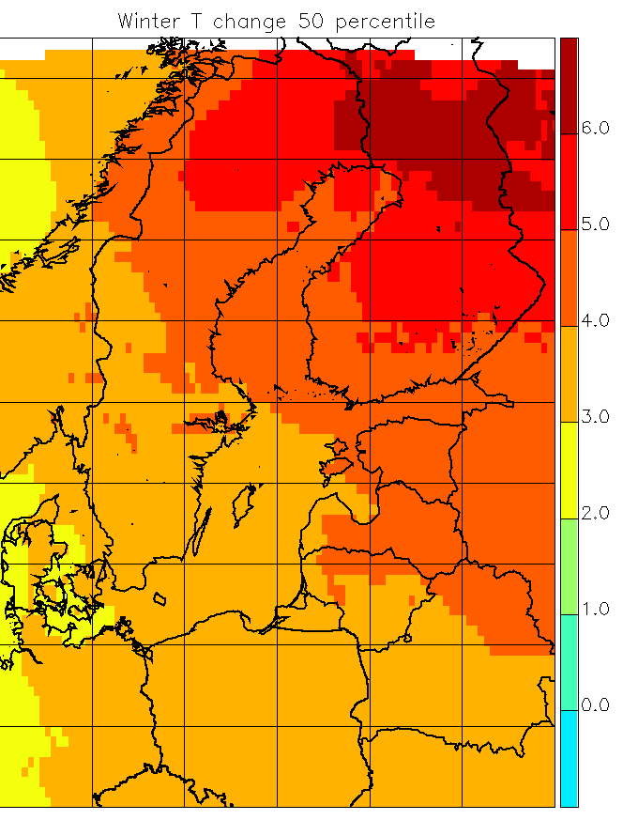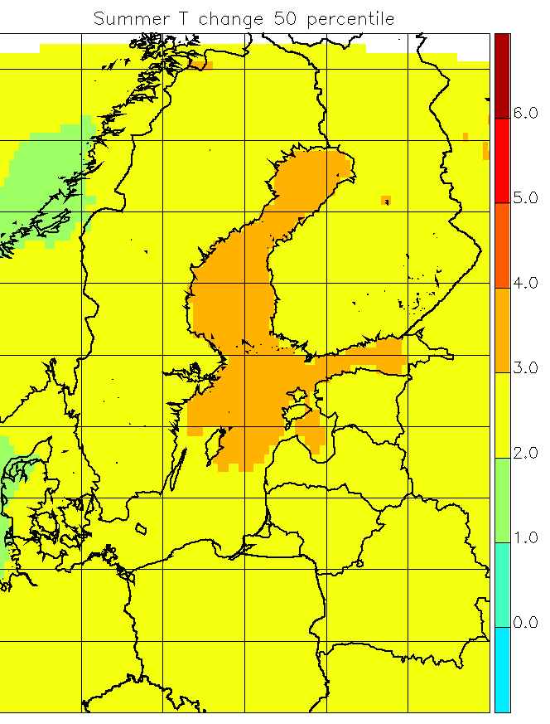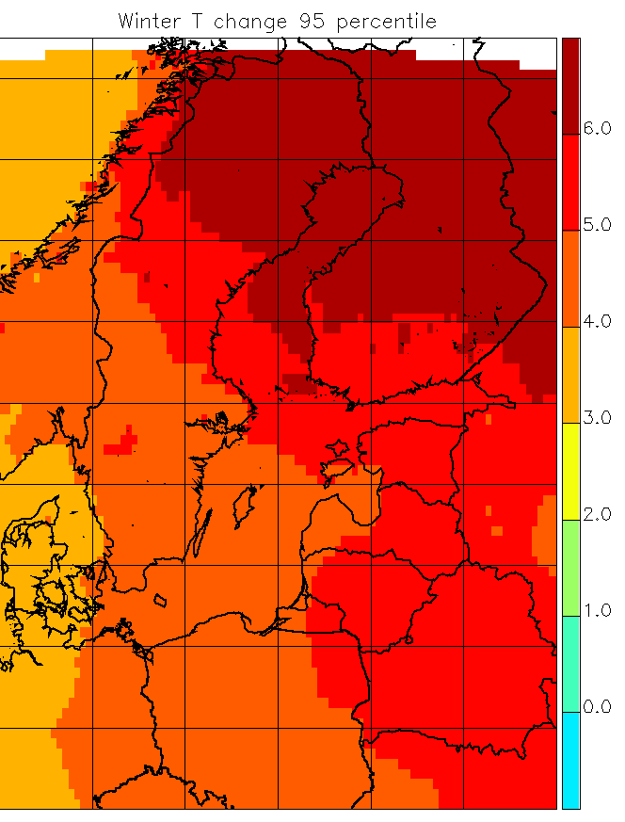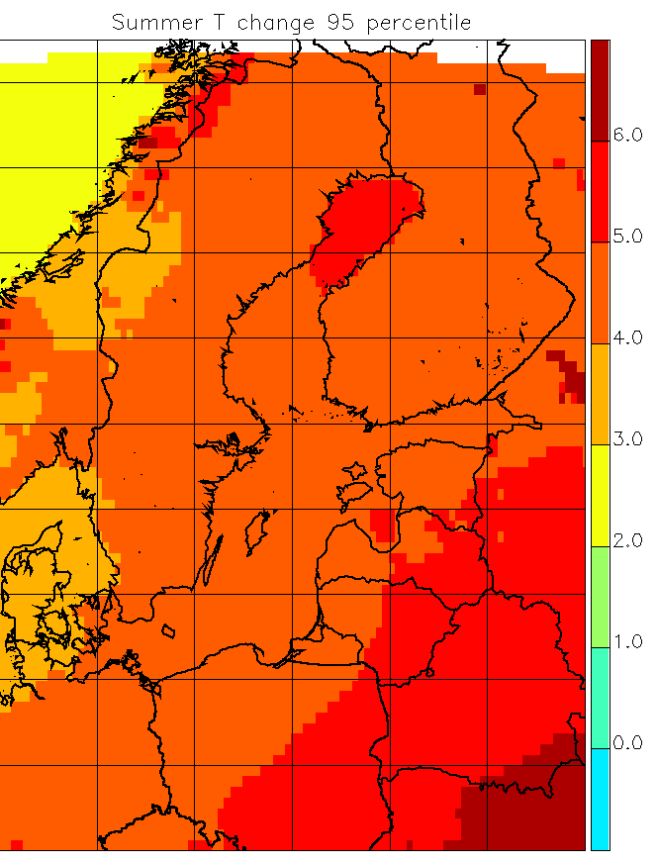
Figure 4.3.3. Simulated temperature change (°C) between 1961-1990 and 2071-2099 according to SRES A1B. Left column: Winter (DJF), right column: Summer (JJA). Upper row: Pointwise smallest result (5th percentile). Middle row: Pointwise median result (50th percentile). Lower row: Pointwise largest result (95th percentile). All these figures will be redone in Draft 2 with a readable typeface and with a Baltic-Basin boundary like in BACC1

4.3.1.6 Precipitation climate
In response to a future warmer atmosphere that can hold more moisture, climate models project an intensification of the global hydrological cycle (e.g. Held and Soden, 2006). On a European scale this implies more precipitation in northern Europe and less in the south in both winter and summer (Christensen et al., 2007). On an annual mean basis precipitation in the Baltic Sea runoff region is projected to increase and there is a strong correlation to the increase in temperature (Fig. 4.3.2). In between areas with projected increase in the north and decrease in the south there is a broad zone extending some 500-1000 km or more where only small changes are projected (e.g. Kjellström et al., 2011). This border zone moves with the seasons and is located more to the south in winter and more to the north in summer. As a consequence, precipitation is projected to increase in the entire Baltic Sea runoff region in winter, while in summer increases in precipitation are mostly projected for only the northern parts of the basin. In the south, precipitation is projected to change only little, though with a large spread between different models including both increases and decreases.
In Fig. 4.3.4 we show the annual cycle of precipitation change for northern Sweden according to the same CMIP3 simulations as in Fig. 4.3.1. A look at the change in the seasonal cycle reveals that the uncertainty is larger than for temperature and that the range of simulations encompasses both increasing and decreasing precipitation during summer.
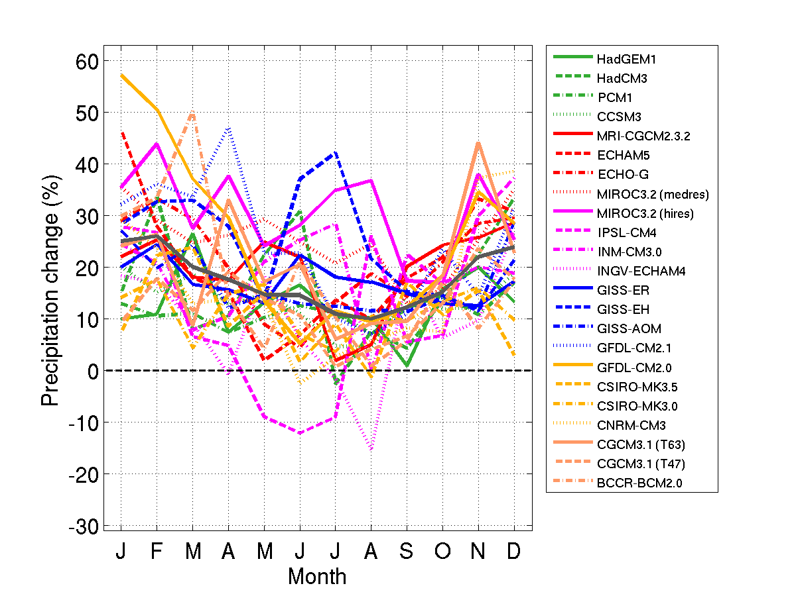
Figure 4.3.4. Projected precipitation change in northern Sweden as calculated in 23 CMIP3 AOGCM-simulations under the SRES A1B scenario (Lind and Kjellström, 2008). 30-year averages of monthly mean data has been compared between 1961-1990 and 2071-2100. The thick grey line is an average of all individual model results while the dashed line indicates no change.
In Fig. 4.3.5 we see the range of relative precipitation change for the same 11 ENSEMBLES simulations as in Fig. 4.3.3. For both seasons there is a clear north-south gradient: The further north, the more positive the change. An exception to this is the Norwegian west coast where relatively small increases, or even decreases, are projected in winter and in some case also in summer. This relatively small increase is related to changes in the large-scale atmospheric circulation as the wind direction relative to the Scandinavian mountains to a large degree determines the sign of change (e.g. Räisänen et al., 2004). We see a definite increase in winter and changes of both signs in summer with an indication of a positive signal in the southernmost parts of the area. With a larger set of ENSEMBLES simulations, but a nearer future period, Déqué et al. (2011) find significantly positive summer precipitation signals for almost all land points in the Baltic Sea catchment. As discussed above for temperature we note also here that the spread in Fig. 4.3.5 may be different given another set of GCM/RCM combinations as indicated by the spread in the larger range of GCMs in Fig. 4.3.4.
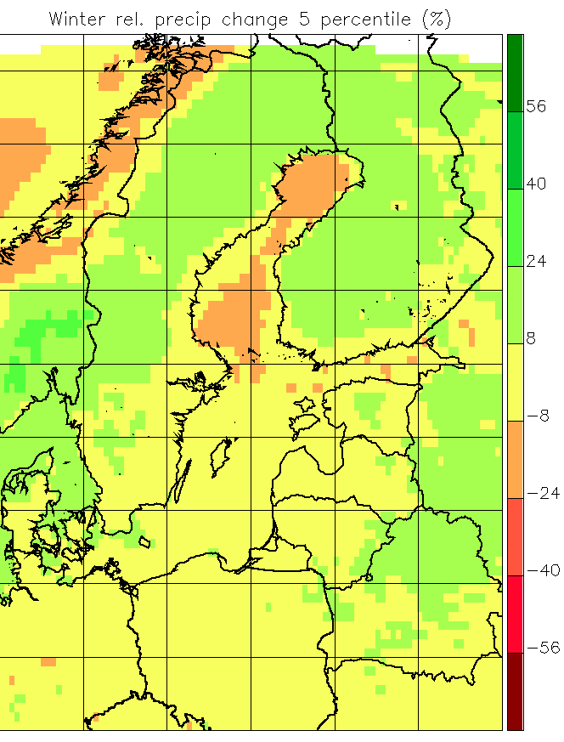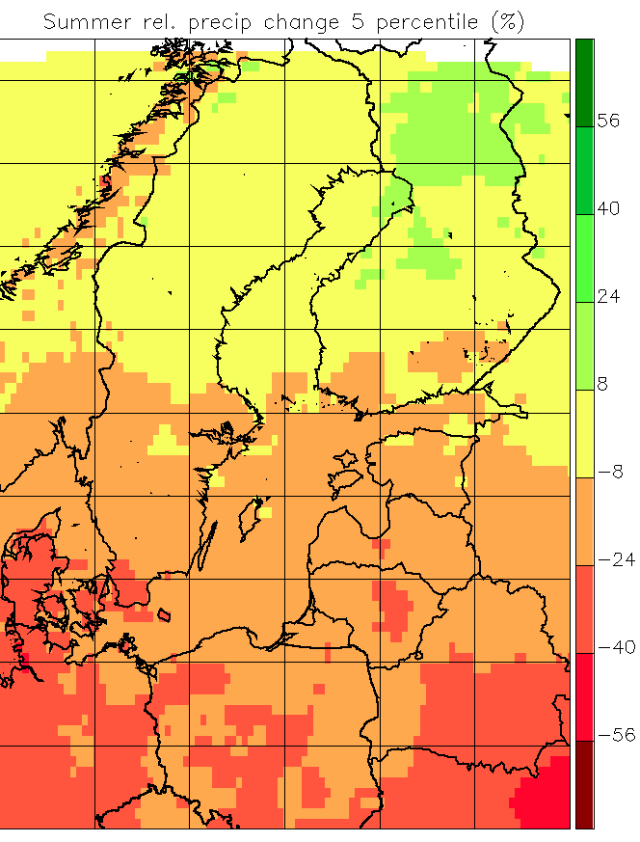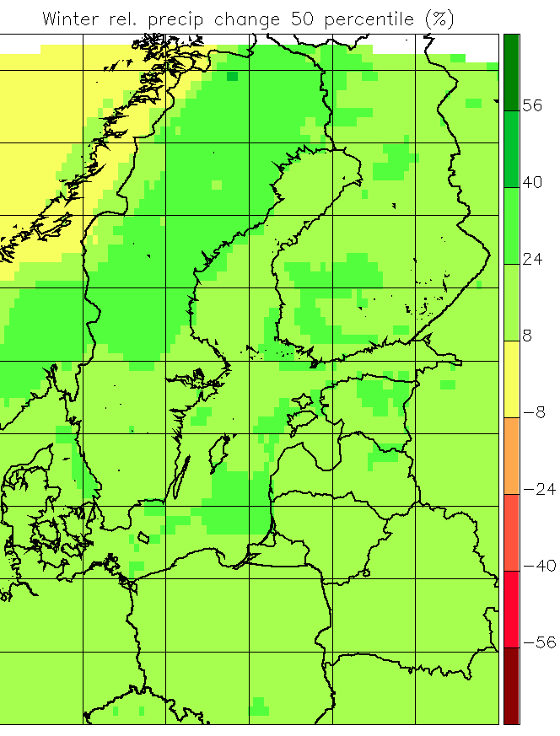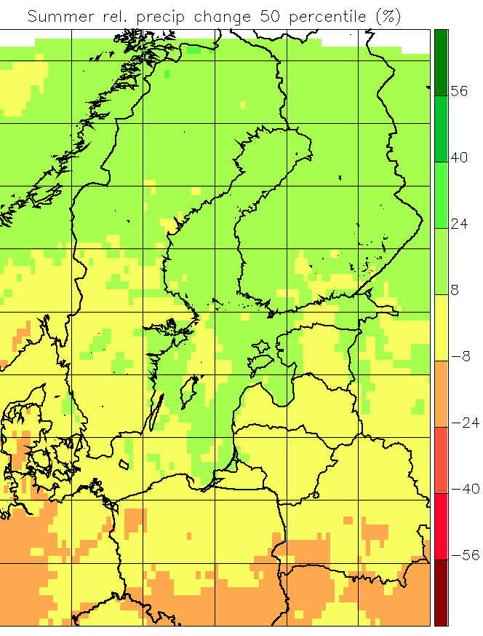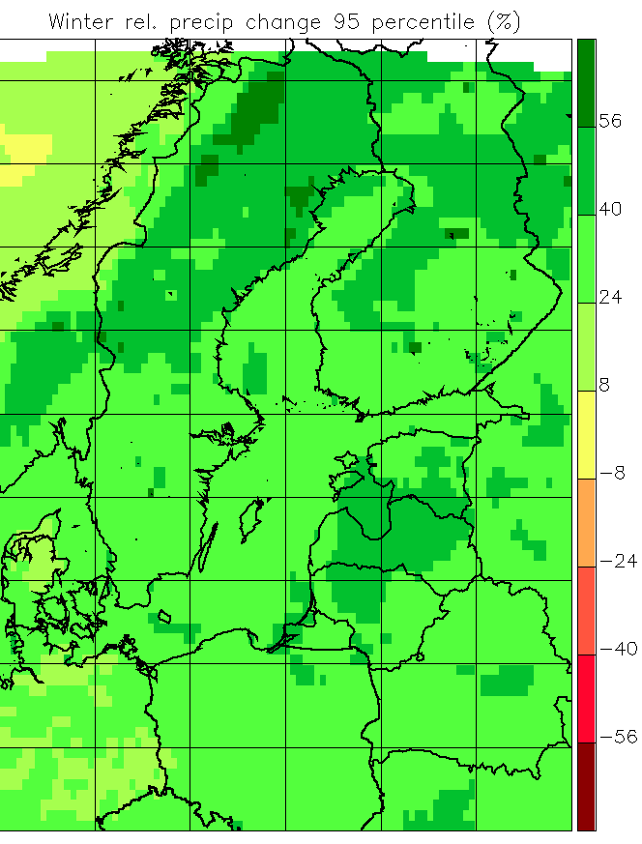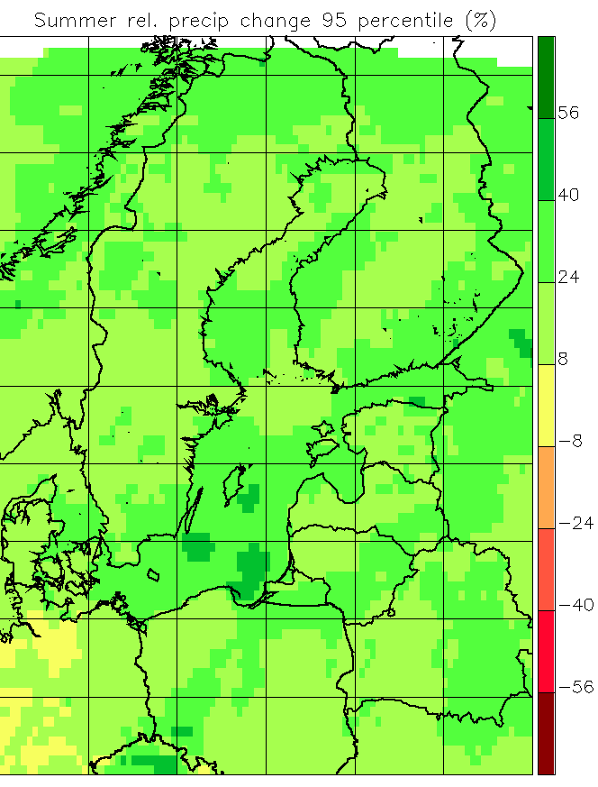
Figure 4.3.5. Like Fig. 4.3.3, but for per cent change in average precipitation.
Extreme weather events are very important for many aspects of society. Extreme precipitation is responsible for urban flooding, and this aspect of climate change has received considerable attention. As the water-holding capacity of the atmosphere increases in the future warmer climate, also precipitation extremes are projected to increase (e.g. Lenderink and van Meijgaard, 2010).
Building on the PRUDENCE project, Christensen and Christensen (2003) showed that projections showing considerable decreases in average summer precipitation at the same time showed increased likelihood of very extreme precipitation. Heavier precipitation can be expected on different time scales from single rain showers to long-lasting synoptic scale precipitation.
It is likely that changes for shorter time scales may exceed those for longer time scales as indicated by Lenderink and van Meijgaard (2010). They show that change in hourly precipitation extremes in one RCM considerably exceeds the prediction from the theoretical Clausius-Clapeyron relation that sets an upper bound to the water vapor content in the atmosphere.
As an example of changes in daily precipitation, Nikulin et al. (2011) show that the recurrence time of precipitation extremes decrease from 20 years in the 1961-1990 period to 6-10 years in 2071-2100 for summer over northern Europe and to 2-4 years in winter in Scandinavia. Similarly, Larsen et al. (2009) show that the recurrence time for 20-year rain fall events on a 1-hour basis decrease to 4 years over Sweden based on a high-resolution RCM integration.
For the Rhine catchment, Hanel and Buishand (2011) investigated 15 RCM simulations from the ENSEMBLES project and found some overestimation of extreme precipitation when compared to a gridded observation set. The RCM models all project increases of extreme precipitation with long return periods.
An analysis covering 9 models from the ENSEMBLES project listed in Table 4.3.1 is illustrated in Fig. 4.3.6; the ICTP and CNRM models have been excluded from the extremes analysis, as they use a different grid projection than the others. In spite of the change in the number of models investigated, we still make the rough association of minimum and maximum among the models with a 5th and 95th percentile of the result, respectively. The change in 10-year return values of daily precipitation is shown. The median signal is consistently positive with very few exceptions. The increase in the Baltic Basin is of the same order for both summer and winter, but the inter-model spread is somewhat larger in summer, corresponding to the larger influence of local processes in this season. Comparing to the corresponding plots in Fig. 4.3.5 we see that the relative change in winter of the extreme looks very much like the relative change of average precipitation, indicating an unchanged shape of the intensity distribution function. The picture is very different for summer, where the change in extremes is considerably larger than the change in the average.
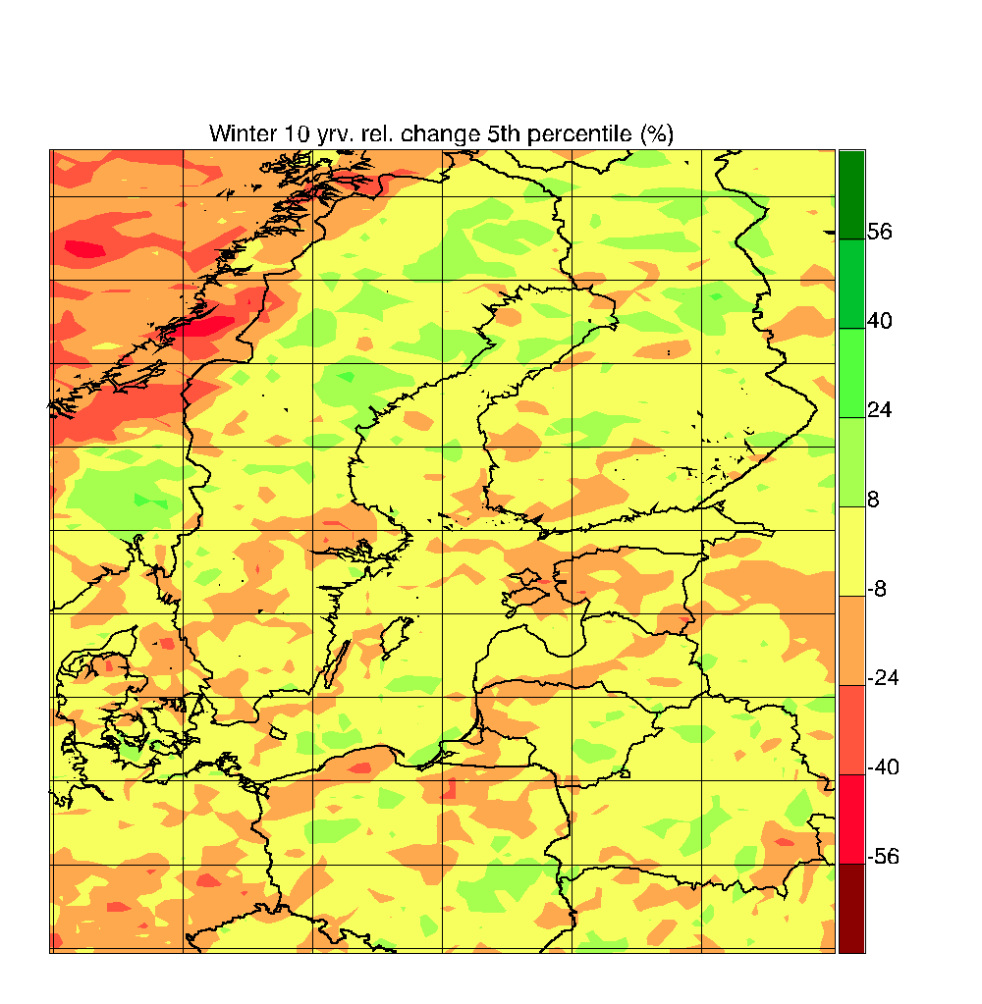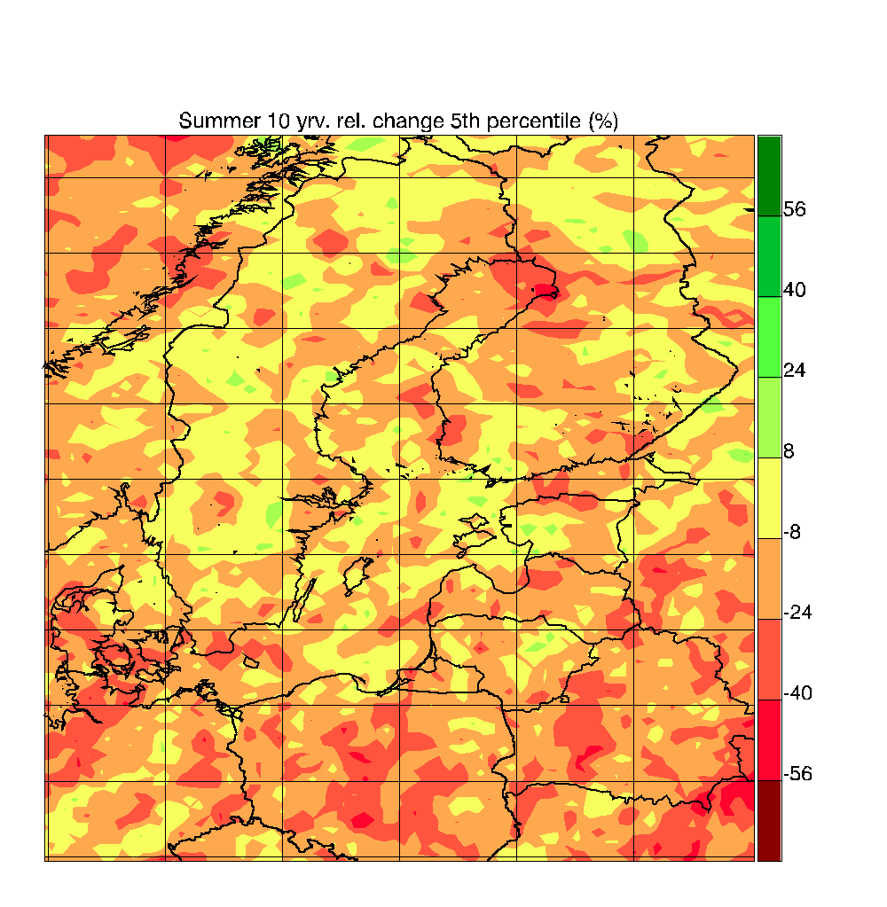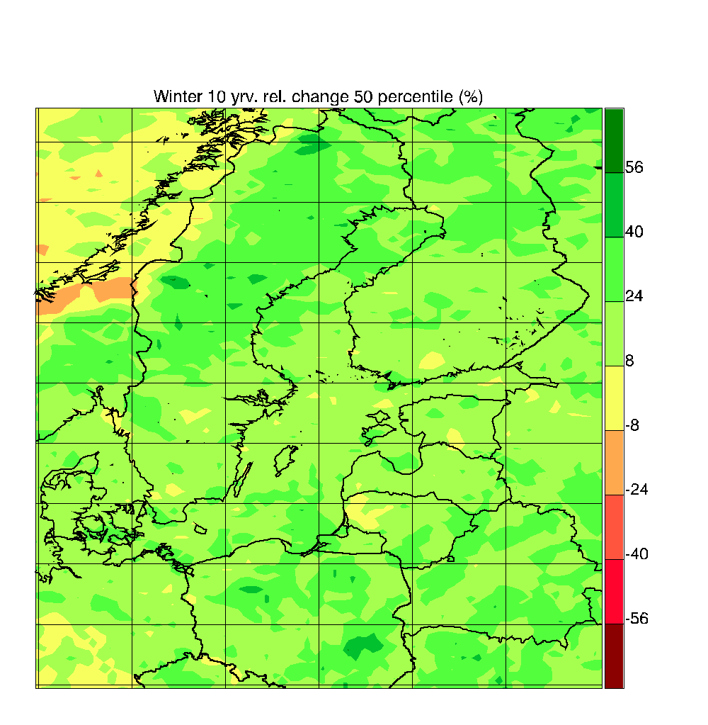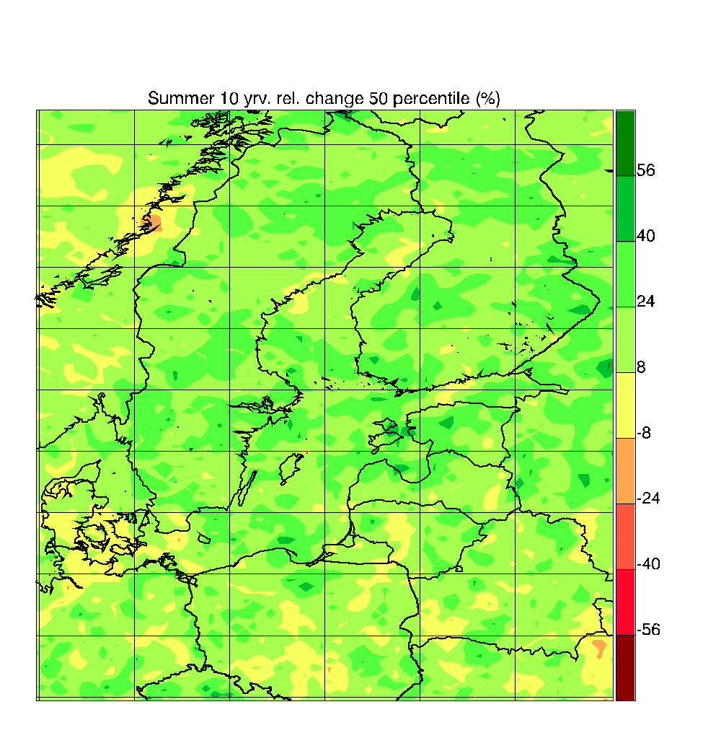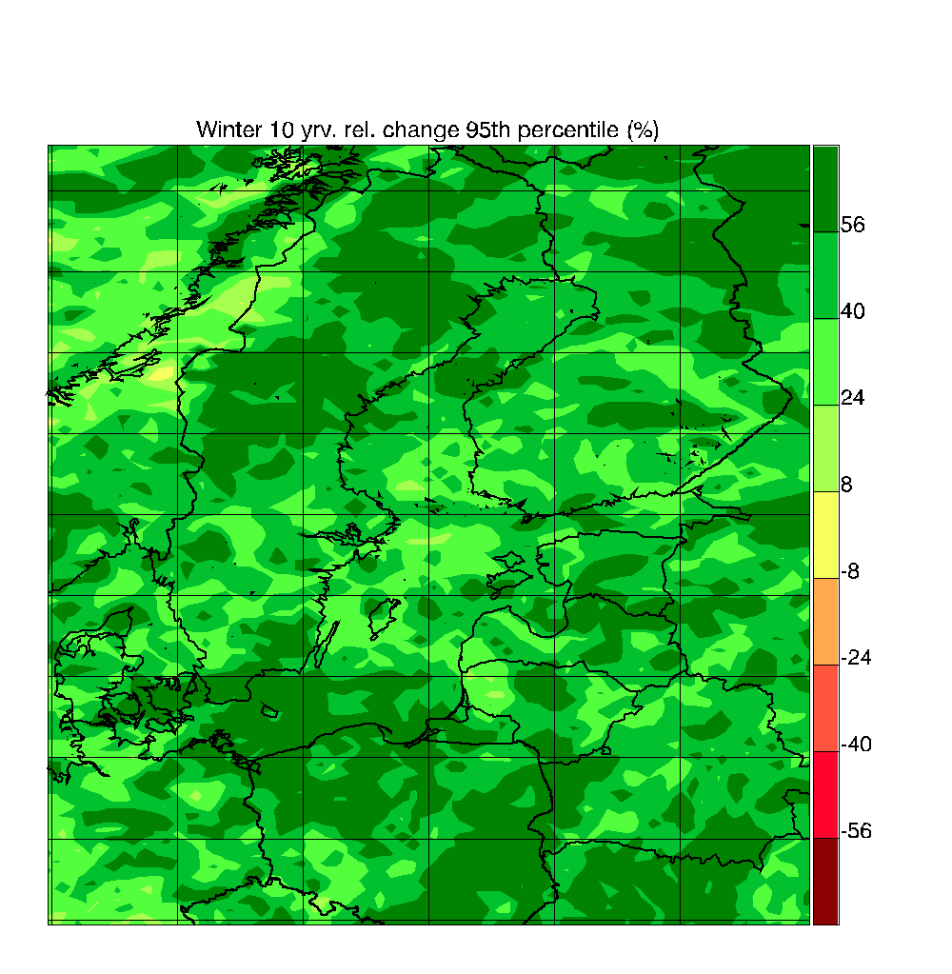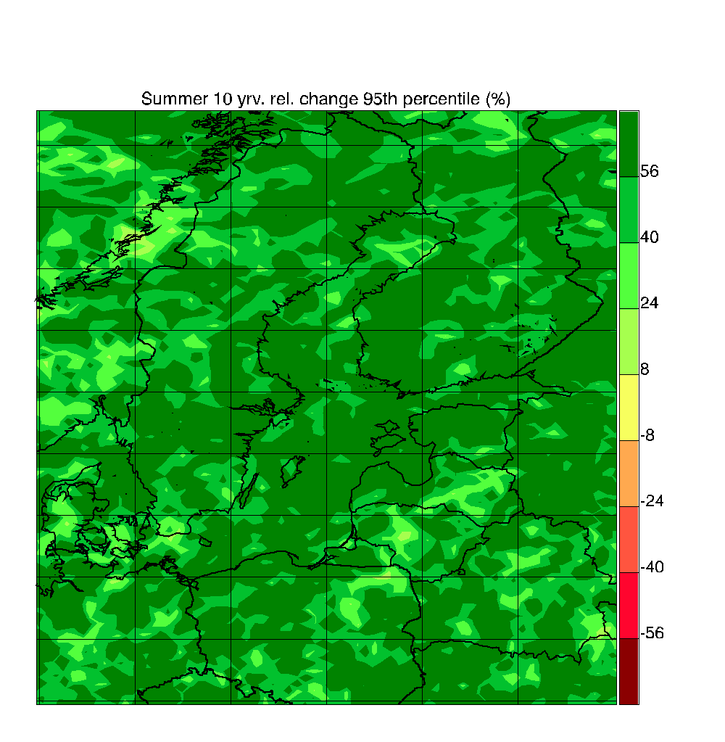
Figure 4.3.6. Like Fig. 4.3.3, but for change in 10 year return value of daily precipitation.

4.3.1.7 Wind climate
Changes in the wind climate are even more uncertain than it is the case for the precipitation climate both for seasonal mean conditions and for extremes on shorter time scales (e.g. Kjellström et al., 2011; Nikulin et al., 2011). Figure 4.3.7 shows average changes over the Baltic Sea in 16 RCA3 simulations at three different time horizons in relation to the temperature change. It is evident that the correlation is much weaker than in the case of precipitation (cf. Fig. 4.3.1) and also that the changes are relatively small including mostly increasing, but also decreasing wind speed. In many of the integrations increasing wind speed is seen over ocean areas that are ice covered in today’s climate but not in the future climate, likely a result of reduced static stability in the lower atmosphere when the surface gets warmer (e.g. Kjellström et al., 2011).

Figure 4.3.7. Change in annual mean wind speed (%) versus T_{2m} (°C) over all ocean grid points in the Baltic Sea. Emission scenarios and forcing AOGCM for each RCA3-simulation are given in the legend (A-P). Simulated changes are shown for three different time periods; (1) 2011-2040, (2) 2041-2070 and (3) 2071-2100. The grey line is a least-square fit to the data (the slope k is 1.6% per °C and the correlation coefficient r is 0.53).
For the purpose of investigations into wind power potential, as well as into possible changes in storm damages, it is the strongest winds that are of interest. We have therefore chosen to look at the daily maximum wind speed instead of the daily average of wind speed. It should be kept in mind that such a maximum is an average over the model time step of several minutes, as well as over the grid square in question. The 11 ENSEMBLES RCMs of Table 4.3.1 are plotted in Fig. 4.3.8 for relative change in the daily maximum of wind speed on a seasonal basis. Note that the range is only a quarter of the range in Fig. 4.3.7. For both seasons the climate change is of uncertain sign with a slight tendency towards an increase, particularly over sea as also indicated for daily mean wind speed in Fig. 4.3.7. Similar results are seen for the corresponding analysis of average wind speed.
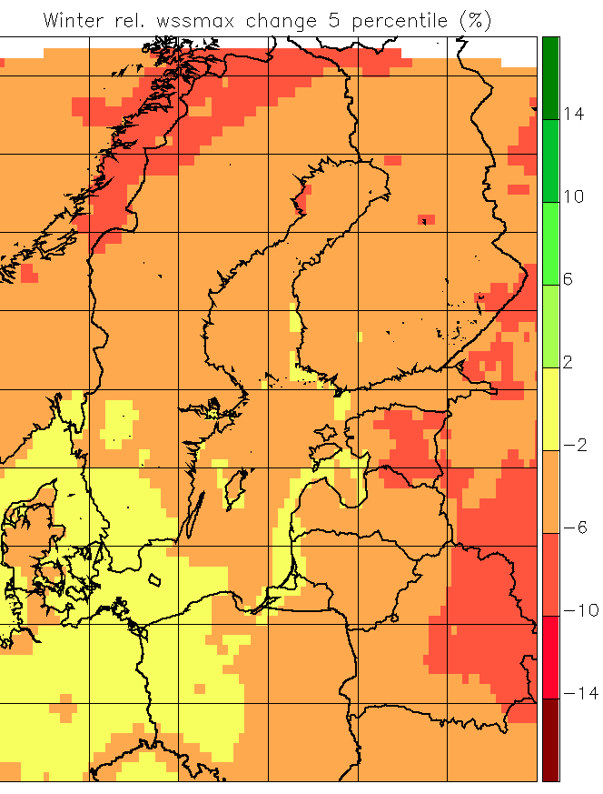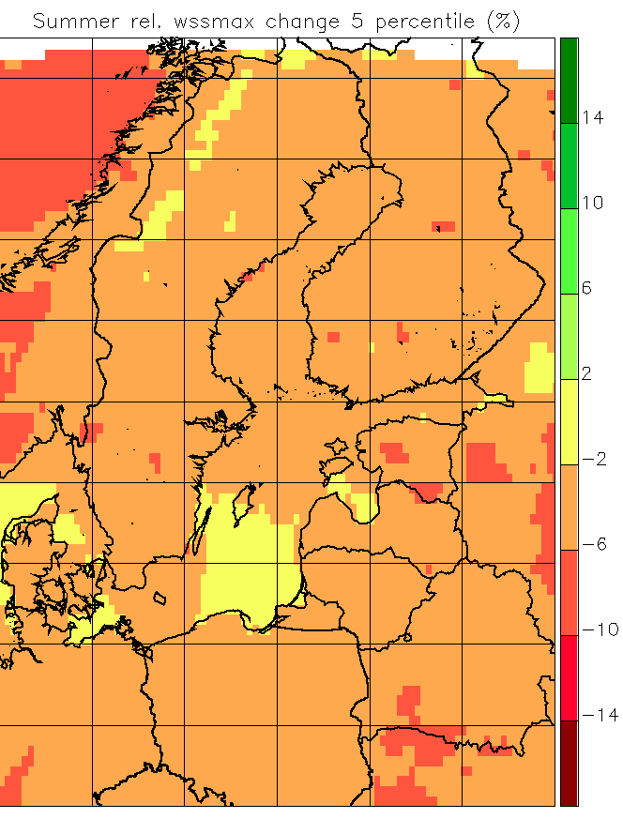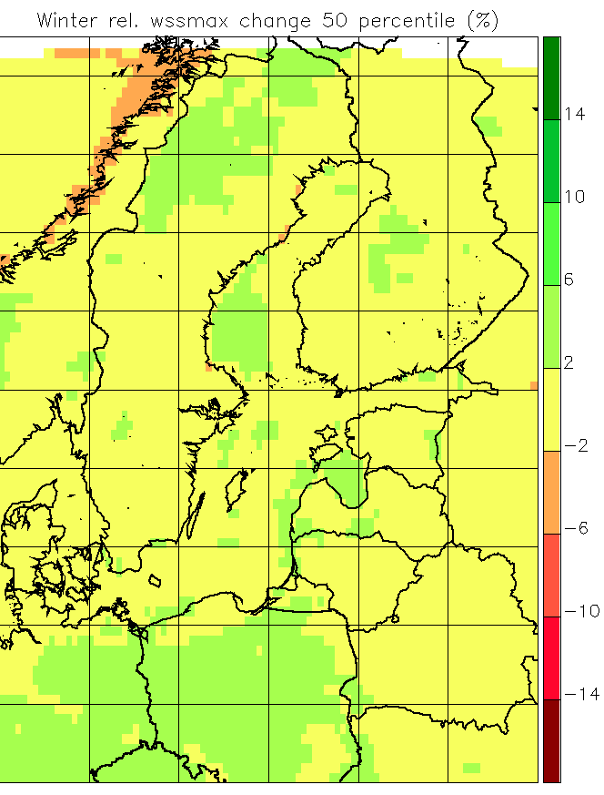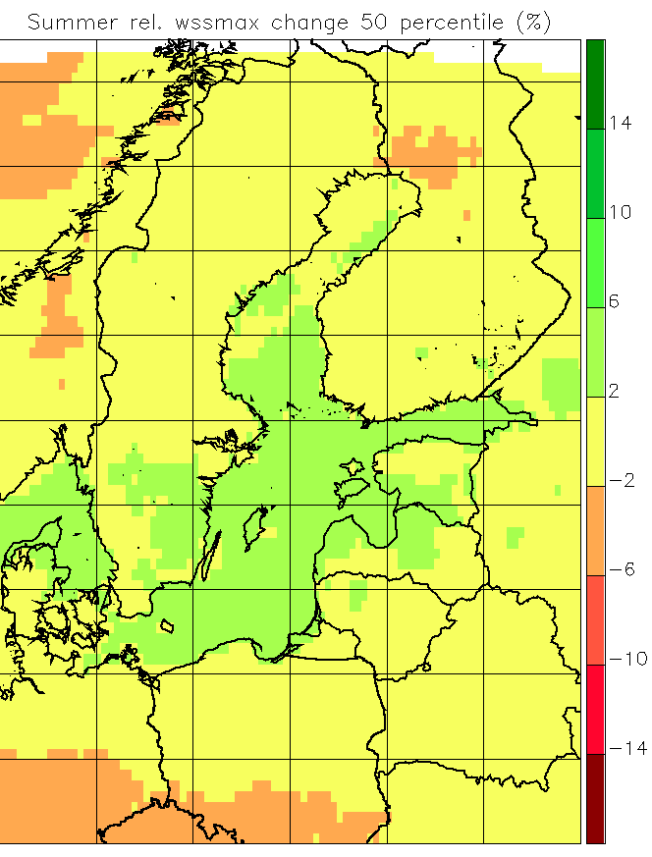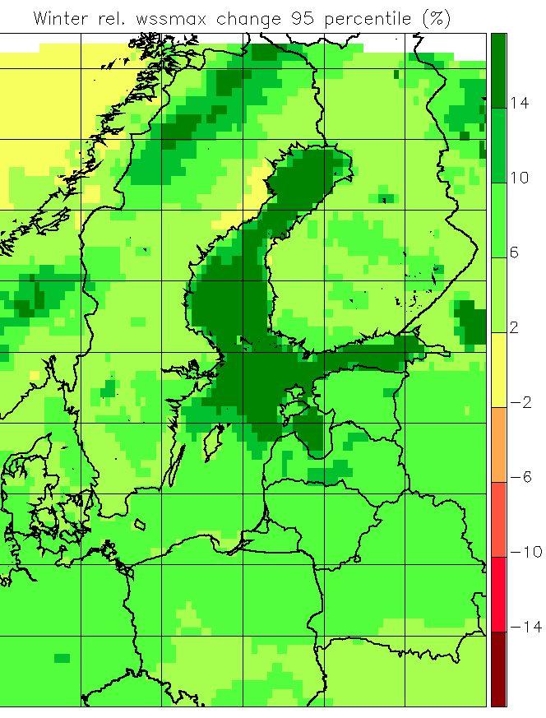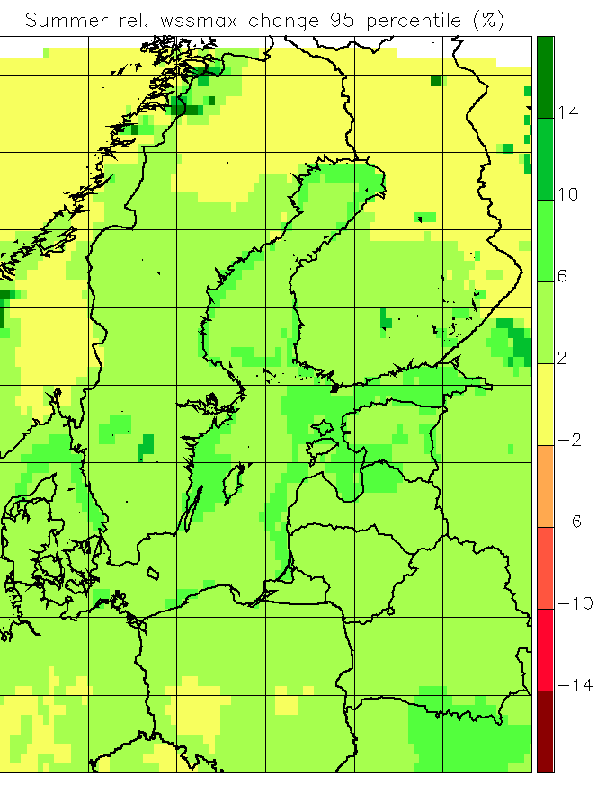
Figure 4.3.8. Like Fig. 4.3.3, but for relative change in average daily-maximum wind speed.
Extremes of wind speed are relevant for expected changes in frequencies of wind storms, though it should be kept in mind that the wind speeds in RCMs are grid point averages as well as averages over model time steps of a few minutes. Potential for wind power is proportional to the third power of the wind speed, and it is therefore relevant for this to investigate extremes of wind power.
Donat et al. (2011) looked at mid-century as well as end-of-century changes of the annual 98th percentile of daily maximum wind in 14 ENSEMBLES RCM simulations. The ensemble average, like the driving GCMs, showed a tendency to an increase in a belt from the British Isles to the Baltic Sea, and a tendency to reduction in the Mediterranean area.
In Fig. 4.3.9 we plot the projected change in extreme wind speed, with the 10 year return value of daily-maximum wind speed as an example. The models are the same 9 ENSEMBLES models as in Fig. 4.3.6. It can be seen that there is a much larger spread than was the case for changes in the average. There is a very slight median increase in the lower part of the area in winter, consistent with Donat et al. (2011), as the highest wind extremes are found in winter and autumn. Generally there are changes of both signs over the entire area, so no systematic climate change in extreme winds can be observed for this area in the ENSEMBLES RCM data set.
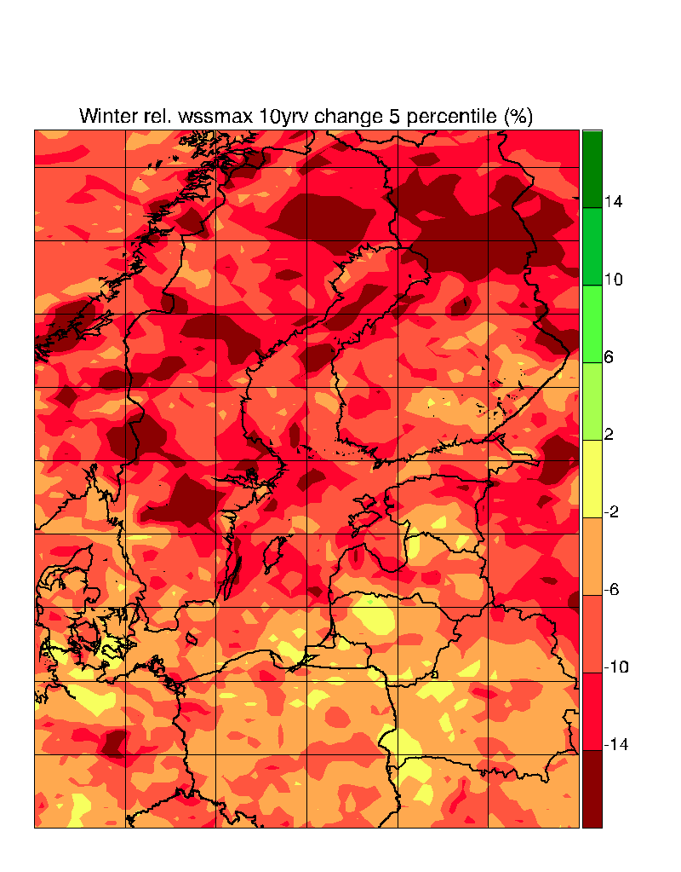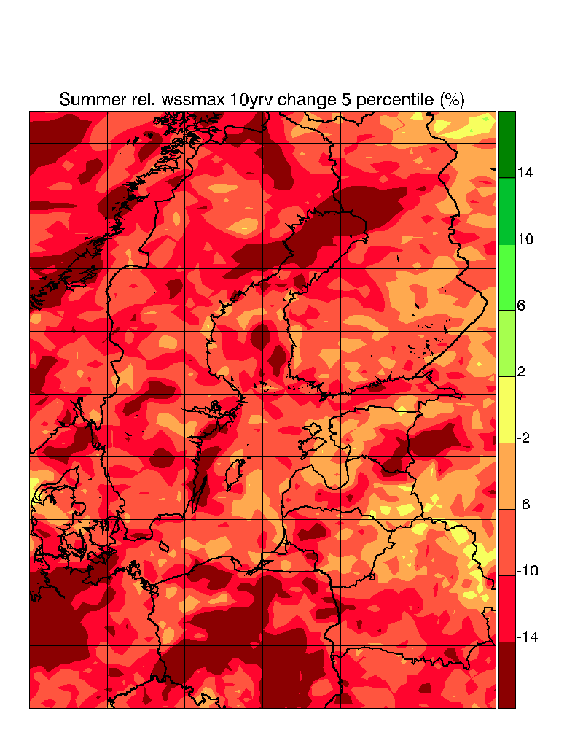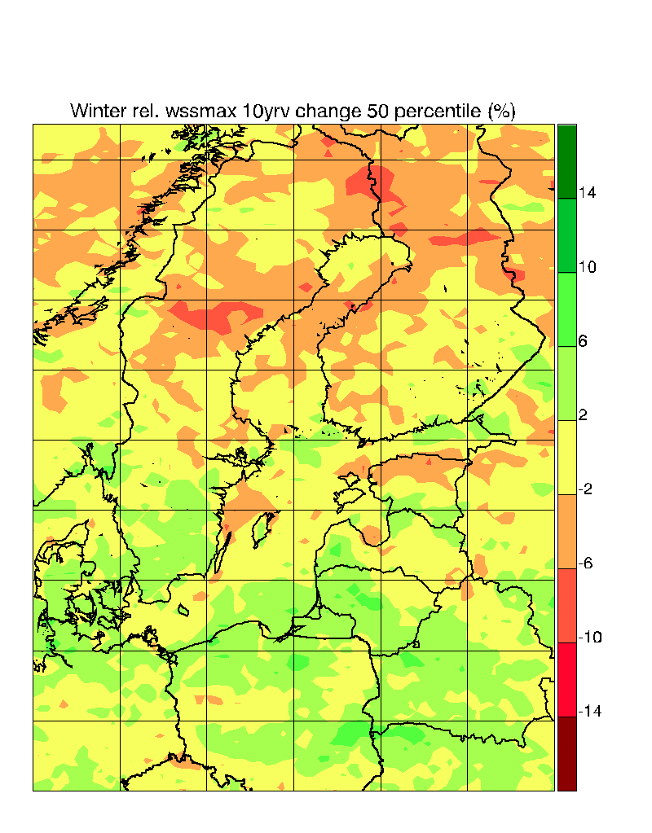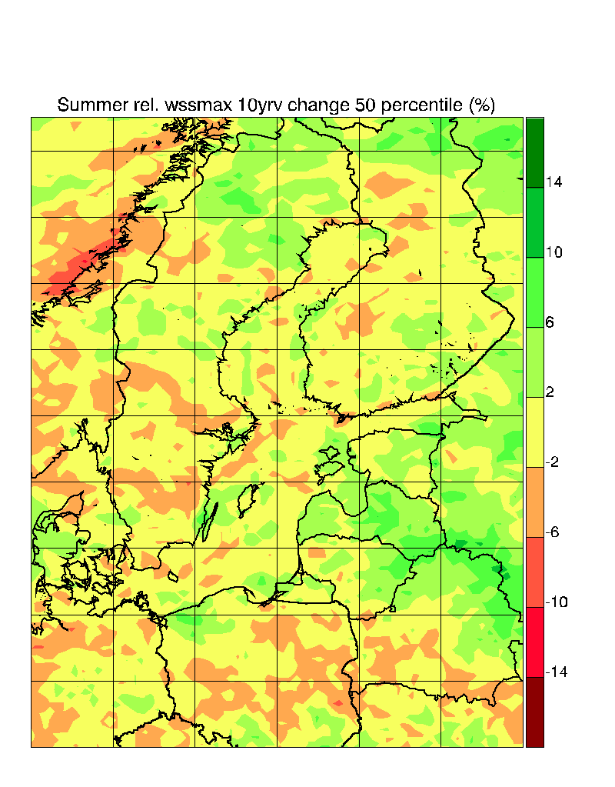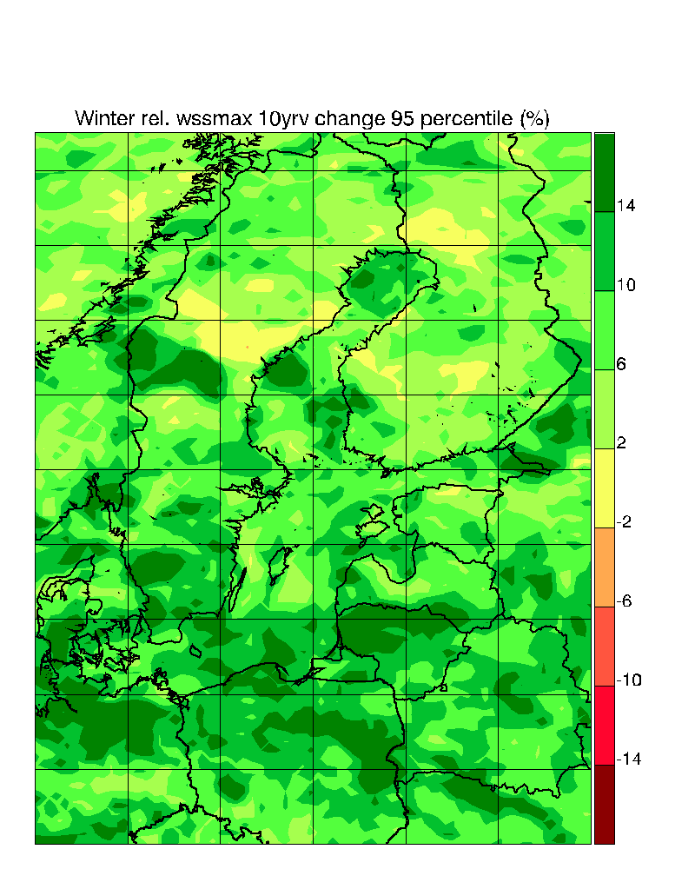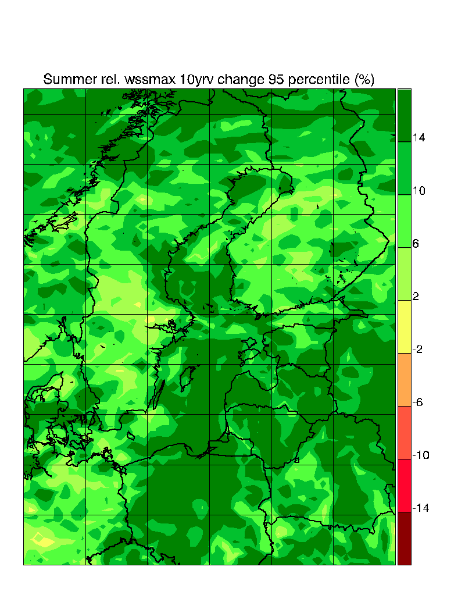
Figure 4.3.9. Like Fig. 4.3.3, but for change in 10 year return value of daily-maximum wind speed.

4.3.1.8 Snow
On the one hand, increasing temperatures are expected to lead to decreased snow cover, as more precipitation will fall as rain, and snow melt will be accelerated; on the other hand, anthropogenic climate change is expected to lead to an increased winter precipitation in Scandinavia, possibly compensating the former effect. Changes in snow cover from climate models needs to be analysed quantitatively in order to estimate the relative importance of these two counteracting changes. Data from the ENSEMBLES project have been analysed by Räisänen and Eklund (2011) with the clear conclusion that snow volume is going to decrease in the future, even though the Scandinavian mountain areas may experience slight and statistically insignificant increases. Such increases have earlier been reported by Schuler et al. (2006) in a detailed study for Norway based on two regional climate model scenarios forced with different GCMs. They also pointed out that in extreme years, the maximum amount of snow could very well be larger than that in extreme years in the recent past climate, even if it is reduced on average. In Fig. 4.3.10 below, one simulation with a known bug in the surface description has been ignored (DMI-HIRHAM5_ARPEGE). It has been judged that this error does not have a decisive influence on the temperature and precipitation development, but it leads to unrealistic changes in the snow cover. ((OBC: All analyses could be redone with just the 8, if reviewers think so))
The conclusion remains that only very small high-altitude mountain areas in few simulations may experience an increase in snow cover. The southern half of the Baltic Catchment is projected to experience significant reductions in snow cover with median reductions of around 75%.
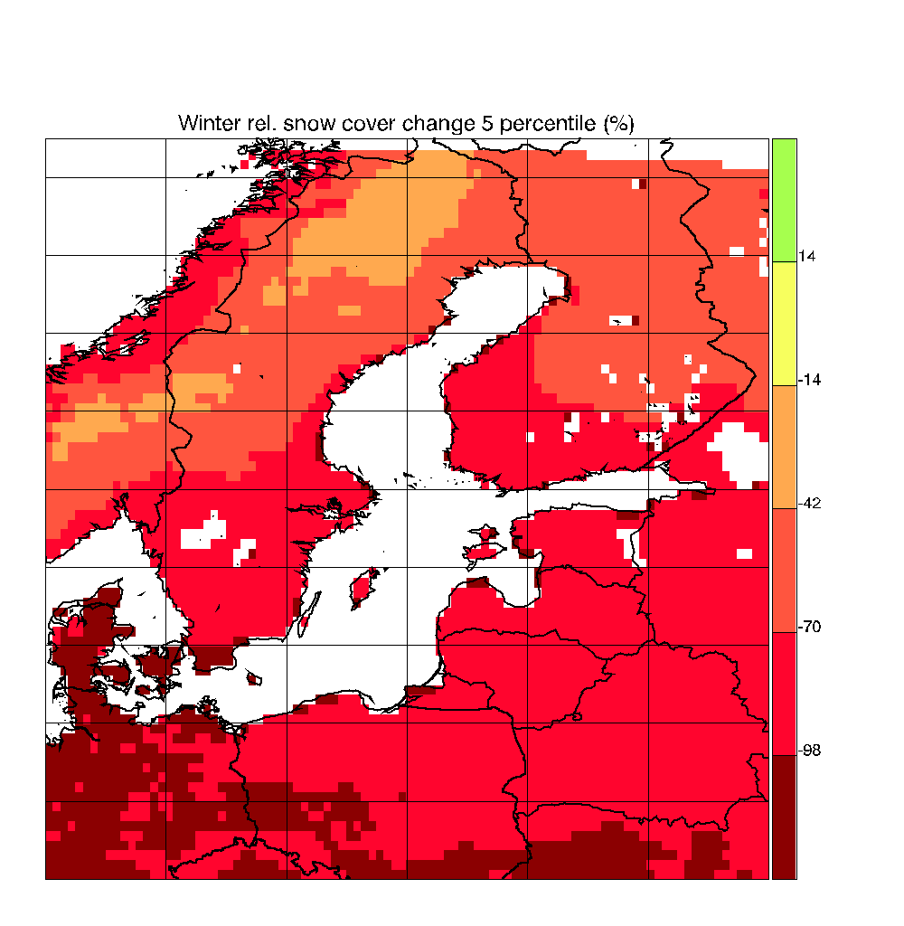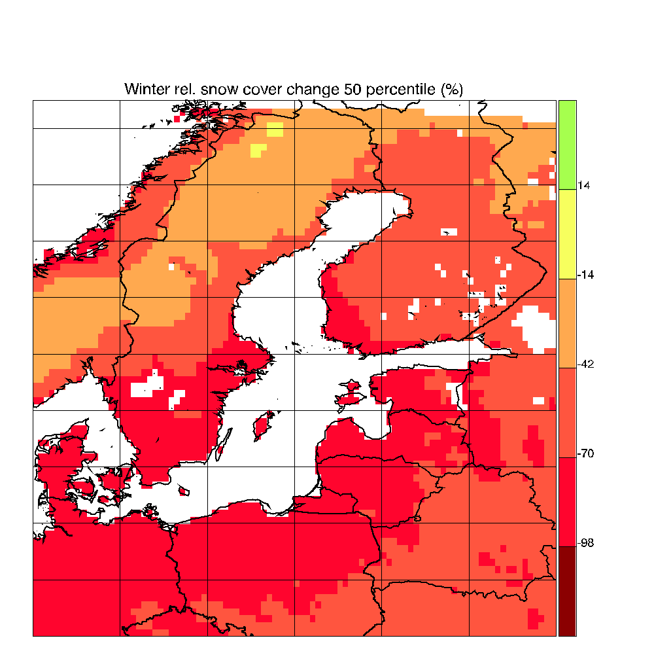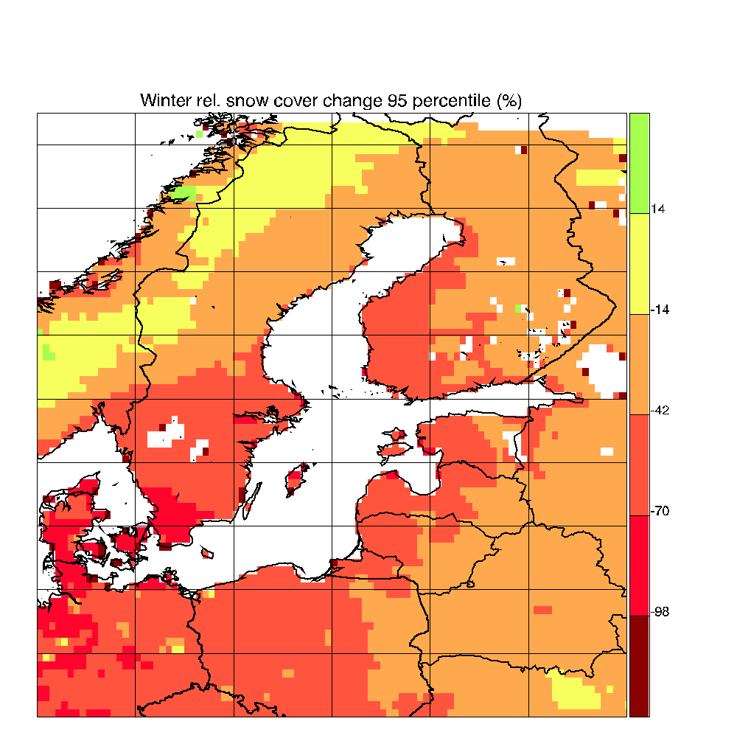
Figure 4.3.10. Like Fig. 4.3.3, but for relative change in average snow amount in winter. The minimum, the median, and the maximum relative changes are shown.

4.3.1.9 Statistical Downscaling
This section summarizes the literature on the application of statistical downscaling (SD) methods for the Baltic Sea area since the publication of the last BACC Report (2008). As described in previous sections in this chapter, SD methods aim at correcting in some way or another the output of climate model simulations, either with global climate models or regional climate models, to achieve a better estimation of climate change at scales of the same order or smaller than the resolution of the models. They have mostly been applied to climate variables that strongly depend on physical parameterizations within the models, like precipitation, cloudiness, extreme winds, since these parameterizations are usually quite uncertain and may lack general validity. The predictors used in SD should be, as also described in Section 4.2, large scale variables that are regarded as well simulated by climate models. These variables tend to be fields with large spatial coherence and that mostly depend on the dynamical core of the model, such as sea-level pressure (SLP) or geopotential height. However, one caveat that has to be borne in mind is that it is not assured that the predictors that best describe the variability of the predictand in the 20th century –which is the usual period to calibrate SD models– will also be the ones that best estimate the changes in the future climate. For instance, SLP and geopotential height are good predictors for observed seasonal mean winter precipitation in many areas of Western Europe. However, in future climates, precipitation changes will be brought about not only by the possible changes in the atmospheric circulation but also by changes in the water content of the atmosphere. Some analysis of SD methods in the virtual world provided by climate models seem to indicate that for the Baltic Sea area this latter contribution cannot be neglected (Frías et al., 2006).
For the Baltic Sea area, SD methods have been mostly applied to estimate future changes in hydrological variables like precipitation and run-off, and of storm-related variables like wind. The usual large-scale predictors are SLP and geopotential height. One particularity of the applications of SD to the Baltic Sea so far is the following: linear regression methods, such as principal component regression or variations of it, have generally been more frequently found in the literature. The applications for the Baltic Sea area have rather made use of non-linear methods, such as weather typing, fuzzy networks and clustering algorithms (see methodological section * in this chapter).
Rogutov et al. (2008) present a nice example of what a standard statistical downscaling method for precipitation would look like. The authors consider the whole of Western Europe and not only the Baltic Sea area, but the results are relevant for the latter area as well. The method used what is usually called principal components regression, which has been applied not only for downscaling purposes but also for climate reconstructions based on proxy data, since mathematically the problem is very similar. Both the predictor (SLP) and the predictand (precipitation) are decomposed by a previous principal component analysis and the leading components are retained for further analysis. This assures that the co-variance matrices that result in the regression analysis are not singular, avoiding over-fitting of the statistical model. There is no clear rule to determine the optimal number of retained principal components, but this number can be approximately estimated by sensitivity calculations until the skill of reconstructed predictand, when compared to observed data, does not grow. About half of the variability of winter precipitation in the last 50 years in Western Europe and, especially over Scandinavia, can be explained by the sea-level-pressure.
Linear regression methods produce predictands with the same probability distribution as the predictors. Since atmospheric circulation variables tend to be approximately normally distributed, linear SD methods may work well to estimate changes in monthly, seasonal or annual precipitation, which also tend to be approximately normally distributed. However, this is not the case for daily precipitation. In this case more sophisticated non-linear methods are needed, for instance those based on classification of weather types (see section *). Wetterhall et al. (2009) employ a classification scheme constructed on a fuzzy logic algorithm to estimate changes in daily precipitation over Sweden based on the output of the global climate model HadAM3H driven by the SRES scenarios A2 and B2 of future concentrations of greenhouse gases. They also employ a weather generator that takes into account the weather type and is able to replicate the serial autocorrelation of daily precipitation. The advantage of this approach is that it is in theory able to estimate changes not only of daily precipitation amounts and occurrence but also of block maxima, i.e. maximum 3-day or 5-day precipitation. Under these two scenarios, and conditional on the global climate model used, Wetterhall et al. (2009) find that precipitation in Sweden tends to increase in the 21st century, and that also the maximum 5-day precipitation tends to become larger (Fig. 4.3.11). This increase was not due to changes in the frequency of weather patterns in the future but rather was due to the increase of specific humidity in the atmosphere, roughly in accordance with the tests of SD methods in simulated climates conducted by Frías et al. (2006). These conclusions were reached by driving the SD method by different combinations of the meteorological forcing from the global climate model, as illustrated in Fig. 4.3.11. This figure shows first that the direct output of the global climate model is not able to reproduce well the annual cycle of precipitation of Sweden and it underestimates its amplitude and is biased high (panel c). The SD downscaling method improves the simulation by the global climate model and reproduces well the observed annual cycle when driven by the meteorological reanalysis or by a control simulation of the present climate (panel a). However, the SD method does not indicate large changes in precipitation when driven by scenario simulations excluding changes in the atmospheric specific humidity (panel a). Only when this variable is explicitly used to drive the SD method, are future precipitation changes evident (panel b)
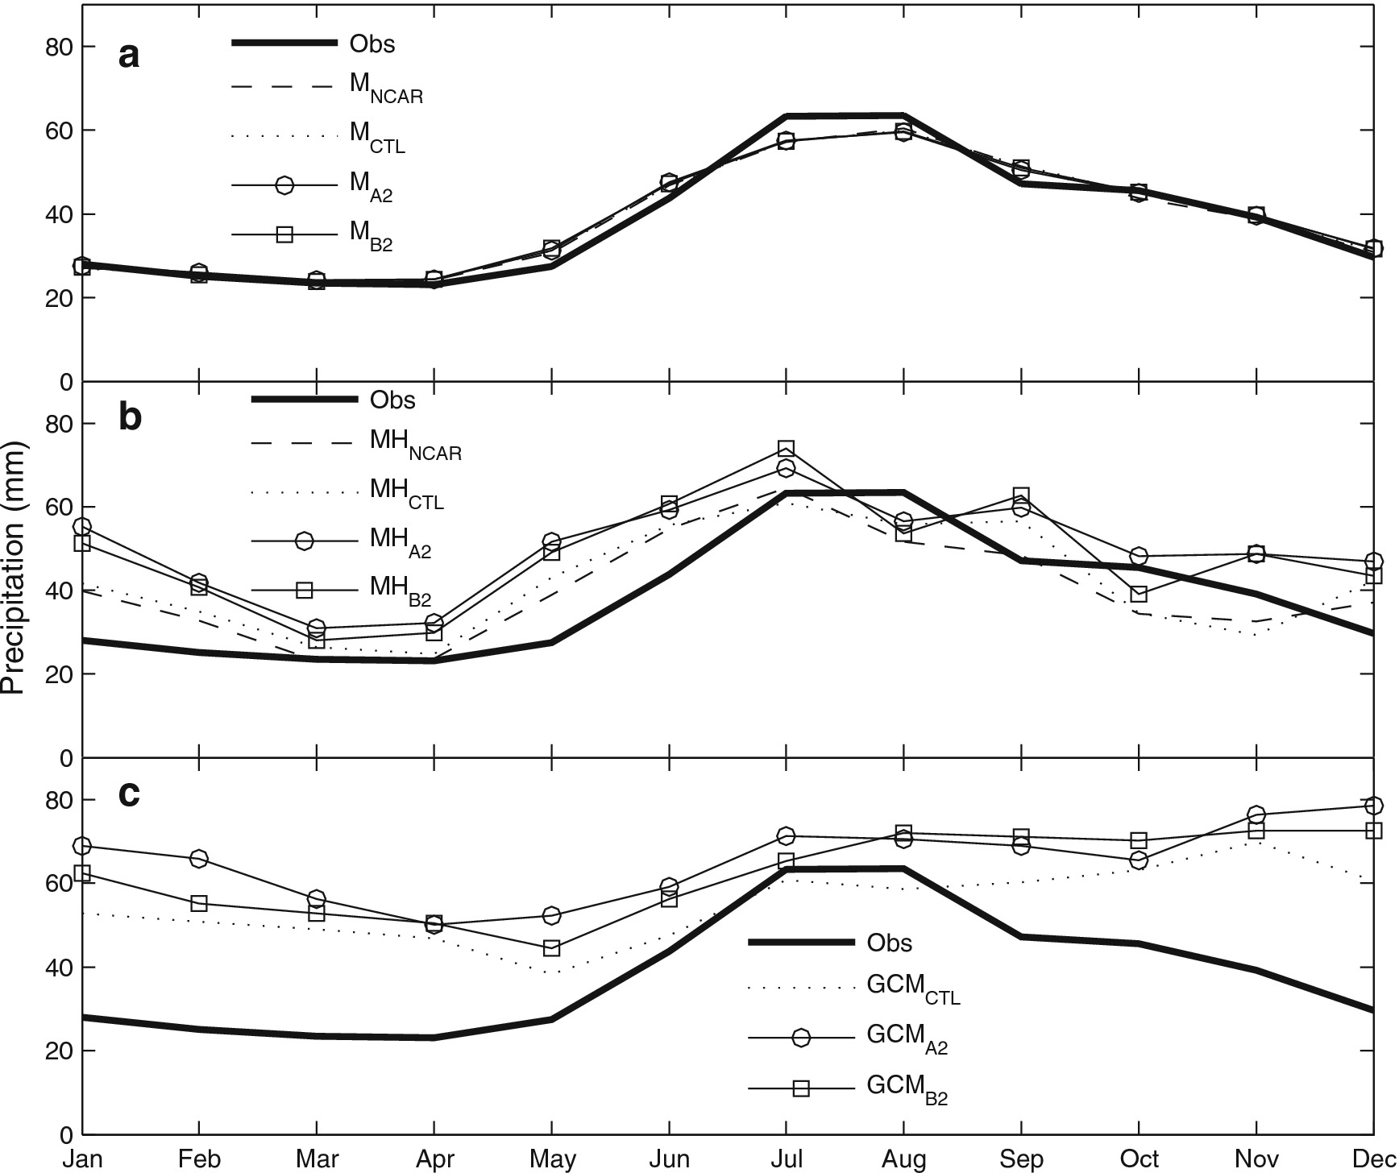
Figure 4.3.11. Observed, simulated and downscaled annual cycle of precipitation over Sweden. Bold line represents the observations; dashed line, output of the downscaling model driven by NCEP/NCAR reanalysis; thin lines, output of the downscaling model driven by a control climate simulation and by two SRES scenarios A2 and B2 with the model HadAM3. The statistical downscaling model did not include specific humidity as a predictor in panel a, but included it in panel b. Panel c shows the direct output from the global climate model HadAM3H for this region (see previous text for a more detailed explanation). From Wetterhall et al. (2009).
The downscaled precipitation can be used, in conjunction with temperature, to drive hydrological models and estimate changes in run-off in the future. However, there are important caveats that have to be borne in mind when applying climate model data to drive models of climate impacts, since climate impacts may be quite sensitive not only to the simulated relative changes in climate from the present state but also to the absolute level of temperatures and precipitation simulated by the climate model. Since climate models are very seldom bias-free, i.e. the simulated mean present climate may deviate from the observations, and sometimes in non-negligible amounts (IPCC, 2007), these biases make the direct application of simulated or downscaled precipitation or temperature problematic. Often it is necessary to apply an empirical bias correction method.
Sennikovs and Bethers (2009) propose a bias correction method for precipitation and temperature that may be subsequently applied to drive a hydrological model in the Eastern Baltic area. The bias correction method is based on a comparison between the probability distribution function of the climate variables simulated by a regional climate model and those derived from observations. A correction function is applied to the simulated data that aligns the simulated and observed quantiles of the probability distribution. This correction function may be in general non-linear, although in some cases a simple re-alignment of the mean and re-scaling to same variance may be adequate. Sennikovs and Bethers (2009) apply their methodology to several regional climate models participating in the European project PRUDENCE (Christensen and Christensen, 2007), selecting the Eastern Baltic Area for their further analysis. They find that regional climate models tend to produce a reasonable annual cycle of temperature but that they clearly overestimate precipitation in winter and underestimate precipitation in summer. By applying their bias correction method to daily precipitation, they are able to bring the model results much closer to observations. The same correction function would then be applied to the output of scenario simulations, under the assumptions that the causes that produce the mean biases in the models remain unchanged under climate change.
The corrected values of precipitation and temperature have been then used by Apsīte et al. (2010) to drive a hydrological model to estimate changes of run-off in the Eastern Baltic Sea catchment area. Future run-off will be modulated by changes in two factors. On the one hand, evaporation will tend to increase due to higher air temperatures. On the other hand, precipitation is expected to increase, as simulated by most regional climate models participating in the PRUDENCE project (Christensen and Christensen, 2007). A somewhat surprising result of the study of Apsīte et al. (2010) is that the first factor seems to be more important in the future, and river run-off will tend to decrease according to the simulations by regional models analysed. Also important is that the annual cycle of run-off will also tend to change considerably, with the late spring maximum observed in the present climate shifting to earlier seasons, even into the months of January and February. This is a consequence of the increasing temperatures and an earlier onset of the melt season, and additionally of changes in the annual cycle of precipitation and increased evaporation. This represents a major shift in the annual cycle of run-off that may have profound consequences on many economic sectors should it remain unmanaged by reservoirs. However, it is not clear whether Apsīte et al. (2010) used the results of a single model simulation or an ensemble of simulations with different models.
Previous projections of river run-off into the Baltic Sea indicated that the uncertainty was large enough to encompass a broad range of projections, from slight reductions to substantial increase (Graham, 2004). In a further study aimed at reconstructing run-off in the past 500 years, Hansson and Omstedt (2010) also apply an SD method using predictors from climate reconstructions of atmospheric circulation and temperature. Although this study is not focused on future projections but rather on past evolution of run-off, their findings about past variability of river run-off were also interpreted in the context of future climate change. Hansson and Omstedt (2010) briefly indicate that, if their SD model is correct, run-off will tend to increase in the Northern Baltic and to decrease in the Southern Baltic. This result is mainly driven by the signal of increasing temperature in the northern Baltic catchment area and by a decrease of precipitation in Central Europe.
The estimation of changes in extreme wind events over a few days present similar characteristics as the estimation of daily precipitation changes, and thus similar methods have also been applied, again in classification algorithms. Leckebusch et al. (2008) present a cluster analysis based on the k-means method to identify the weather situations that give rise to extreme winds in Western Europe. The k-means method is a standard clustering algorithm that in this case was applied after a pre-filtering by Principal Component Analysis. The same algorithm was then applied to a climate change simulation with the model ECHAM4/OPYC3 driven by a somewhat older future scenario (IS92a) of changing greenhouse gas concentrations in the atmosphere. However, the basic results of this simulation should not be qualitatively different from the more modern simulations based on SRES scenarios. They find that the frequency of extreme winds increases over whole Western Europe and in the Southern Baltic Sea, a result that is consistent with the simulated increase in the intensity of the North Atlantic Oscillation in this model. This study, however, is based on a simulation by a single model and it will be interesting to ascertain weather the results are robust to the choice of global climate model.
Finally, SD downscaling methods have been also applied to the estimation of future changes in sea-ice and snow in the Baltic Sea area (Jylhä et al., 2008). This study analyses the results of simulations with global and regional climate simulations participating in the project PRUDENCE over the Baltic Sea area driven by future scenarios of greenhouse gas concentrations and that are described elsewhere in this report. To estimate changes in sea-ice cover, however, the authors apply an SD method, since the resolution of the regional climate model is too coarse to represent sea-ice at the coastlines. The predictor in this regression model is air-temperature and the regression model is calibrated using observations between 1902 and 2001. The calibrated regression model is then applied to the projected temperature change. Additionally, a bias correction has to be applied to account for the mean temperature bias in the model, since the formation of sea-ice is a strongly non-linear process that obviously depends on the absolute temperature and not only on the temperature change. This study adopts the so-called 'delta change' correction, which amounts to realigning the temperature simulation in the present-climate simulation with the observed mean temperature, conserving the temperature change signal as given by the differences between scenario and present-day simulation. The main conclusion of this study is that coastal sea-ice cover will be dramatically reduced in the coming decades, regardless of the future emission scenario, albeit the more pessimistic scenario A2 yields the largest reductions of sea-ice cover in the Baltic.

4.3.1.10 Summary and conclusions
A number of climate change simulations have been undertaken in recent years. Compared to previous experiments models now operate at higher horizontal resolution. Further, the simulations cover a larger degree of the uncertainty range including: a wider range of emission scenarios (sampling the uncertainty in forcing), more climate models (model uncertainty) and ensemble members (natural variability). The picture emerging from these simulations confirm what previous studies have shown in terms of climate change in the Baltic Sea region. Climate models suggest that:
The future climate will get warmer and mostly so in winter. Changes increase with time and/or increasing emissions of greenhouse gases. There is a large spread between different models, but they all project warming.
Cold extremes in winter and warm extremes in summer are expected to change more than the average conditions in the two seasons implying a narrower (broader) temperature distribution in winter (summer).
The future precipitation will be larger than today. Again, the relative increase is largest in winter. In summer, increases in the far north and decreases in the south are seen in the simulations. In between even the sign of change is uncertain.
Precipitation extremes are expected to increase though with a higher degree of uncertainty compared to projected changes in temperature extremes.
Future changes in wind speed are highly dependent on changes in the large-scale circulation simulated by the GCMs. The results diverge and it is not possible to say if there will be a general increase or decrease in wind speed in the future. A common feature of many model simulations, however, is an increase in wind speed over oceans that are ice covered in today’s climate but not in the future. Future changes in extreme wind speed are uncertain.

4.3.1.11 References
Apsīte E., Bakute A., Kurpniece L., and Pallo I., 2010. Changes in river run-off in Latvia at the end of the 21st century. Fennia 188, 50-60.
BACC, 2008. Assessment of Climate Change for the Baltic Sea Basin. Regional Climate studies, XXI, 473 p., Springer, Berlin Heidelberg, ISBN: 978-3-540-72785-9.
Benestad, R.E., 2011. 'A new global set of downscaled temperature scenarios', J. Climate, Vol. 24, No. 8, 2080-2098. doi: 10.1175/2010JCLI3687.1
Christensen, J. H., and O. B. Christensen, 2003: Severe summertime flooding in Europe, Nature 421, 805-806.
Christensen J.H. and Christensen O.B., 2007. A summary of the PRUDENCE model projections of changes in European climate by the end of the century. Clim. Change 81:7-30
Christensen, J.H., B. Hewitson, A. Busuioc, A. Chen, X. Gao, I. Held, R. Jones, R.K. Kolli, W.-T. Kwon, R. Laprise, V. Magaña Rueda, L. Mearns, C.G. Menéndez, J. Räisänen, A. Rinke, A. Sarr and P. Whetton, 2007: Regional Climate Projections. In: Climate Change 2007: The Physical Science Basis. Contribution of Working Group I to the Fourth Assessment Report of the Intergovernmental Panel on Climate Change [Solomon, S., D. Qin, M. Manning, Z. Chen, M. Marquis, K.B. Averyt, M. Tignor and H.L. Miller (eds.)]. Cambridge University Press, Cambridge, United Kingdom and New York, NY, USA.
Christensen, J.H., Kjellström, E., Giorgi, F., Lenderink, G., Rummukainen, M., 2010. Weight assignment in regional climate models. Climate Research, 44(2-3), 179-194.
Christensen, O.B., 2011: Report on regional simulation of climate change according to an RCP8.5 scenario. Deliverable 1.3 of the FP7 ClimateCost project. Available by request from Ole B. Christensen, obc@dmi.dk.
Collins, M., Booth, B. B., Bhaskaran, B., Harris, G. R., Murphy, J. M., Sexton, D. M. H. and Webb, M. J., 2011. Climate model errors, feedbacks and forcings: a comparison of perturbed physics and multi-model ensembles. Clim. Dyn. 36:1737-1766. doi:10.1007/s00382-010-0808-0.
Déqué, M., Somot, S., Sanchez-Gomez, E., Goodess, C.M., Jacob, D., Lendering, G. And Christensen, O.B., 2011. The spread amongst ENSEMBLES regional scenarios: regional climate models, driving general circulation models and interannual variability. Clim. Dyn. Doi: 10.1007/s00382-011-1053-x
Donat, M.G. Leckebusch, G.C., Wild, S. and Ulbrich, U., 2011. Future changes in European winter storm losses and extreme wind speeds inferred from GCM and RCM multi-model simulations. Nat. Hazards Earth Syst. Sci., 11, 1351-1370, doi:10.5194/nhess-11-1351-2011
Frías M. D., Zorita E., Fernandez J.,and Rodrıguez-Puebla C, 2006. Testing statistical downscaling methods in simulated climates. Geophys. Res. Lett. 33, L19807, doi:10.1029/2006GL027453
Graham P., 2004. Climate change effects on river ﬂow to the Baltic Sea. Ambio 33: 235-241.
Hanel, M. and Buishand, A., 2011. Analysis of precipitation extremes in an ensemble of transient regional climate model simulations for the Rhine basin. Clim. Dyn. 36, 1135-1153. DOI 10.1007/s00382-010-0822-2
Held, I. and Soden, B., 2006. Robust response of the hydrological cycle to global warming. J. Clim. 19, 5686-5699.
IPCC, 2001. Climate Change 2001: The Scientific Basis. Contribution from Working Group I to the Third Assessment Report of the Intergovernmental Panel on Climate Change [Houghton, J.T., Y.Ding, D.J. Griggs, M. Noguer, P.J. van der Linden, X. Dai, K. Maskell, and C.A. Johnson (eds.)]. Cambridge University Press, Cambridge, United Kingdom and New York, NY, USA, 881 pp.
IPCC, 2007. Climate Change 2007: The Physical Science Basis [Solomon, S., Qin, D., Manning, M., Marquis, M., Averyt, K., Tignor, M.M.B., Miller, H.L., and Chen Z. (eds.)]. Cambridge University Press, Cambridge, United Kingdom and New York, NY, USA, 996 pp.
Iversen, T., 2008. Preface to RegClim special issue. Tellus, 60(3). DOI: 10.1111/j.1600-0870.2008.00319.x
Jacob, D.; Göttel, H.; Kotlarski, S.; Lorenz, P., and Sieck, K., 2008, in Mahrenholz, P. (ed.) Klimaauswirkungen und Anpassung in Deutschland - Phase 1: Erstellung regionaler Klimaszenarien für Deutschland. Max-Planck-Institut für Meteorologie (MPI-M), Hamburg, Umweltbundesamt, 2008. ISSN: 1862-4359
Jylhä K, Fronzek S., Tuomenvirta H., Carter T.R, and Ruosteenoja K., 2008. Changes in frost, snow and Baltic sea ice by the end of the twenty-first century based on climate model projections for Europe. Climatic Change 86, 441-462
Kendon, E., Jones, R., Kjellström, E. and Murphy, J., 2010. Using and designing GCM-RCM ensemble regional climate projections. J. Clim., 23, 6485-6503.
Kjellström, E., 2004. Recent and future signatures of climate change in Europe. Ambio, 33(4-5), 193-198
Kjellström, E. & Lind, P., 2009: Changes in the water budget in the Baltic Sea drainage basin in future warmer climates as simulated by the regional climate model RCA3. Boreal Env. Res. 14: 114-124.
Kjellström, E., Bärring, L., Jacob, D., Jones, R., Lenderink, G and Schär, C., 2007. Modelling daily temperature extremes: Recent climate and future changes over Europe. Climatic Change. 81 (Suppl. 1), 249-265. doi:10007/s10584-006-9220-5
Kjellström, E., Nikulin, G., Hansson, U., Strandberg, G. and Ullerstig, A., 2011., 21st century changes in the European climate: uncertainties derived from an ensemble of regional climate model simulations. Tellus, 63A(1), 24-40. DOI: 10.1111/j.1600-0870.2010.00475.x
Kjellström, E., Räisänen, J., Skaugen, T.E., Rögnvaldsson, O., Agustsson, H., Olafsson, H., Nawri, N., Björnsson, H., Ylhäisi, J., Tietäväinen, H., Gregow, H., Jylhä, K., Ruosteenoja, K., Shkolnik, I., Efimov, S., Jokinen, P. and Benestad, R., 2012. Climate Scenarios. In: Thorsteinsson, T. (ed). CES final report. In press.
Kyselý, J., Gaál, L., Beranová, R. and Plavcová, E., 2011. Climate change scenarios of precipitation extremes in Central Europe from ENSEMBLES regional climate models. Theoretical and Applied Climatology 104(3), 529-542. 10.1007/s00704-010-0362-z
Larsen, A. N., Gregersen, I. B., Christensen, O. B., Linde, J. J. and Mikkelsen, P. S., 2009. Potential future increase in extreme one-hour precipitation events over Europe due to climate change. Water Science & Technology, 60(9), 2205-2216.
Lenderink G., and E. van Meijgaard, 2010: Linking increases in hourly precipitation extremes to atmospheric temperature and moisture changes. Environ. Res. Lett., 5, 9pp.
Leckebusch G.C., Weimer A., Pinto J. G., Reyers M. and Speth P., 2008: Extreme wind storms over Europe in present and future climate: a cluster analysis approach. Meteorologische Zeitschrift, 17, 67-82
Lind, P., and Kjellström, E., 2008. Temperature and precipitation changes in Sweden; a wide range of model-based projections for the 21st century. Reports Meteorology and Climatology, 113, SMHI, SE-60176 Norrköping, Sweden, 50 pp.
van der Linden P, Mitchell JFB (eds) (2009) ENSEMBLES: climate change and its impacts: summary of research and results from the ENSEMBLES project. Met Office, Hadley Centre, Exeter
Meehl, G. A., C. Covey, T. Delworth, M. Latif, B. McAvaney, J. F. B. Mitchell, R. J. Stouffer, and K. E. Taylor, 2007a: The WCRP CMIP3 multi-model dataset: A new era in climate change research, Bulletin of the American Meteorological Society, 88, 1383-1394.
Meehl, G.A., et al., 2007b. Global Climate Projections. In: Climate Change 2007: The Physical Science Basis. Contribution of Working Group I to the Fourth Assessment Report of the Intergovernmental Panel on Climate Change [Solomon, S., et al. (eds.)]. Cambridge University Press, Cambridge, United Kingdom and New York, NY, USA.
Murphy, J. M., et al., 2007. A methodology for probabilistic predictions of regional climate change from perturbed physics ensembles. Phil. Trans. R. Soc. A, 365, 1993-2028.
Nakićenović, N., Alcamo, J., Davis, G., de Vries, B., Fenhann, J., Gaffin, S., Gregory, K., Grübler, A., et al., 2000. Emission scenarios. A Special Report of Working Group III of the Intergovernmental Panel on Climate Change. Cambridge University Press, 599 pp.
Nikulin, G., Kjellström, E., Hansson, U., Jones, C., Strandberg, G. and Ullerstig, A., 2011. Evaluation and Future Projections of Temperature, Precipitation and Wind Extremes over Europe in an Ensemble of Regional Climate Simulations. Tellus, 63A(1), 41-55. DOI: 10.1111/j.1600-0870.2010.00466.x
Ruosteenoja, K., Tuomenvirta H., Jylhä, K., 2007. GCM-based regional temperature and precipitation change estimates for Europe under four SRES scenarios applying a super-ensemble pattern-scaling method. Clim. Change, 81, 193-208.
Räisänen, J., 2010. Probabilistic projections of temperature and precipitation change for the period 2021-2050, In Proc. of Future climate and renewable energy: Impacts, risks and adaptation, Oslo, 31 May - 2 June 2010, pp. 78-79.
Räisänen, J. and J. Eklund, 2011. 21st Century changes in snow climate in Northern Europe: a high-resolution view from ENSEMBLES regional climate models. Clim. Dyn. Online. Doi: 10.1007/s00382-011-1076-3
Räisänen J, Hansson U, Ullerstig A, Döscher R, Graham LP, Jones C, Meier M, Samuelsson P, Willén U., 2004. European climate in the late 21st century: Regional simulations with two driving global models and two forcing scenarios. Clim Dyn 22, 13-31
Rogutov, V.S., Chavro A.I., and Dmitriev E.V., 2008: Reconstruction of Seasonal and Semiannual Precipitation Totals over Europe from Atmospheric Pressure over the North Atlantic. Russian Meteorology and Hydrology 33, 351-359.
Samuelsson, P., Jones, C., Willén, U., Ullerstig, A., Gollvik, S., Hansson, U., Kjellström, E., Nikulin, G., Wyser, K., 2011. The Rossby Centre Regional Climate Model RCA3: Model description and performance. Tellus, 63A(1), 4-23. DOI: 10.1111/j.1600-0870.2010.00478.x
Schuler, D.V., Beldring, S., Førland, E.J., Roald, L.A. and Engen-Skaugen, T., 2006. Snow cover and snow water equivalent in Norway: current conditions (1961-1990) and scenarios for the future (2071-2100). Met.No. Report no. 01/2006 Climate. Oslo, Norway, 34 pp.
Sennikovs, J. and Bethers U., 2009. Statistical downscaling method of regional climate model results for hydrological modelling. 18th World IMACS / MODSIM Congress, Cairns, Australia 13-17 July
Sterl, A., Severijns, C., Dijkstra, H., Hazeleger, W., van Oldenborgh, G. J., and co-authors, 2008. When can we expect extremely high surface temperatures? Geophys. Res. Lett. 35, L14703, doi:10.1029/2008GL034071.
van Vuuren, D.P., Edmonds, J.A., Kainuma, M., Riahi, K. and Weyant, J., 2011. A special issue on the RCPs. Climatic Change 109, 1-4. DOI 10.1007/s10584-011-0157-y
Wetterhall F., Bárdossy A., Chen D., Halldin S., Xu C., 2009. Statistical downscaling of daily precipitation over Sweden using GCM output. Theor Appl Climatol 96, 95-103.
Wetterhall, F., Graham, L.P., Andréasson, J., Rosberg, J., and Yang, W., 2011. Using ensemble climate projections to assess probabilistic hydrological change in the Nordic region. Nat. Hazards Earth Syst. Sci., 11, 2295-2306, doi:10.5194/nhess-11-2295-2011

4.3.2 Hydrological Changes in the Baltic Region
Torben Sonnenborg
The majority of studies of expected changes in the hydrology of the Baltic Sea Basin have been performed at a national level. We have therefore structured the following description according to countries.

4.3.2.1 Hydrological Changes for Individual Countries in the Baltic Basin

4.3.2.1.1 Belarus
No separate studies on catchments in Belarus were found. However, the river Neman/Nemunas covers part of Belarus and is described under Lithuania.

4.3.2.1.2 Denmark
In Thodsen et al. (2008) the impacts of both direct and indirect effects of climate change on suspended sediment transport in Danish rivers were analysed. Two lowland catchments were examined, an alluvial catchment characterised by stable base flow and a clayey moraine catchment characterised by a more flashy flow regime. Both catchments were modelled using the rainfall-runoff model NAM for discharge and a regression model for the relation between discharge, precipitation and suspended sediment transport. Climate input from the HIRHAM regional climate model representing the SRES A2 emission scenario for 2071-2100 was used. The effect of climate change was found to be more important than changes in the length of growing season. While changes in mean annual precipitation of 6-7% were found, the mean annual river discharge was found to increase by 11-14% and the sediment transport was estimated to increase by 24-27% for the moraine catchment and 9-17% for the alluvial catchment, depending on the scenario chosen for growing season. Hence, the study indicates that the effect of climate change is magnified from the change in precipitation to discharge to sediment transport, presumably because of strong seasonal changes.
Jeppesen et al. (2009) used the NAM rainfall-runoff model at 10 small catchments in Denmark to quantify the effects of the climate projection provided by the ECHAM4/OPYC general circulation model (SRES-A2 emission scenario) downscaled by the Danish HIRHAM regional climate model (25-km grid). Annual discharge for the scenario period 2071-2100 was found to increase with 9-34% compared to the control period 1961-1990. However, stronger seasonal changes were observed as a response of seasonal changes in precipitation with monthly runoff generally increasing in winter and decreasing in late summer. The projected discharge was used in combination with a statistical phosphorus loading model. Increases of phosphorus loading between 3.3% and 16.5% were found, corresponding to a decreasing P concentration by -2.2% to -13.4%.
van Roosmalen et al. (2007) used the distributed, physically based hydrological model MIKE SHE to evaluate the impact of climate change on two large-scale catchments, a sandy area in the western part of Denmark and a clayey area in the eastern part. The two models were forced by projections from the PRUDENCE project (Christensen and Christensen, 2007) as simulated with the HIRHAM RCM nested in the HadAM3H GCM. SRES A2 and B2 scenarios for the period 2071-2100 were considered, and the delta change approach was used for bias-correction. They found that the magnitude of the hydrological response is highly dependent on the geological settings of the model area. In the sandy catchment increasing groundwater recharge was generated as a result of higher winter precipitation. Therefore, groundwater levels increased significantly, up to 3 m, resulting in elevated base flow and drain flow to the rivers. Significant increases in winter river discharge were found, whereas the summer discharge was found to be only slightly affected. In contrast, only small changes in groundwater level were found for the clayey area since the infiltration capacity of the low permeable shallow geology was exceeded. Here, the increase in precipitation was found to result in significant changes in drain flow and overland flow to rivers, with changes in mean monthly river discharge of up to +50% in winter and -50% during summer.
In a subsequent study, van Roosmalen et al. (2009) used the same modelling system to quantify the combined effects of climate change, sea level rise, and land use changes on irrigation demands and water resources. The study showed that climate change had the most substantial effect on the hydrological system. However, indirect effects were also found to be significantly. Irrigation demands were found to increase by up to 90% for the SRES-A2 emission scenario. Although groundwater levels generally increased due to increasing mean precipitation, the water content in the root zone was found to decrease during summer in response to decreasing summer precipitation and increasing evapotranspiration. Changes in land cover from grass to forest and changes in growing season resulted in minor effects on the groundwater recharge. More significant effects were found when assuming that plant respiration becomes more water efficient with increasing CO₂ concentrations. A simple approach was used where future potential evapotranspiration (PET) was assumed to equal present PET and not to increase in response to the projected rise in future temperature. The resulting reduction in actual evapotranspiration was found to have a relatively large impact on groundwater recharge, groundwater levels and stream discharge. Sea level rise of 0.5 m and 1.0 m was shown to have a pronounced effect on groundwater levels, however, only in coastal areas, where groundwater up to 10 km inland from the coast was affected.
In van Roosmalen et al. (2011) the impact of bias-correction method on the response of a hydrological model was studied. The delta change method, where the observed database of meteorological variables are perturbed according to the changes projected by the climate model, was compared to a distribution based scaling (Piani et al., 2010), where the projected meteorological variables are corrected. In contrast to the delta change method, the distribution based scaling method will reproduce the dynamics of the climate model, e.g., prolonged periods of drought and number of days with precipitation. When comparing the hydrological simulations using both methods, only small differences on the hydrological variables were found. It should however be noted that only average quantities such as annual groundwater recharge, mean change in groundwater level or mean monthly rivers discharge were analysed. The authors recommend that additional analysis is needed to analyse the impact on extremes and the sensitivity towards the characteristics of the hydrological systems, e.g., sandy versus clayey catchments.

4.3.2.1.3 Estonia
No recent studies of the impact of climate change on basins in Estonia were found.

4.3.2.1.4 Finland
The effect of climate change on design floods where evaluated on 34 dams in Finland by Veijalainen and Vehviläinen (2008). A 14 days design precipitation period with a return period of 1,000 years was generated for both present and future climate conditions. Results representing the period 2071-2100 from three GCMs, three emissions scenarios and two different estimates of design precipitation were applied in order to evaluate the uncertainty of the resulting change in design flood. As impact model the rainfall-runoff model WSFS was used. In northern Finland the timing and magnitude of the floods were on average found to remain unchanged. Warmer winters with less snow accumulation were partly compensated by increases in winter and spring precipitation. On dams in western and central Finland the design floods increased whereas the timing remained unchanged (summer and autumn). In eastern Finland the time of the design floods changed from spring to summer while both increasing and decreasing magnitudes of the design floods were found. The range of changes in the simulated design floods were large at most sites resulting in projections of both increasing and decreasing design floods at several dams. However, the relative contribution from the individual uncertainty sources was not quantified. The authors draw the attention to the fact that additional uncertainty sources such as the impact model type or the parameters of the impact model would result in even larger uncertainty ranges.
In Veijalainen et al. (2010a) the impact of climate change on the regulation of three lakes in eastern Finland was assessed. The rainfall-runoff model WSFS was forced by results from 14 projections of climate change generated by combining four GCMs, where one was found as an average of 19 GCMs (IPCC, 2007), and three SRES emission scenarios. Two scenarios were downscaled using the RCA3 regional climate model. The delta change approach was on all cases used for bias-correction. Clear changes in seasonality of runoff and water levels were found, with decreases in late spring and summer and increases in late autumn and winter. The changes were primarily caused by changes in snow accumulation and melt whereas changes in precipitation and evaporation were less important. Current regulation permits and limits were found to be unsuited for the future hydrological conditions in many lakes, and it was recommended that the permits should be changed.
The effects of climate change on discharge and fluvial erosional potential was studied by Lotsari et al. (2010) for a Sub-Arctic catchment located on the border area between Finland and Norway in northern Fennoscandia. Impact modelling was carried out by combining results from the rainfall-runoff model WSFS with the two-dimensional hydraulic model TUFLOW. Future scenarios using three different emission scenarios and two different GCMs were applied. Additionally, two GCM projections were downscaled using the regional climate model RCA3. The future period 2070-2099 was considered and the delta change approach was applied for bias-correction. Based on annual maximum discharges predicted by WSFS, floods with return periods of two years and 250 years were estimated using an extreme value type I distribution. These floods were used as input to the hydraulic model. For all eight scenarios the flood with a return period of two years was found to decrease in a future climate while for the 250 years flood a decrease was found in seven out of eight cases. The reason for decreasing flood discharges was found to be a decline in snowfall together with a shorter snow accumulation period and warm spells with snow melt during winter. As a result the future erosion power was reduced, i.e., diminishing flow velocity, bed shear stress and stream power.
Veijalainen et al. (2010b) used the same methodology as Lotsari et al. (2010) to assess the impacts of climate change on flooding in Finland. However, the number of climate change projections was increased to 20, including three emission scenarios (SRES A2, A1B and B1), five GCMs and four RCMs. The delta change approach was used for transferring the climate model results to the hydrological model. Changes in flooding were evaluated at 67 study sites covering Finland. The 100-year floods were on average found to decrease by 8-22% in 2070-2099 compared to the reference period 1971-2000. However, considerable variation between regions was observed. In areas currently dominated by spring snowmelt floods, the 100-year flood generally decreased because of less snow accumulation. In areas where autumn and winter flooding currently occur frequently, the projected increases in temperature and precipitation result in increasing floods. For the central lakes characterised by long-lasting volume floods a clear increase was found. The changes in discharges were not linearly reflected in flood area extent. The characteristics of the river channels and floodplains were found to greatly influence the spatial extent of flood inundation. Flat floodplains showed a larger change of inundation than the predicted changes in discharge, whereas floodplains with greater variations in topography experienced smaller changes of inundation. It was recommended to avoid generalisations based on a few case studies or a few climate scenarios in countries with variable hydrological conditions.
Based on a statistical relation between the elevation of the groundwater table and snowmelt, precipitation and evapotranspiration Okkonen and Kløve (2010) predicts the fluctuations in groundwater table for the period 2010-2039. The analysis was based on a lumped conceptual water balance model and climate projections are based on SRES A2 (climate model is unspecified). The groundwater table for a catchment in central Finland is found to increase during winter and decrease during summer. However, the changes are relatively small with differences in mean monthly values of up to approximately 20 cm.

4.3.2.1.5 Germany
No studies on German catchments areas to the Baltic Sea were found.

4.3.2.1.6 Latvia
Apsīte et al. (2011) evaluated the impact of climate change on river runoff at eight river basins in Latvia for the period 2071-2100. Based on SRES A2 and B2 scenarios results from the GCM-RCM combination HadAM3H-RCAO were used as forcing to a conceptual rainfall-runoff model. While mean annual temperature, precipitation and evapotranspiration were expected to increase, the mean annual river runoff was predicted to decrease by 2-24%. However, strong seasonal changes were found especially during winter, spring and autumn. A shift in the timing of maximum runoff from spring to winter was predicted and especially winter runoff was shown to increase significantly. Summer runoff was not expected to change considerable. Additionally, a higher frequency of days with heavy rainfall was predicted. It was concluded that the river runoff regime will become similar to present day Western European rivers with two principal periods, one with high flow during winter and one with low flow during summer.

4.3.2.1.7 Lithuania
Kriaučiūnienė et al. (2008) carried out an impact assessment of climate change on the river Nemunas located in eastern Lithuania and western Belarus. Based on projections from two GCMs (ECHAM5 and HadCM3) each forced by three emission scenarios (SRES A2, A1B, and B1) the delta change method was used to transfer the climate change signal to the conceptual rainfall-runoff model HBV. The changes in river runoff were forecasted for five 10-year periods covering the period 2011-2100. The impact of climate change increased over time and generally showed the same tendency during the scenario period. The river discharge decreased significantly and the spring flood moved earlier and decreased greatly. The largest changes in average discharge were found for the A1B emission scenario, with a decrease of up to 41%, whereas the effects found for A2 and B1 were comparable and less significant. The reason is that the temperature increased the most for the A1B scenario whereas precipitation was almost unchanged. Hence, the probability for snowfall decreased resulting in a reduction of spring flood with the effect that the maximum flood discharge also decreased significantly.
In Kriaučiūnienė et al. (2009) the study by Kriaučiūnienė et al. (2008) was extended to also include the impact of hydrological model uncertainty. Using a GLUE methodology the impact of model parameter uncertainty was compared to the uncertainty from the choice of GCM and emission scenario. 1000 parameter sets were initially chosen using a Monte Carlo method and subsequently ranked according to a likelihood function that express the match to the observed data. A threshold values was defined in order to select the parameter sets resulting in the best match to the observed discharge. It was found that the emission scenario has a larger influence on forecasting the runoff than the GCMs. The impact of parameter uncertainty was only 7% of the total uncertainty. However, the significance of the parameter uncertainty depends to a high degree on the choice of threshold value used in the GLUE methodology, which is subjective. If all 1000 parameter sets are considered, the parameter uncertainty adds up to 23% of the total uncertainty.

4.3.2.1.8 Norway
Beldring et al. (2008) presented projections of climate change impacts on four catchments in Norway using the rainfall-runoff model HBV based on scenarios from two global climate models (HadAM3H and ECHAM4/OPYC3), one RCM (HIRHAM), two SRES emission scenarios (A2 and B2) and two methods for bias-correction of climate model results. Especially the choice of bias-correction method was found to have an important effect on the resulting predictions of river discharge. The delta change method was compared to an empirical adjustment procedure developed by Engen-Skaugen (2007) that not only adjusts the mean but also the variance of the RCM data. The delta change approach was found to predict too high temperatures around 0°C because the same changes are applied to all temperature intervals resulting in too large snowmelt intensity. The empirical adjustment procedure of Engen-Skaugen (2007) was found more trustworthy than the delta change approach as changes in the frequency of temperature and precipitation events and trends in the climate scenarios are preserved. The most important impacts of climate change were found as earlier snowmelt and reduced snow storage, with the result that snowmelt floods occur earlier, and decreasing winter and autumn discharge. The changes were found to be caused primarily by changes in temperature compared to changes in precipitation.

4.3.2.1.9 Poland
Szwed et al. (2010) analysed the impact of climate change on water resources in Poland with focus on the agricultural effects. Based on results from the GCM-RCM combination ECHAM5-MPI-M-REMO a water balance given by precipitation minus evapotranspiration was calculated for the scenario period 2061-2090. It was found that the water balance for the whole country will attain more negative values, indicating increasing water deficit. A cumulative probability curve for water deficit in the whole country show a shift to lower values, with a decrease in median value from -32 mm to -50 mm. Additionally, the maximum number of consecutive dry days is projected to increase in most of Poland. It was concluded that the water budget is likely to become increasingly stressed. Therefore higher additional water supplies would be needed in order to use the agro-potential of the environment However, already the present limited water resources of Poland do not allow massive irrigation and the situation will therefore become more severe in the future.

4.3.2.1.10 Russia
No specific studies on catchments discharging to the Baltic Sea. However, part of Russia is included in the study by Veijalainen et al. (2010a), see Finland.

4.3.2.1.11 Sweden
In Yang et al. (2010) results from ECHAM5/RCA3 forced by the emission scenario A1B were used as input to the rainfall-runoff model HBV to quantify the effects of climate change on three catchments located in the northern, middle and southern part of Sweden. Two different methods for adjusting the output from the RCMs were tested; the delta change method and an approach referred to as distribution based scaling (DBS). Whereas the delta change method uses the observed data as baseline and adjustment of only the mean is carried out, the DBS method use the RCM results as baseline and adjust the entire frequency distribution. The DBS approach was found to better preserve the future variability of the RCM outputs. Based on comparison of future discharge from the HBV model larger variability in discharge was found using the DBS adjusted data resulting in, e.g., larger extreme discharges than the delta change approach. DBS was found to be more sensitive to the projections used and preserved the annual variability from the corresponding climate model projection.
Olsson et al. (2010) used an ensemble of climate projections to investigate the uncertainties in hydrological changes. 12 climate model projections were used to simulate the inflow to Lake Vänern by the HBV rainfall-runoff model. Results from three different GCMs were downscaled using four different RCMs operated with different resolutions. In all cases the climate signal from the RCM was adjusted using distribution based scaling, which was established for the reference period 1961-1990. The impact of emission scenario, GCM, initial conditions for the GCM, RCM, and resolution of the RCM were examined. All projections were found to accurately reproduce the observed discharge to the lake during the reference period. Subsequently, the changes predicted by the 12 models for the period 1991-2008 were evaluated against observed changes. The performance of the different projections varied widely with respect to simulating the changes in monthly mean discharges. All projections underestimated the observed increase in January-February and most overestimate the discharge in March. During the rest of the year most scenarios were somewhat out-of-phase with the changes simulated using the observed precipitation and temperature. Predictions of the future period 2009-2030 indicated that winter discharge will increase and summer and autumn discharge will decrease. However, the projections disagree on both the sign and the magnitude of the changes for all months of the year. The largest sources of uncertainty were identified to be the GCM used and its initialization, whereas the RCM and its resolution have smaller influence. It is indicated that the effect of emission scenario may depend on the specific scenario chosen. The effect of GCM initialisation shows the importance of natural variability within the models on the resulting climate projections. The authors indicate the importance of further development of climate models that are in phase with the historical climate and thus potentially able to generate decadal forecasts rather than projections. Additionally, it is noted that several uncertainty sources were not covered in the study including the choice of bias-correction method and the choice of hydrological model.
Wetterhall et al. (2011) presented a response surface approach to handle the uncertainties in impact scenario modelling. A framework consisting of four steps was proposed, including the definition of scenarios of changes in key climatic variables (e.g. precipitation or temperature), performing a sensitivity analysis of the climate change using the impact model, identifying critical thresholds (e.g. extreme flows) and evaluation of the probability exceedence of these thresholds. The response surfaces are generated by perturbing the observed time series incrementally and use the resulting data as input to the impact model, in this case the rainfall-runoff model HBV. The probability of exceeding the defined threshold is plotted on diagrams as a function of the key climatic variables. This information can subsequently be used as an easy way to estimate the risk of reaching a predetermined threshold given information on projected changes in the key climatic variables from one or more climate models. Based on three test cases, the Lule River, Lake Vänern and Lake Mälaren, the method is found to provide a visualisation tool for expressing probabilistic hydrological change that is able to assess the uncertainties caused by climate models. Low water levels in Lake Mälaren are likely to become more common in a future climate while the runoff at Lule River is very likely to increase during winter and spring whereas summer runoff will decrease. It is concluded that the thresholds should be selected carefully based on a good understanding of the local conditions. The method also requires that the climate change can be expressed by a few variables, e.g., change in mean temperature or precipitation.

4.3.2.2 Synthesis of Projected Future Hydrological Changes
The studies cited above generally confirm the conclusions from BACC (2008). For areas presently characterized by spring floods due to snow melting, the floods will generally occur earlier and the magnitude will decrease in the future because of less snowfall and shorter snow accumulation period. As a consequence, sediment transport and the risk of inundation are expected to decrease. In the southern part of the Baltic Sea area, increasing winter precipitation is expected to result in an increased river discharge during winter. Additionally, groundwater recharge is projected to increase in areas where the infiltration capacity is not exceeded presently, resulting in increasing groundwater levels. Decreasing precipitation combined with increasing temperature and evapotranspiration during summer are projected to result in drying of the root zone and increasing irrigation demands in the southern part of the Baltic Sea area.
The uncertainty issue has received increasing attention during the last period. Many studies have been carried out using several emission scenarios, GCMs, and RCMs. The results indicate that especially the GCM is important for the projected changes in climate (cf. Section 4.3.1). A single study, Olsson et al. (2010), suggests that also the initialization of the GCM is important for the projected changes, at least for near future projections. This indicates that natural variability of the GCM has a large effect on the projected changes, especially if short scenario periods are considered, or if periods are investigated where the effect of increasing greenhouse gas emissions is low, e.g., the near future or emission scenarios with low greenhouse gas emissions. Olsson et al. (2010) propose that climate models that are able to reproduce historical variability and hence provide forecasts of the future climate should be developed. A few studies have evaluated the impact of how the climate model results are transferred to the hydrological model, also referred to as bias-correction. It is indicated (Beldring et al., 2008, Yang et al., 2010) that the commonly used delta change approach may not produce satisfactory results, e.g., when dealing with snowmelt or extreme discharges. However, the quantity of work done in this area is low and more research is needed to quantify the accuracy and uncertainty associated with alternative bias-correction methods.
In only one study (Kriaučiūnienė et al., 2009), the effect of impact model uncertainty has been investigated. Several uncertainties are associated with impact modelling including parameter uncertainty and model structure uncertainty. The values of the parameters of a hydrological model are normally found through calibration against historical data and are always associated with uncertainty. This uncertainty will translate into uncertainty in the projected changes. Model structure may also affect the response to climate change. In most of the studies cited above, conceptual rainfall-runoff models have been used to quantify impact of climate change the discharge on river discharge. However, different types of hydrological models including physically based and/or distributed models may respond differently to climate change. Hence, studies that not only consider the impact of climate projection uncertainty but also the hydrological model uncertainty are needed.

4.3.2.3 References related to future hydrological changes
Apsīte E, Bakute A, Elferts D, Kurpniece L, Pallo I (2011) Climate change impacts on river runoff in Latvia. Climate Research, 48(1), 57-71, DOI: 10.3354/cr01004.
BACC (2008) Assessment of Climate Change for the Baltic Sea Basin, ISBN: 978-3-540-72785-9, Springer.
Beldring S; Engen-Skaugen T; Førland EJ.; Roald LA (2008) Climate change impacts on hydrological processes in Norway based on two methods for transferring regional climate model results to meteorological station sites: Tellus Series A-Dynamic Meteorology and Oceanography, 60(3), 439-450, DOI: 10.1111/j.1600-0870.2008.00306.x.
Jeppesen E, Kronvang B, Meerhoff M,Søndergaard M, Hansen KM, Andersen HE, Lauridsen TL, Liboriussen L, Beklioglu M, Ozen A, Olesen JE (2009) Climate change effects on runoff, catchment phosphorus loading and lake ecological state, and potential adaptations. J. Environmental Quality, 38(5), 1930-1941, DOI: 10.2134/jeq2008.0113.
Kriaučiūnienė J, Meilutytė-Barauskienė D, Rimkus E, Kažys J, Vincevičius A (2008) Climate change impact on hydrological processes in Lithuanian Nemunas river basin. BALTICA, 21(1-2), 51-61.
Kriaučiūnienė J, Šarauskienė D, Gailiušis B (2009) Estimation of uncertainty in catchment-scale modeling of climate change impact (case of the Merkys River, Lithuania). Environmental Research, Engineering and Management, 1(47), 30-39.
Lotsari E, Veijalainen N, Alho P, Käyhkö J (2010) Impact of climate change on future discharges and flow characteristics of the Tana river, Sub-Arctic northern Fennoscandia. Geografiska Annaler Series A-Physical Geography, 92A(2), 263-284.
Okkonen J, Kløve B (2010) A conceptual and statistical approach for the analysis of climate impact on ground water table fluctuation patterns in cold conditions. J. Hydrology, 388(1-2), 1-12, DOI: 10.1016/j.jhydrol.2010.02.015.
Olsson J, Yang W; Graham LP; Rosberg J, Andreasson J (2011) Using an ensemble of climate projections for simulating recent and near-future hydrological change to lake Vanern in Sweden. Tellus Series A-Dynamic Meteorology and Oceanography, 63(1), 126-137, DOI: 10.1111/j.1600-0870.2010.00476.x.
Piani C, Haerter JO, Coppola E (2010) Statistical bias correction for daily precipitation in regional climate models over Europe. Theor. Appl. Climatol. 99, 187-192. doi:10.1007/S00704-009-0134-9.
Szwed M, Karg G, Pinskwar I, Radziejewski M, Graczyk D, Kedziora A, Kundzewicz ZW (2010) Climate change and its effect on agriculture, water resources and human health sectors in Poland. Natural Hazards and Earth System Sciences, 10(8), 1725-1737, DOI: 10.5194/nhess-10-1725-2010.
Thodsen H; Hasholt B; Kjærsgaard JH (2008) The influence of climate change on suspended sediment transport in Danish rivers. Hydrological Processes, 22(6), 764-774, DOI: 10.1002/hyp.6652.
van Roosmalen L, Christensen BSB, Sonnenborg TO (2007) Regional differences in climate change impacts on groundwater and stream discharge in Denmark. Vadose Zone Journal, 6, 554-571, doi:10.2136/vzj2006.0093.
van Roosmalen L, Sonnenborg TO, Jensen KH (2009) The impact of climate and land-use changes on the hydrology of a large-scale agricultural catchment, Water Resources Research, 45, 1-18, doi:10.1029/2007WR006760.
van Roosmalen L, Sonnenborg TO, Jensen KH, Christensen JH (2011) Comparison of hydrological simulations of climate change using perturbation of observations and distribution based scaling. Vadose Zone Journal, 10, 136-150, doi:10.2136/vzj2010.0112.
Veijalainen N, Vehviläinen B. (2008) The effect of climate change on design floods of high hazard dams in Finland. Hydrology Research, 39(5-6), 465-477, DOI: 10.2166/nh.2008.202.
Veijalainen N, Dubrovin T, Marttunen M, (2010a) Climate change impacts on water resources and lake regulation in the Vuoksi watershed in Finland. Water Resources Management, 24(13), 3437-3459, DOI: 10.1007/s11269-010-9614-z.
Veijalainen N, Lotsari E, Alho P, Vehviläinen B, Käyhkö J (2010b) National scale assessment of climate change impacts on flooding in Finland. J. Hydrology, 391(3-4), 333-350, DOI: 10.1016/j.jhydrol.2010.07.035.
Wetterhall F, Graham LP, Andreasson J, Rosberg J; Yang W (2011) Using ensemble climate projections to assess probabilistic hydrological change in the Nordic region. Natural Hazards and Earth System Sciences, 11(8), 2295-2306, DOI: 10.5194/nhess-11-2295-2011.
Yang W; Andreasson J; Graham LP; Olsson J, Rosberg J, Wetterhall F (2010) Distribution-based scaling to improve usability of regional climate model projections for hydrological climate change impacts studies, Hydrology Research, 41(3-4), 211-229, DOI: 10.2166/nh.2010.004.

4.3.3 Marine physical changes
Markus Meier
This section has been postponed until December 2011. It will contain a review of projected future changes in the physical properties of the ocean including sea ice, storm surges and waves. Sea level changes, which have different causes, are treated in the following section.

4.3.4 Changes in the Baltic Sea Level
Aslak Grinsted
Global warming is causing sea levels to rise, primarily due to loss of land-based ice masses and thermal (steric) expansion of the world oceans (Meehl et al., 2007). The rise in Global Mean Sea Level (GMSL) is projected to accelerate over the 21st century (Meehl et al., 2007; Rahmstorf 2007; Grinsted et al., 2010; Jevrejeva et al., 2010, 2011). Sea level does not rise in a globally uniform manner, but has been observed to vary in complex spatial patterns (Bindoff et al., 2007; Douglas 2001). The projected changes in Relative Sea Level (RSL) will deviate markedly from the global mean for a variety of reasons. In the Baltic region there is a large ongoing Glacial Isostatic Adjustment (GIA) due to the loss of the Fennoscandian ice sheet at the end of the last glacial period. In the Bay of Bothnia the RSL changes due to this adjustment are in the order of 1m/century (Hill et al., 2011). The dynamic sea surface topography response to climate change will be far from uniform, and similarly mass loss from ice sheets will not distribute evenly across the world oceans (Farrel and Clark, 1976; Mitrovica et al., 2001). A practical approach to projecting regional sea level rise is to project the individual major contributions to global mean sea level rise, and combine this budget with the corresponding spatial fingerprints of each contributor.

4.3.4.1 The global sea level budget
The individual major contributors to global mean sea level rise will have very different spatial ‘fingerprints’ in the Baltic. It is therefore necessary to estimate how the sea level budget evolves into the future. This is a challenging task. At present the process models used to estimate the climate response of the contributors fail to reproduce recent sea level trends (Rahmstorf et al., 2007). In particular, it has been observed that ice sheet models cannot reproduce the rapid dynamic mass loss observed in recent years. This issue was acknowledged in the AR4 report and an empirically tuned ‘scaled-up ice sheet discharge’ was introduced to account for this effect (Meehl et al., 2007). In response to the large known uncertainties of the process based budget, there has been a number of semi-empirical models relating the GMSL response to global mean surface air temperatures (Grinsted et al., 2010; Rahmstorf 2007; Horton et al., 2008; Vermeer and Rahmstorf 2009), and radiative forcing (Jevrejeva et al., 2009, 2010, 2011; Moore et al., 2010). At the same time, there is a large on-going effort to improve the projections of land based ice loss. There is, however, still considerable uncertainty on the evolution of the sea level budget. Therefore the focus here is primarily on the projected budget relevant to the A1B scenario for 2090-2099.
On century timescales the major sea level contributors will respond to the integrated climate forcing history. A practical approach to estimating the LSL response for other scenarios than A1B can be estimated by scaling the A1B projections with the relative steric response between the two scenarios. The error introduced by this crude scaling approach will be smaller than the uncertainties in the A1B LSL projections themselves.

4.3.4.2 Steric expansion
Increasing greenhouse gas concentrations are causing a radiative imbalance of Earth, which will heat Earth until thermal radiation once more balances incoming solar radiation. The majority of the energy imbalance imposed by the emission scenario will be absorbed by the ocean, and as a consequence the oceans will on average expand due to thermosteric expansion (Table 4.3.2). The steric expansion will be largest in the open ocean where the water column is deepest (Landerer et al., 2007; Yin et al., 2010). This leads to a differential increase in the steric Sea Surface Heights (SSH), which will drive a redistribution of ocean mass from the ocean interior to shallower regions (Landerer et al., 2007, Yin et al., 2010). Changes in ocean circulation and in the hydrological cycle will additionally induce thermosteric and halosteric changes. The combined sea surface topography response is a complex spatial pattern of sea level rise. The sea surface topography has been modeled by the ensemble of models in the CMIP3 archive (Yin et al., 2010, Meehl et al., 2007, Slangen 2011a, Meehl et al., 2007), but unfortunately the Baltic Sea region is very poorly resolved by the majority of the models. We therefore separate the dynamic sea surface topography into a global average steric response, and the deviation from the mean, which we call the Dynamic Sea Level (DSL) (Following Meehl et al., 2007; Landerer et al., 2007, Yin et al., 2009 & 2010) and depict in Fig. 4.3.12. The full CMIP3 ensemble of projections will be used for the global steric contribution, but for the DSL contribution in the Baltic region we are forced to restrict the DSL calculation to the mean of 3 models (GFDL CM2.1; MIROC 3.2 HiRES; MPI ECHAM5). The uncertainty in the DSL response near the Baltic is estimated to be ±20cm by considering the spread in the ensemble (Yin et al., 2010; Pardaens et al., 2011).
Table 4.3.2. The contribution of steric expansion to global mean sea level rise by 2090-2099 as projected by the ensemble of models in the CMIP3 archive (Meehl et al., 2007). The rise is also shown as a percentage relative to A1B.
 | B1 | B2 | A1B | A1T | A2 | A1FI
Steric | 0.10-0.24 m | 0.12-0.28 m | 0.13-0.32 m | 0.12-0.30 m | 0.14-0.35 m | 0.17-0.41 m
% | 75% | 88% | 100% | 93% | 109% | 128%

The model runs in the CMIP3 archive have not been forced with the additional freshwater flux coming as a consequence of decay of land based ice masses. Freshwater fluxes arising from a negative Greenland mass balance have been shown to perturb the North Atlantic circulation, and thus induce changes in SSH (Stammer 2008; Hu et al., 2011; Hu et al., 2009; Stammer et al., 2011). Hu et al. (2011) model the combined effect of forcing a model with both the A1B scenario and a freshwater hosing from Greenland. They find that a hosing flux equivalent to 60cm of global sea level rise results in an additional global average steric contribution of about 2cm by the end of the 21st century, and that the hosing has little detectable influence on DSL in near Scandinavia and the Baltic. Stammer et al. (2011), however, find that atmospheric feedbacks increase the hosing response significantly in the North Atlantic.
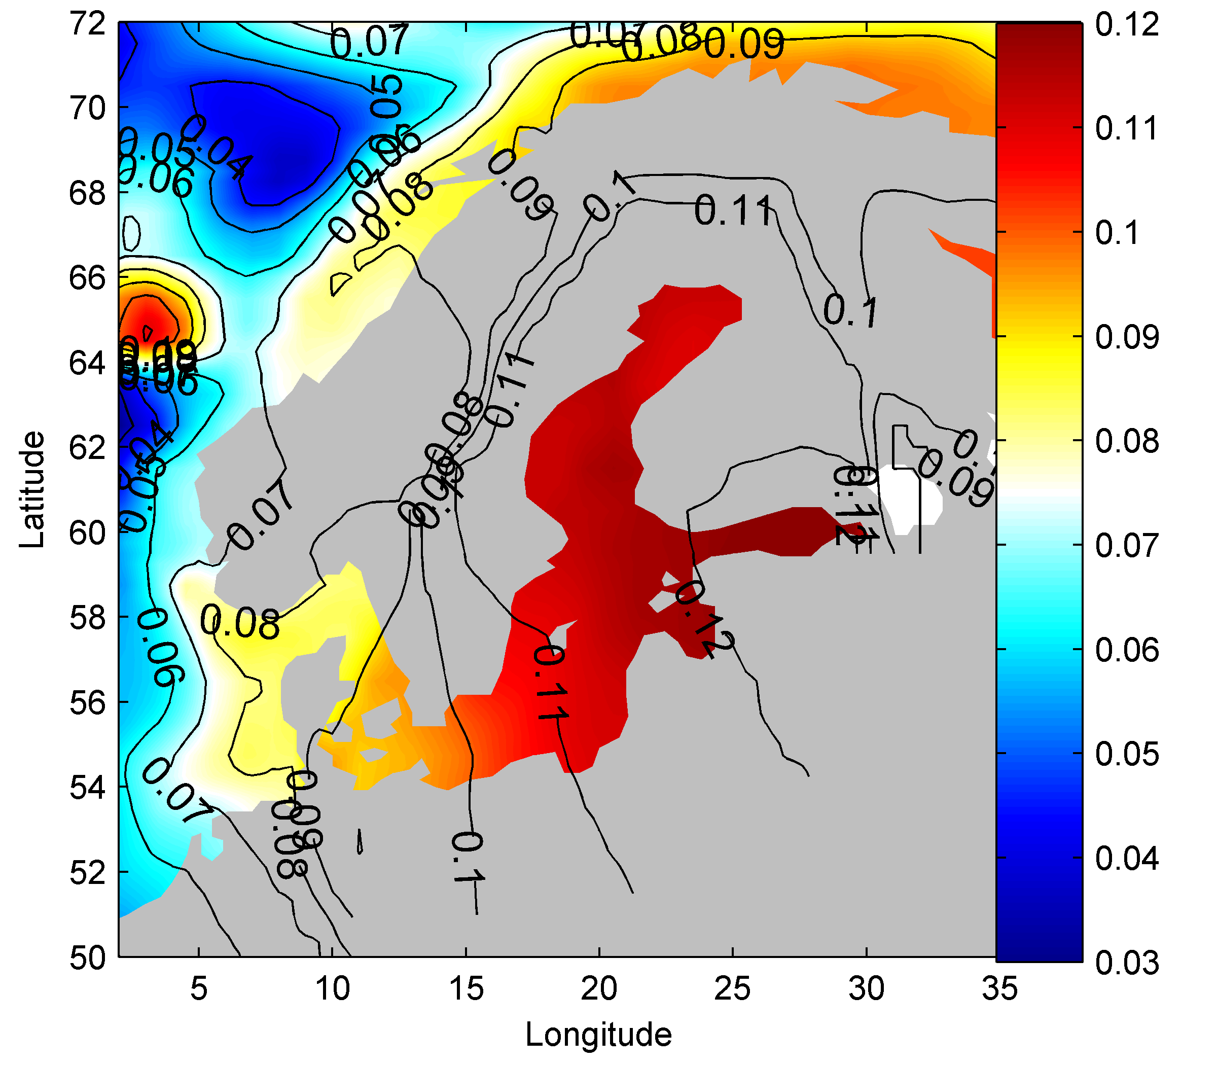
Figure 4.3.12. The spatial pattern of the dynamic sea level response is projected to be approximately 10cm in 2090-2099 under A1B. The DSL response is calculated based on the average response of GFDL CM2.1, MIROC 3.2 HiRES, MPI ECHAM5.

4.3.4.3 Geoid changes induced by ice melt
Large masses such as the ice contained in the Greenland ice sheet gravitationally attract the oceans close by. This gravitational pull will be reduced if the mass is reduced through a negative mass balance. Reducing the ice load will also cause an immediate elastic rebound of the solid Earth. These effects will combine with a rotational response to form a new Static Equilibrium (SE) in the sea level configuration (Farrel and Clark 1976, Mitrovica et al., 2001, Bamber and Riva 2010; Kopp et al., 2010; Mitrovica et al., 2009). The net SE sea level response is that sea level contribution from melting ice will not be distributed evenly on earth but be characterized by a spatial fingerprint. Sea level will even drop up to ~20° away from the source (Mitrovica et al., 2001). As a consequence the Baltic region will only feel a small fraction of the global average sea level contribution from Greenland Ice sheet mass loss, but a slightly greater than average response from the Antarctic Ice Sheet, see Fig. 4.3.13.
It is important to use realistic estimates of the patterns of ice loss when calculating the spatial fingerprints (Mitrovica et al., 2011). Here we use the present day spatial patterns of ice loss for the two ice sheets (Bamber and Riva, 2010), and the projected pattern of mass loss from mountain Glaciers and Ice Caps (GIC) from Radic and Hock (2010) (Slangen et al., 2011a). We then calculate the total SE response by scaling these fingerprints with the projected mass loss from these three sources: Greenland ice sheet, Antarctic Ice sheet, GIC.
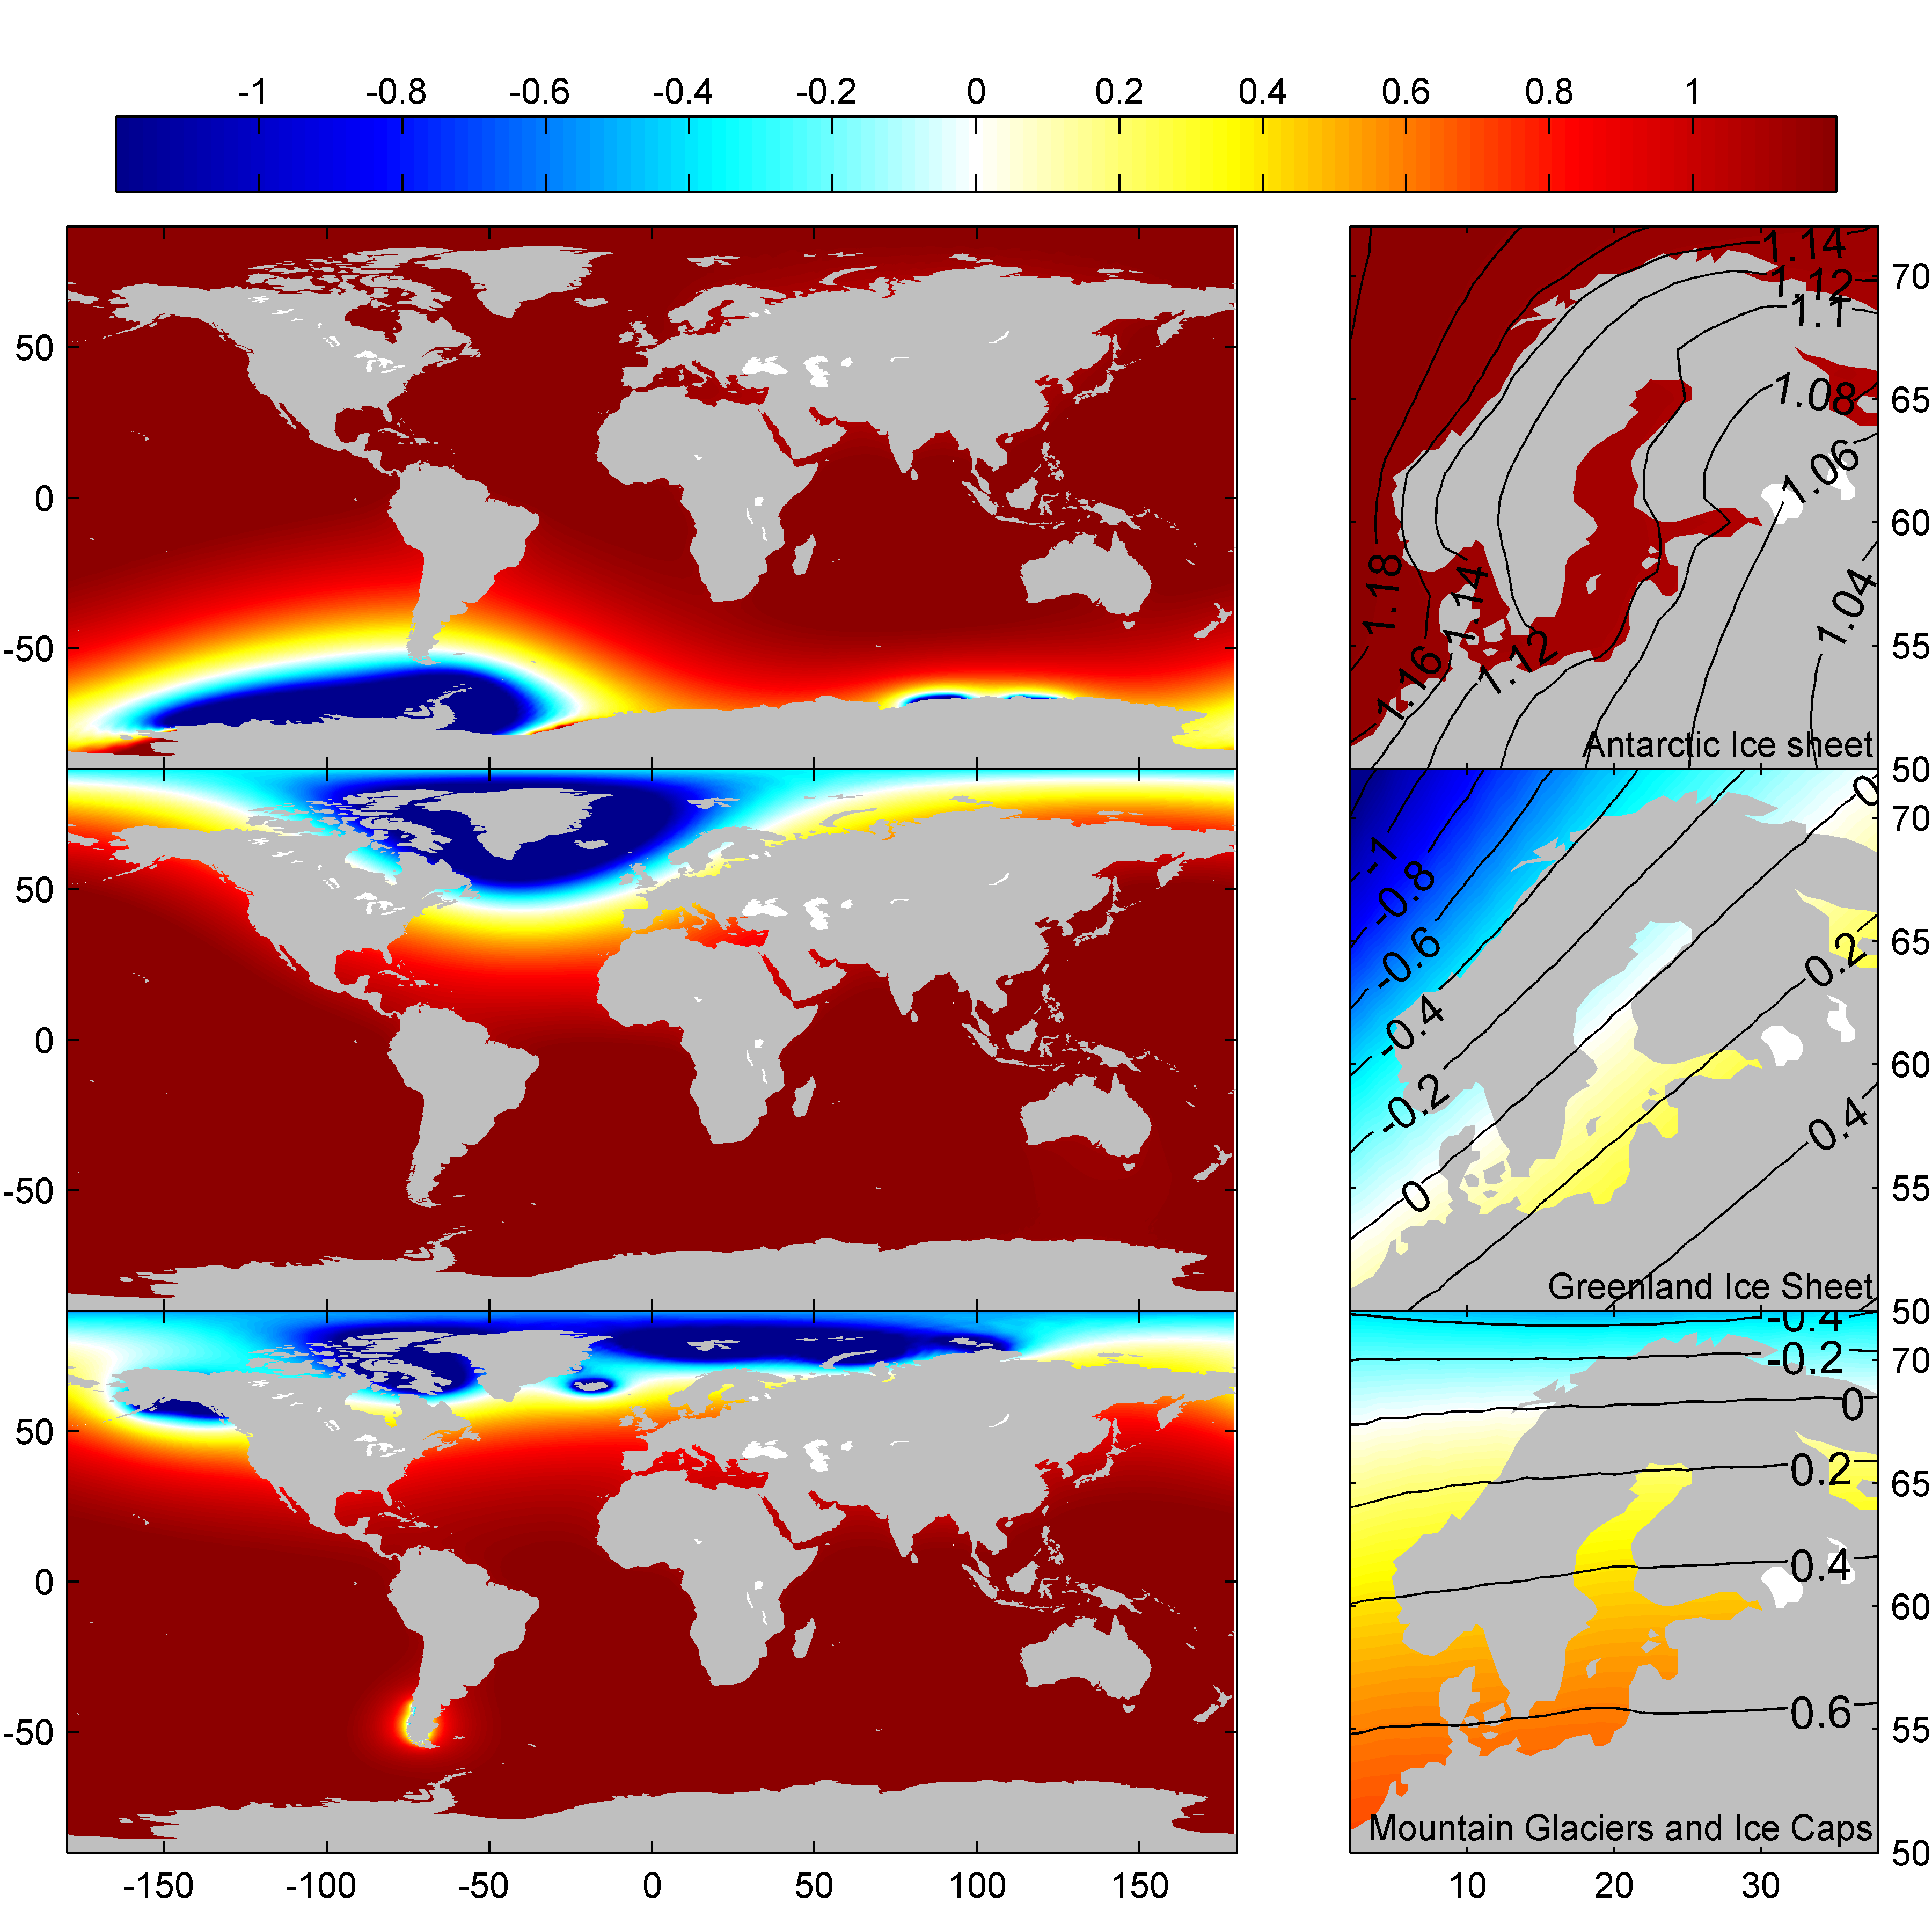
Figure 4.3.13. The spatial fingerprint of sea level rise expressed as a ratio to the global mean sea level equivalent loss from a) the Antarctic ice sheet; b) the Greenland Ice Sheet; c) Mountain Glaciers and Ice caps. (a,b: from Bamber and Riva, 2010; c: from Slangen et al., 2011a).

4.3.4.4 Mountain glaciers and ice caps
Glacier inventories are incomplete, but there are an estimated 300,000-400,000 glaciers and small ice caps in the world (Dyurgerov and Meier, 2005). Detailed observations of these glaciers are very sparse, and this leads to substantial uncertainty in their present-day total volume and present-day rates of mass loss. The uncertainty in total volume will propagate to the projections of the GIC contribution. Most projections of the glacier contribution to global sea level rise are based on a semi-empirical approach, where mass loss is related to global temperature change (e.g. Meehl et al., 2007). Radić and Hock (2011) explicitly consider glacier inventory data for more than 122.000 individual glaciers and ice caps, as well as the spatial projections of climate change from an ensemble of global climate models. Bahr et al. (2009) estimate how far present accumulation area ratios (AARs) are from being in equilibrium, and from that estimate a lower bound of glacier mass loss. The AAR derived lower bounds are substantially greater than other projections. The contributions have been summarized in Table 4.3.3.
Table 4.3.3. Review of projected contributions of Mountain Glaciers and Ice Caps to global mean sea level rise between 1990-1999 and 2090-2099.
 | Source | Contribution (m sle) | Present-day Volume (m sle) | Method
Total | Radic & Hock 2011 | 0.08-0.16 |  | SMB model (A1B)
 | Radic & Hock 2010 |  | 0.50-0.65
 | AR4 | 0.08-0.15 | 0.15-0.72 | Semi-empirical (A1B)
 | Meier et al., 2007 | 0.10-0.24 |  | Statistical Extrap.
 | Pfeffer et al., 2008 | 0.17-0.55 |  | Statistical Extrap. + Heuristic dynamic
 | Bahr et al., 2009 | 0.18-0.38 | 0.86 | AAR conservative estimate of equilibrium (may not be reached by 2100)
 | Slangen et al., 2011b | 0.10-0.20 | 0.50 | Semi-empirical (A1B), uncertainty study.
 | Katsman et al., 2008 | 0.07-0.19 | 0.10-0.40 | Semi-empirical (A1B)
 | Katsman et al., 2011 | 0.07-0.20 | 0.15-0.60 | Semi-empirical (high-end)

4.3.4.5 The Greenland ice sheet
The surface mass balance of the Greenland ice sheet has been projected to contribute to global sea level rise as the Surface Mass Balance (SMB) becomes increasingly negative. Several studies have modeled the Greenland SMB response to the projected climates in the CMIP3 simulations. These studies in general project a greater range than that reported in the AR4 (Yoshimori and Abe-Ouchi 2011; Graversen et al., 2011), and also project a generally greater mass loss. Models of dynamical ice loss are lacking, and no models include a prognostic model of calving, grounding line migration, and the impact of changing basal hydrology on ice dynamics. Observations suggest that dynamic ice loss scales with the SMB for Greenland (Rignot et al., 2008). Dynamic mass loss projections are based on heuristic estimates, and statistical extrapolations of present day trends and accelerations, which are not specifically related to an SRES scenario (See Tab. 4.3.4). To conclude, there are large uncertainties in projections of Greenland mass loss. This uncertainty is much reduced for sea level projections in the Baltic Sea due to the spatial fingerprint of Greenland mass loss.
Table 4.3.4. Estimated contributions from Greenland ice sheet mass loss to global mean sea level rise between 1990-1999 and 2090-2099.
 | Source | Contribution (m) | Method
SMB | AR4 (Meehl et al., 2007) | 0.01-0.08 | Positive Degree Day (A1B)
 | Fettweis et al., 2008 | 0.03-0.05 | Temperature index from EBM (A1B)
 | Mernild et al., 2010 | 0.12 | EBM (A1B)
 | Graversen et al., 2011 | 0.01-0.12 | PDD (A1B)
 | Yoshimori and Abe-Ouchi 2011 | 0.03-0.17 | PDD, systematic examination of uncertainties (A1B)
 | Graversen et al., 2011 | 0.00-0.17 | Shallow ice, tuned sliding in outlet glaciers. (A1B)
 | Seddik et al., 2011 | 0.10 | Full stokes, PDD, tuned sliding
 | Franco et al., 2011 | 0.05
DYN | Pfeffer et al., 2008 | 0.09-0.47 | Heuristic.
 | Price et al., 2011 | 0.06-
 | Graversen et al., 2011 | 0.03 | Stationary tuned outlet-glacier  Sliding (Shallow Ice)
 | Rignot et al. (2011) | 0.07 | Statistical extrapolation of acceleration (* not A1B)
 | Seddik et al. (2011) | 0.07 | Heuristic: Doubled sliding.
 | Katsman et al. (2011) | 0.10 | Heuristic
Total | Katsman et al., 2008 | 0.02-0.17 | Semi-empirical
 | Meier et al., 2007 | 0.05-0.25 | Extrapolation

4.3.4.6 The Antarctic Ice Sheet
The Surface Mass Balance of the Antarctic ice sheet is projected to increase in warmer climate. The increased moisture holding capacity of warm air brings increased precipitation to the continent. This effect is modeled to dominate over the increased ablation in the marginal areas of the ice sheet. The dynamic mass loss of the Antarctic ice sheet is, like for Greenland, primarily estimated using heuristic and statistical extrapolation. Pollard and de Conto (2009) employ a novel approach to simulate grounding line mass flux over the past 5 million years and find the West Antarctic Ice Sheet (WAIS) to be particularly sensitive to warming with a 3m contribution to sea level rise for 2 degrees warming. Estimates of current Antarctic mass balance are negative and dominated by mass loss in regions of WAIS which are thought to be most dynamically sensitive (Rignot et al., 2011). Results are summarized in Table 4.3.5.
Table 4.3.5. Estimated contributions from the Antarctic ice sheet mass loss to global mean sea level rise between 1990-1999 and 2090-2099
 | Source | Contribution (m) | Method
SMB | AR4 (Meehl et al., 2007) | -0.12 – -0.02 | Positive Degree Day
 | Genthon et al., 2009 | -0.10 | PDD CMIP3 corrections
 | Krinner et al., 2007 | -0.12
DYN | Pollard and de Conto 2009 | 0.33 | ~3m/2°C/1000yrs (WAIS volume)
 | Pfeffer et al., 2008 | 0.12-0.55 | Heuristic
 | Katsman et al., 2011 | 0.07-0.49 | Statistical extrap. /Heuristic max
 | Rignot et al., 2011 | 0.07 | Statistical extrapolation (not a1b)
Total | Rignot et al., 2011 | 0.36 | Statistical extrapolation
 | Katsman et al., 2011 | -0.01 – 0.41 | Heuristic (moderate-severe)
 | Katsman et al., 2008 | -0.02 – 0.14 | Semi empirical
 | Meier et al., 2007 | 0.05-0.06 | Statistical extrap
 | Pfeffer et al., 2008 | 0.14-0.62 | Heuristic

4.3.4.7 The compiled budget
In the previous sections projections of the individual major contributions to global sea level rise were reviewed. Based on these estimates, the budget and uncertainties in Table 4.3.6 have been compiled, and we project 0.78 m ± 0.4 m of global mean sea level rise under SRES scenario A1B by 2090-2099. This tally of contributions compares well to the range of published semi-empirical models of GMSL which projects 0.96 m ± 0.4 m rise (Rahmstorf 2007; Horton et al., 2008; Grinsted et al., 2010; Jevrejeva et al., 2010). In the budget (Table 4.3.6) the contribution from groundwater mining and reservoir construction is excluded. Currently reservoir building is slowing down while groundwater mining is expected to increase with population (Shiklomanov and Rodda, 2003), and it is therefore expected that these will contribute to a net sea level rise in the future. The local inverse barometer contribution is also disregarded as it is only has minor impact on RSL rise in the Baltic region (Stammer and Huttemann 2008).
The central estimates in the budget are combined with their respective spatial fingerprints to provide local sea level (LSL) projections for the Baltic region (Fig. 4.3.14). The change in LSL can be compared to the local glacial isostatic adjustment to yield local projections of Relative Sea Level (RSL) rise. Very locally there may be additional sources of uplift/subsidence which should be taken into account in infrastructure planning. The dominant uncertainty in the GMSL budget is the dynamic contribution of the Antarctic Ice Sheet. Errors in this term will be inflated by the spatial fingerprint. Furthermore, the uncertainty in RSL projections will be larger than in projections of GMSL because of uncertainty in the spatial fingerprints and in the spatial distribution of DSL changes.
The sea level budget is poorly constrained, and for some infrastructure decisions a high-end scenario may be warranted (e.g. Katsman et al., 2011). A heuristic high-end scenario (Fig. 4.3.15) is constructed from high estimates of projected budget, and incorporating the possibility of an error in the spatial fingerprint in the Baltic. At present this high-end estimate cannot be ruled out, but is not considered likely. To better constrain the high-end projections it is necessary to validate models of the most uncertain contributors to both global and local sea level rise against their response over the next decade.
We acknowledge the international modelling groups for providing their data for analysis, the Program for Climate Model Diagnosis and Intercomparison (PCMDI) for collecting and archiving the model data, the JSC/CLIVAR Working Group on Coupled Modelling (WGCM) and their Coupled Model Intercomparison Project (CMIP) and Climate Simulation Panel for organising the model data analysis activity, and the IPCC WG1 TSU for technical support. The IPCC Data Archive at Lawrence Livermore National Laboratory is supported by the Office of Science, US Department of Energy.
Table 4.3.6. Best estimate and high-end estimate sea level rise budget in the period from 1990-1999 to 2090-2099. Top contributors to Global mean sea level the lower part of the table is listed terms which do not contribute to GMSL, but which can have a significant impact locally in the Baltic.
Global sea level Contributor | Best estimate (m)  A1B | High-end scenario (m)
Greenland Ice Sheet (SMB) | 0.10 ± 0.1 | 0.15
Greenland Ice Sheet (DYN) | 0.10 ± 0.1 | 0.15
Antarctic Ice Sheet (SMB) | -0.07 ± 0.1 | -0.03
Antarctic Ice Sheet (DYN) | 0.28 ± 0.3 | 0.45
Mountain Glaciers & Ice Caps | 0.15 ± 0.1 | 0.18
Global mean steric | 0.22 ± 0.1 | 0.30
Groundwater mining and reservoir storage | Excluded | 0.10
Total GMSL | 0.78 ± 0.4 | 1.30
Semi-empirical GMSL models | 0.96 ± 0.4
Local sea level contributor
Baltic hosing response | Excluded ± 0.02 | 0.10
Baltic fingerprint error (Geoid & DSL) | Excluded ± 0.3 | 0.20
Baltic Inverse barometer | Excluded ± 0.02 | 0.00

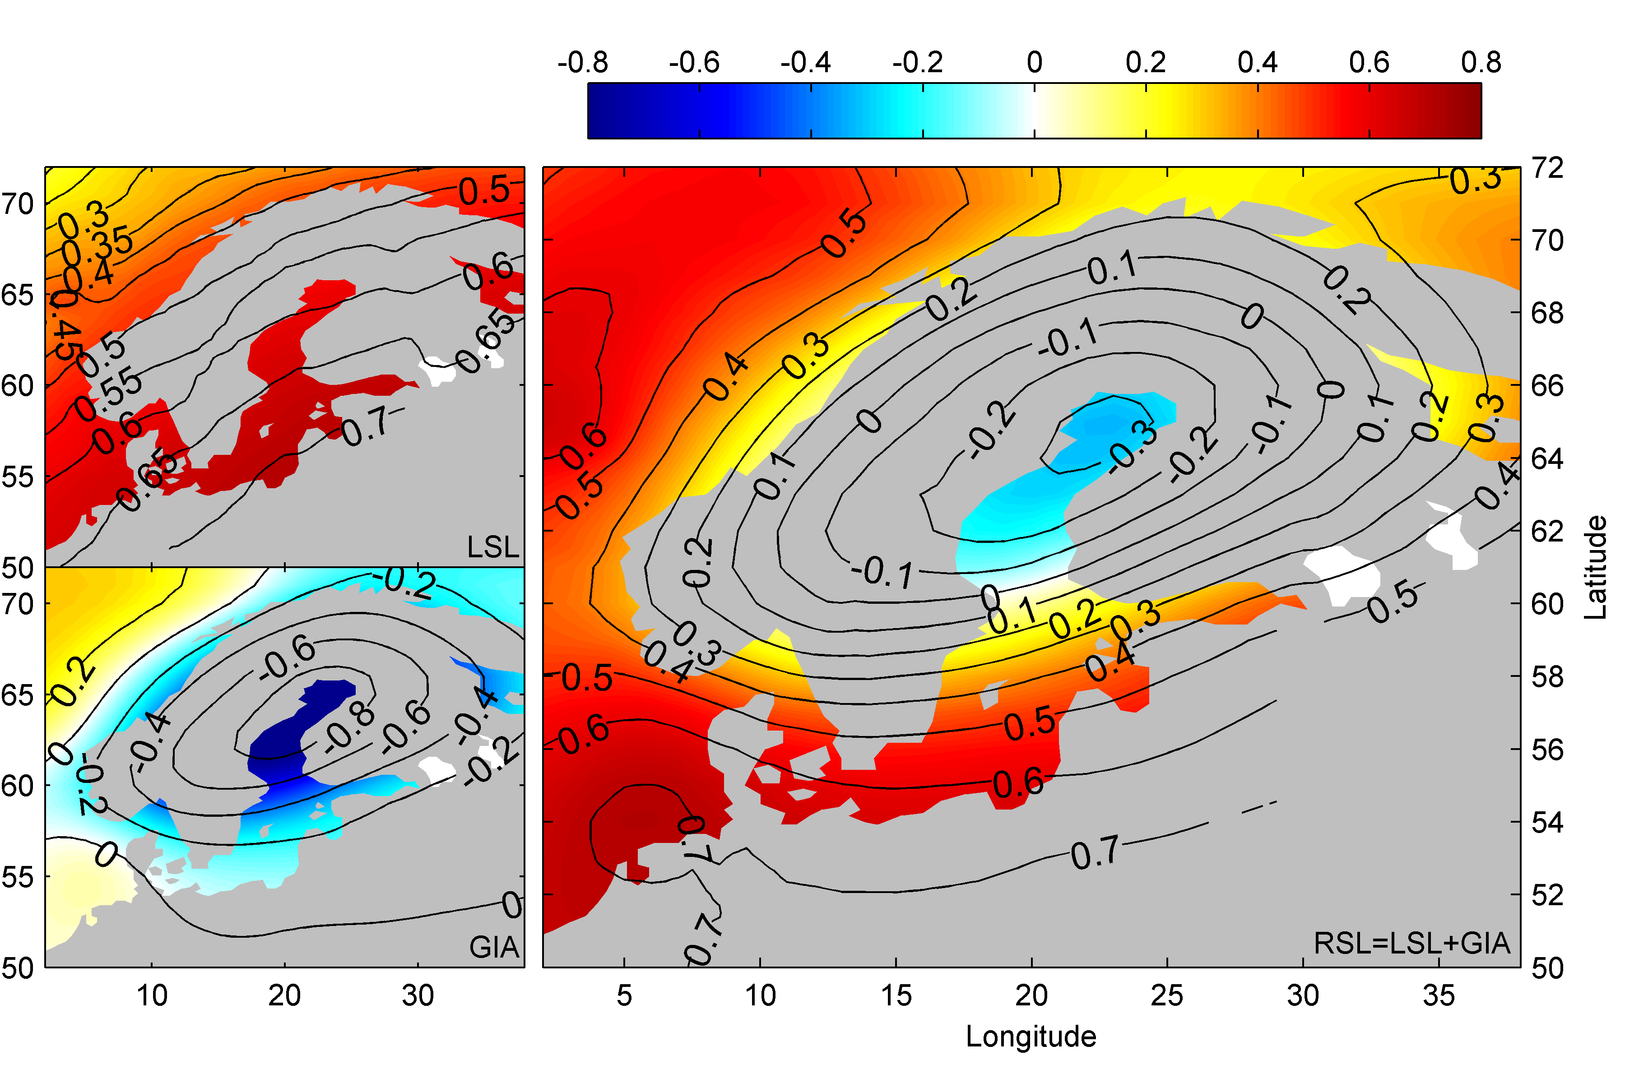
Figure 4.3.14. Right panel shows the projected Regional Sea Level rise from 1990-1999 to 2090-2099 under SRES scenario A1B, decomposed into local sea level rise (left top) and glacial isostatic adjustment (left bottom; Hill et al., 2010).

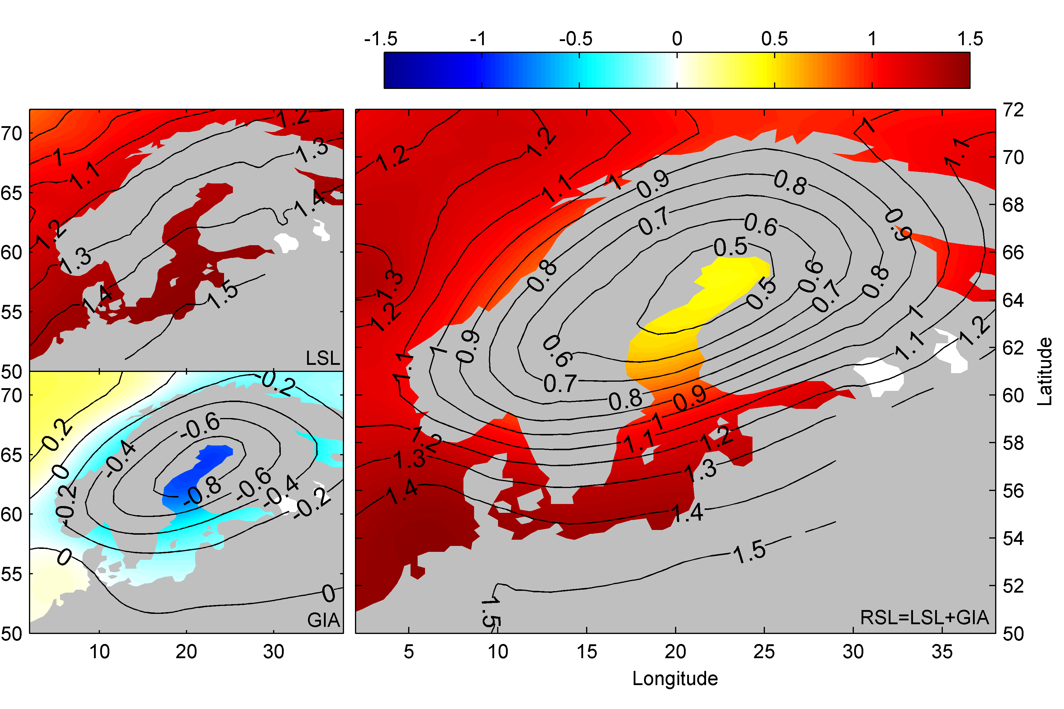
Figure 4.3.15. A high-end estimate of sea level rise in the Baltic. Right panel shows the projected Regional Sea Level rise from 1990-1999 to 2090-2099, decomposed into local sea level rise (left top) and glacial isostatic adjustment (left bottom; Hill et al., 2010).

4.3.4.8 References about sea level change
Bamber, J. and Riva, R.: The sea level fingerprint of recent ice mass fluxes, The Cryosphere, 4, 621-627, doi:10.5194/tc-4-621-2010, 2010.
Bindoff, N.L., J. Willebrand, V. Artale, A, Cazenave, J. Gregory, S. Gulev, K. Hanawa, C. Le Quéré, S. Levitus, Y. Nojiri, C.K. Shum, L.D. Talley and A. Unnikrishnan. "Observations: Oceanic Climate Change and Sea Level." In: Climate Change 2007: The Physical Science Basis. Contribution of Working Group I to the Fourth Assessment Report of the Intergovernmental Panel on Climate Change [Solomon, S., D. Qin, M. Manning, Z. Chen, M. Marquis, K.B. Averyt, M. Tignor and H.L. Miller (eds.)] (Cambridge, United Kingdom and New York, NY, USA: Cambridge University Press, 2007).
Dyurgerov, M. B., and M. F. Meier, 2005, Glaciers and the changing Earth system: A 2004 snapshot, Occas. Pap., 58, 117 pp., Inst. of Arct. and Alp. Res., Boulder, Colo. (Available at http://instaar.colorado.edu/other/occ_papers.html )
Farrell, W. E. & Clark, J. T. On postglacial sea level. Geophys. J. R. Astron. Soc. 46, 647±667 (1976).
Grinsted, A., J. Moore, and S. Jevrejeva, 2010: Reconstructing sea level from paleo and projected temperatures 200 to 2100AD, Climate Dynamics, 461-472, doi: 10.1007/s00382-008-0507-2
Horton, R., C. Herweijer, C. Rosenzweig, J. P. Liu, V. Gornitz, and A. C. Ruane, 2008: Sea level rise projections for current generation CGCMs based on the semi-empirical method. Geophysical Research Letters, 35, 5.
Hu, A. et al. (2009) Transient response of the MOC and climate to potential melting of the Greenland Ice Sheet in the 21st century. Geophys Res Lett 36:L10707. doi:10.1029/2009GL037998
Hu, A., G. A. Meehl, W. Han, and J. Yin, 2011: Effect of the potential melting of the Greenland Ice Sheet on the meridional overturning circulation and global climate in the future. Deep-Sea Research II, 58, 1914-1926.’
Jevrejeva, S., A. Grinsted, and J. Moore, 2009: Anthropogenic forcing dominates sea level rise since 1850. Geophysical Research Letters, 36, L20706.
Jevrejeva, S., J. Moore, and A. Grinsted, 2010: How will sea level respond to changes in natural and anthropogenic forcings by 2100? Geophysical Research Letters, 37, L07703, doi: 10.1029/2010GL042947
Jevrejeva, S., J.C. Moore, A. Grinsted, Sea level projections to AD2500 with a new generation of climate change scenarios, Global and Planetary Change, Available online 21 September 2011, ISSN 0921-8181, 10.1016/j.gloplacha.2011.09.006.
Katsman, C. A., et al., 2011: Exploring high-end scenarios for local sea level rise to develop flood protection strategies for a low-lying delta - the Netherlands as an example. Climati Change, doi:10.1007/s10584-011-0037-5.
Katsman CA, Hazeleger W, Drijfhout SS, van Oldenborgh GJ, Burgers G (2008) Climate scenarios of sea level rise for the northeast Atlantic Ocean: a study including the effects of ocean dynamics and gravity changes induced by ice melt. Clim Change. doi:10.1007/s10584-008-9442-9
Kopp, R. E., J. X. Mitrovica, S. M. Griffies, J. Yin, C. C. Hay and R. J. Stouffer, 2010: The impact of Greenland melt on regional sea level: a partially coupled analysis of dynamic and static equilibrium effects in idealized water-hosing experiments. Climatic Change, 103, 619-625, doi:10.1007/s10584-010-9935-1
Levermann A., A. Griesel, M. Hofmann, M. Montoya, S. Rahmstorf (2005), Dynamic sea level changes following changes in the thermohaline circulation, Climate Dynamics, 24, 347-354. doi:10.1007/s00382-004-0505-y
Meehl, G.A. et al. (2007) Global Climate Projections. In: Climate Change 2007: The Physical Science Basis. Contribution of Working Group I to the Fourth Assessment Report of the Intergovernmental Panel on Climate Change [Solomon, S., D. Qin, M. Manning, Z. Chen, M. Marquis, K.B. Averyt, M.Tignor and H.L. Miller (eds.)]. Cambridge University Press, Cambridge, United Kingdom and New York, NY, USA.
Meehl, T. F. Stocker, W. D. Collins, P. Friedlingstein, A. T. Gaye, J. M. Gregory, A. Kitoh and R. Mitrovica JX et al. (2001) Recent mass balance of polar ice sheets inferred from patterns of global sea-level change. Nature 409:1026–1029
Mitrovica JX, Gomez N, Clark PU., 2009. The sea-level ﬁngerprint of West Antarctic collapse. Science 323:753
Mitrovica, J.X., N. Gomez, E. Morrow, C. Hay, K. Latychev, and M.E. Tamisiea. (2011). On the robustness of predictions of sea-level fingerprints. Geophysical Journal International. doi:10.1111/j.1365-246X.2011.05090.x
Moore, J. C., Jevrejeva, S., Grinsted, A., 2010. Efficacy of geoengineering to limit 21st century sea level rise, Proc Natl Acad Sci USA, 107, 15699-15703
Knutti, J. M. Murphy, A. Noda, S. C. B. Raper, I. G. Watterson, A. J. Weaver and Z. Zhao, 2007: Global climate projections, in Climate Change 2007: The Physical Science Basis. Contribution of Working Group I to the Fourth Assessment Report of the Intergovernmental Panel on Climate Change, S. Solomon, D. Qin, M. Manning, Z. Chen, M. Marquis, K. B. Averyt, M. Tignor and H. L. Miller (editors), Cambridge University Press.
Pfeffer WT, Harper JT, O’Neel S (2008) Kinematic constraints on glacier contributions to 21st century sea-level rise. Science 321:1340–1344
Plag HP. (2006). Recent relative sea level trends: An attempt to quantify forcing factors. Philos. Trans. R. Soc. Lond. A 364:1841–69
Rahmstorf, S., A. Cazenave, J.A. Church, J.E. Hansen, R.F. Keeling, D.E. Parker, and R.C.J. Somerville, 2007: Recent climate observations compared to projections. Science, 316, 709, doi:10.1126/science.1136843.
Rahmstorf, S., 2007: A semi-empirical approach to projecting future sea-level rise. Science, 315, 368-370
Rignot, E., I. Velicogna, M. R. van den Broeke, A. Monaghan, and J. Lenaerts, 2011: Acceleration of the contribution of the Greenland and Antarctic ice sheets to sea level rise. Geophys. Res. Lett., 38.
Riva, R. E. M., J. L. Bamber, D. A. Lavallée, and B. Wouters (2010), Sea-level fingerprint of continental water and ice mass change from GRACE, Geophys. Res. Lett., 37, L19605, doi:10.1029/2010GL044770.
Shiklomanov AI, Rodda J (2003) World water resources at the beginning of the 21st century. Cambridge University Press, Cambridge
Stammer, D., and S. Huttemann, 2008: Response of regional sea level to atmospheric pressure loading in a climate change scenario. Journal of Climate, 21, 2093-2101.
Stammer, D. (2008), Response of the global ocean to Greenland and Antarctic ice melting, J. Geophys. Res., 113, C06022, doi:10.1029/2006JC004079.
Slangen, A.B.A., C.A. Katsman, R.S.W. van de Wal, L.L.A. Vermeersen and R.E.M. Riva (2011a), Towards regional projections of twenty-first century sea-level change based on IPCC SRES scenarios, Climate Dynamics, 2011, doi: 10.1007/s00382-011-1057-6
Slangen, A. B. A. and van de Wal, R. S. W. (2011b): An assessment of uncertainties in using volume-area modelling for computing the twenty-first century glacier contribution to sea-level change, The Cryosphere, 5, 673-686, doi:10.5194/tc-5-673-2011.
Vermeer, M., and S. Rahmstorf, 2009: Global sea level linked to global temperature. Proceedings of the National Academy of Sciences, 106, 21527-21532.
Yin, J., M. E. Schlesinger, and R. J. Stouffer, 2009: Model projections of rapid sea-level rise on the northeast coast of the United States. Nature Geoscience, 2, 262-266
Yin, J., S. M. Griffies, and R. J. Stouffer, 2010: Spatial variability of sea-level rise in 21st century projections. Journal of Climate, 23, 4585-4607, doi:10.1175/2010JCLI3533.1

