6 Attributing causes of regional climate change

6.1 Introduction and Summary (preliminary, not discussed with other LAs yet)
This chapter deals with the decomposition of climate variability into systematic changes that are due to external factors and natural variability that is generated in the climate system itself. External factors that influence climate include human-induced changes in atmospheric composition such as increasing concentrations of greenhouse gases but also natural fluctuations in solar irradiance or the changes of Earth’s orbit. We refer to systematic changes in response to external forcings as climate change. In contrast, internal variability denotes the random fluctuations that are an inherent property of a complex system such as the climate system. It is important to note that in the real world, internal variability and externally forced change only occur in conjunction. Variability and change are thus present at all temporal and spatial scales from virtually instantaneous (small-scale turbulence) to millennia (decay of continental ice shelfs) with varying relative importance of variability and external forcings. Being able to distinguish between internal variability and the effects of external forcings is key to projecting changes into the future. Only aspects of the climate system that respond to a change in external forcing mechanisms are predictable far into the future given that the evolution of the external forcing mechanism is predictable. In the following we outline how we decompose the climate record into variability and forced change to learn about the effect of different factors causing climate change.

6.1.1 How do we learn about causes of climate change?
Learning about cause and effect is at the heart of most scientific studies. In contrast to many other branches of science, however, climate change science suffers from the fact that one cannot perform controlled experiments with the real system, as we do not have a spare Earth to experiment with. For example, we cannot directly (experimentally) investigate the effect of changing greenhouse gas concentrations on global temperatures all else being equal, as simultaneous with the recent increase in greenhouse gases all other forcing factors of the climate system have changed as well. The absence of controlled experiments with the climate system significantly complicates the analysis of cause and effect relationships.
In the absence of opportunities to examine cause and effect relationships through controlled experiments, we base inference on the causes of climate change on a cascade of arguments in favor of (or against) a hypothesized cause. That is, one seeks to answer questions such as the following: How likely is it that the observed change would have occured at random, that is due to natural internal variability of the climate system? How well do we understand the mechanisms by which a hypothesized forcing factor influences climate? How well do we understand the past evolution of the hypothesized forcing factor? Is our predicted response to the hypothesized cause consistent with the observed change? Is the hypothesized cause the only plausible explanation for the observed change or do other causes result in similar changes? And in the regional context also questions such as: is the regional change consistent with change in other regions with similar characteristics (or is it consistent with the global change)? The evidence is then combined to inform statements about possible causes of climate change.
Most of the above questions cannot be answered from observations alone. For example we cannot deduce warming rates during the past century in a hypothetical world without human influence from the observations. Therefore, most inferences on causes of long-term climate change rely on some sort of climate model to be able to experiment with and to develop testable hypotheses. In these models, we can switch of different forcings and thus quantify the impact of each individual forcing on recent and future climate change. The climate models employed to learn about cause and effect relationships range from the simplest empirical models assuming that a change in an external forcing translates linearly to a response in a given climate parameter to coupled Atmosphere-Ocean General Circulation Models (AOGCMs) that explicitly resolve many of the known processes of the climate system (Hegerl and Zwiers, 2011, and references therein).
All attribution statements are conditional on our understanding of the system and especially conditional on our understanding of response to other plausible forcing factors. New knowledge on a specific forcing mechanism and and new knowledge on processes thus alters the balance of evidence for all forcings. Therefore, attribution statements have to be revisited as new knowledge and new data accumulate.
TO DO: Structure and scope of the subchapters, summary of subchapters pulled together

6.2 Global warming

Summary
Most of the observed global warming over the second half of the twentieth century has been attributed to anthropogenic influence – mainly increasing atmospheric greenhouse gas concentrations. In this section, we assess whether the influence of the factors causing global warming can be identified as causing regional climate change in the Baltic Sea area as well. The last assessment of climate change in the Baltic Sea (the BACC author team, 2008) identified a lack of regional studies that can robustly attribute recent trends in climate to increased greenhouse gases. Since the last assessment, a few such studies have become available.
Summertime near-surface warming in northern Europe has been detected to exceed natural internal variability of the climate system and has been attributed to anthropogenic influences. Furthermore, there is evidence of an increasing likelihood of very warm seasons in northern Europe due to human influence in all seasons. The attribution of recent warming to anthropogenic influence is further supported by various studies using continental to global constraints and looking at different aspects of the warming such as extreme temperatures, growing-season length and the onset of spring. In addition, the observed warming in the Baltic Sea area is found to be consistent with the anthropogenic signal derived from model simulations.
Circulation in the northern hemisphere – the North Atlantic Oscillation in particular – strongly affect weather and climate in the Baltic Sea area. A human influence on sea-level pressure changes in the northern hemisphere and globally has been detected, however, it is also found that most present-day climate models underestimate observed circulation changes.
No formal detection and attribution study for regional precipitation in northern Europe is available so far. Anthropogenic influence on observed changes in precipitation has been successfully detected at the global scale, in the Arctic and in northern midlatitude precipitation extremes. Consistent with the assessments of circulation changes, climate models are found to underestimate observed precipitation changes as well. Correspondence of observed and simulated changes in precipitation increases after removing the effect of the major modes of circulation variability such as the North Atlantic Oscillation.
Attribution of changes in physical properties of the Baltic Sea such as changes in salinity or ocean heat content to human influence has not yet been achieved. Reconstructed salinity and integrated temperature changes for the past 500 years, however, suggest that the most recent changes are not exceptional in the light of historic variability.
The assessment of what caused recent observed change is conditional on our understanding of the climate system. The deficiencies in reproducing observed changes in circulation and precipitation in present-day climate models point to gaps in our understanding. To what extent the lack of understanding of regional circulation changes affects attribution of recent warming to human influence is still a matter of debate, but evidence accumulated so far suggests that warming can be robustly attributed to human influence at least in summer. Furthermore, additional information on the effect of locally important forcing mechanisms such as aerosols and land-use changes will affect attribution results. Therefore, the here presented evidence for an emerging anthropogenic signal at the regional scale has to be revisited periodically in the light of new findings.

6.2.1 Introduction and scope
In this subchapter, we assess how the factors causing global warming affect climate and climate change impacts in the Baltic Sea area. In contrast to subchapters 6.3 and 6.4, we focus on globally uniform or at least large-scale forcings including changes in greenhouse gases, solar irradiance, and stratospheric volcanic aerosols.
Due to the still limited availability of formal detection and attribution work, we describe regional climate change effects through a cascade of analyses. At the top are formal detection and attribution analyses that seek to quantify the contribution of various external forcing factors in explaining recent observed change. These include both studies using regional data only and studies using global constraints but providing regional information. Furthermore, we assess studies analyzing the consistency of recent changes with expected change due to anthropogenic influence. Consistency is only a necessary but not sufficient condition for causes of recent change. In order to be able to show that the recent observed change is due to a hypothesized forcing mechanism, we also would have to demonstrate that all other plausible forcing mechanisms and internal variability cannot explain the observed change. At the regional scale, however, internal variability often contributes significantly to the recent observed change and thus inhibits the detection of an external influence. In these cases, consistency of the observed change with the expected change due to anthropogenic (or anthropogenic and natural) influences demonstrates our ability to simulate past regional changes.
Formal detection and attribution consists of the process to demonstrate that the recent observed change is different from internal variability – the detection – and further to compare different combinations of external forcings and assess their relative contribution in explaining the once detected change – the attribution. Such a framework has been successfully applied at the global and continental scale to detect and attribute anthropogenic near-surface and upper-level warming and large-scale changes in other climatic parameters. At the regional scale, however, there are only very few formal detection and attribution studies available (see Stott et al. 2010 for a review of recent advances).
Climate change detection and attribution at the regional scale is complicated by three factors. First, variability increases with decreasing area of aggregation. That is, the influence of small-scale phenomena does not average out as well as at larger scales. This generally leads to a decrease in the signal-to-noise ratio of externally forced changes and thus reduces the detectability of regional climate change (Stott, 2003, Zwiers and Zhang, 2003). Second, model biases play a more important role at the regional scale as model performance depends on the spatial resolution of quantities under analysis (Masson and Knutti, 2011). This influences our skill in detecting and attributing changes at the regional scale as the simulations of recent change and variability deteriorate with decreasing area of aggregation. Third, local forcings such as land-use changes or changes in industrial aerosols that have a negligible effect on global climate change may be locally important ( Stott et al., 2010, see sections 6.3 and 6.4 for further discusssion). In addition to all of the above, regional detection and attribution in northern Europe seems to be especially difficult compared with other sub-continental regions world-wide. Owing to the position of northern European land masses at the end of the North Atlantic storm track and due to the complex land-sea distribution, interannual variability in most climatic parameters is very strong thus masking external influences (see figure 9.12 in Hegerl et al., 2007a).

6.2.2 Processes causing global warming
The amount of incoming energy from the Sun together with the properties of Earth’s atmosphere and surface determine global mean climate. Changes to the properties of Earth’s atmosphere or surface thus lead to changes in Earth’s energy balance and result in changes in the mean climate such as warming or cooling. Among the factors causing climate change over the last century are variability in incoming energy due to the varying solar irradiance, changes in atmospheric composition due to emissions from human and natural sources, and land-cover changes mostly related to human activities. The effects of changes to the atmospheric composition on climate are diverse: Greenhouse gases including carbon dioxide (CO2), methane (CH4), nitrous oxide (NO2), and many more trap outgoing long-wave radiation and thus increasing concentrations of greenhouse gases in the atmosphere lead to a warming. Most of these greenhouse gases are very long-lived and their effect thus persists over centuries. In contrast, the injection of particles into the stratosphere by large volcanic eruptions leads to increased reflection and absorption of incoming sunlight in the stratosphere and thus lower levels of the atmosphere and the surface generally exhibit a cooling. These particles, however, fall out and the effect vanishes after a few years.
Some properties of Earth’s atmosphere and surface itself depend on the mean climate thus leading to feedbacks. Positive feedbacks amplify an initial response whereas negative feedbacks mediate the initial response. An example for a positive feedback is the ice-albedo feedback that occurs when near-surface warming leads to a reduction of snow and ice covered areas thus causing a reduction in the reflectivity of Earth’s surface. The darker surface then absorbs more incoming sunlight which in turn leads to further warming. Feedbacks are very important in understanding past and future climate change.
To assess the relative importance of the individual forcing factors, the concept of radiative forcing is established which describes by how much a specific forcing factor alters Earth’s energy balance. Positive radiative forcing corresponds to global warming and negative radiative forcing to global cooling. Figure 1 illustrates the contributions of various external forcings to changes in the Earth’s energy balance since pre-industrial times. The increase in atmospheric concentrations of long-lived greenhouse gases contributed significantly to the positive radiative forcing during industrial times. The corresponding warming is partly offset by the cooling effect (negative radiative forcing) of aersols over the same period. Nontheless, the global average anthropogenic effect on climate during industrial times is one of warming.

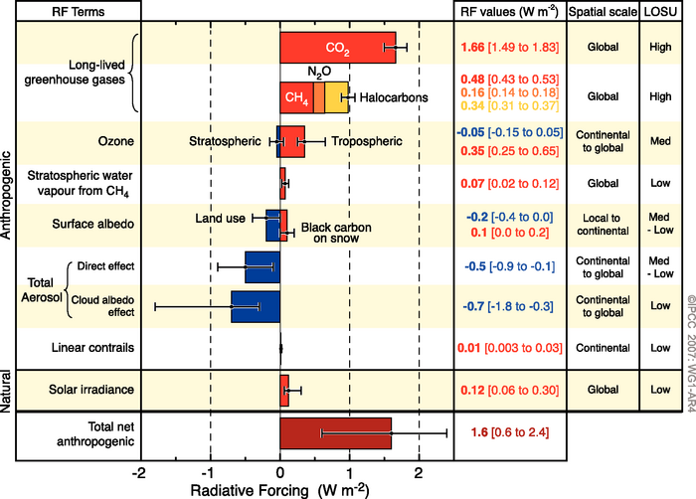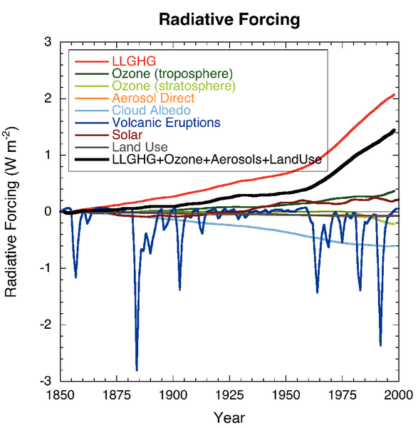
Figure 1: Left: Estimates of global average radiative forcings from pre-industrial conditions to 2005 along with the typical geographical extent of the forcing and an estimate of the respective level of scientific understanding (LOSU). Volcanic eruptions have not been included due to their episodic nature (IPCC, 2007). Right: Global average radiative forcing time series for various forcing agents as simulated in the MIROC-SPRINTARS model (Forster et al., 2007).
The effects of different external forcings vary greatly both in space and time (see figure 1). Long-lived greenhouse gases, for example, are almost globally uniformly distributed and have been increasing gradually over the past century. In contrast, land-cover changes have been occuring at distinct locations and times in the past century with a small contribution to global average radiative forcing but potentially large contributions in specific areas (see discussion in section 6.4). Among the major forcing factors, volcanic eruptions are arguably the most episodic (figure 1).
The various processes and feedbacks in the climate system further alter the response to external forcings. The spatio-temporal pattern of the response to external forcings depends mainly on the type of forcing and the parameter of interest. It is this distinct spatio-temporal pattern of the response to a given forcing mechanism that allows us to attribute global near-surface temperature changes to anthropogenic and natural forcings with high confidence (Huntingford et al., 2006, Hegerl et al., 2007a). At the regional scale, in contrast, we often find little spatial pattern in the response to different forcings. Thus the only aspect of recent change that can be used to discriminate between different forcings is the temporal evolution. This, together with the low signal-to-noise ratio of regional changes and inter-model differences in the estimated response patterns to different forcings strongly limits regional attribution.

6.2.3 Temperature
Changes in mean near-surface temperature
A cascade of evidence from global to sub-continental scales illustrates the anthropogenic influence on recent observed warming. The human influence on global warming (Hegerl et al., 1997), continental warming in Europe (Stott, 2003), and warming in northern Europe in summer has been successfully detected (Jones et al., 2008).
The analysis of citetJones2008 suggests that anthropogenic warming has already significantly increased the likelihood of a very warm summer. Stott et al. (2011) find mixed evidence of an anthropogenic effect on the frequency of very warm seasons with a detectable anthropogenic influence in spring (MAM) and autumn (SON) and no detectable natural influence. In summer (JJA) and winter (DJF), the detectability of external influences depends on the climate model used. Zorita et al. (2008) use an alternative approach to the detection problem. Based on assumptions on the long-term memory in temperature time series, they compute the likelihood, that there are XX record warm years in the last 17 years until 2006. Depending on the model for long-term memory, they identify a statistically significant (at the 5% level) clustering of record years in northern Europe or not.
At the grid-box scale, the observed warming up to 2002 is not significantly different from changes due to internal variability alone in the Baltic Sea region and therefore, an anthropogenic influence at the grid-box level is not detectable (Karoly and Wu, 2005). However, the simulated warming in the Baltic Sea area is consistent with the observed warming when anthropogenic forcing (changes in GHG and sulphate concentrations) is included in the simulations (Karoly and Wu, 2005). The observed warming is found to be consistent with anthropogenic signals derived from regional climate models (Bhend and von Storch, 2009), whereas van Oldenborgh et al. (2009) find significant differences between observed and simulated warming in spring (MAM) using global climate models. They identify misrepresentations in circulation and snow cover changes as the main reasons for the underestimation of warming in spring in global climate models.
In addition to the studies using local information only, evidence for a regional anthropogenic warming is also found in formal detection and attribution studies using global constraints (e.g. Christidis et al., 2010, 2011). Pooling information across the globe helps to significantly increase the signal-to-noise ratio of externally forced changes. The additional information further helps to distinguish responses to different forcings which may be undistinguishable at the regional scale. Christidis et al. (2010) detect and attribute warming in northern Europe (see figure 2). The authors further compute the fraction of attributable risk (FAR) of the observed warming in northern Europe. The FAR measures by how much anthropogenic influence changed the likelihood of a given amount of warming compared to a world without anthropogenic influence but the same changes in natural forcings (and a resulting cooling in northern Europe of -0.15 K per decade). They conclude that the likelihood for a warming of 0.056 K per decade (the observed warming) more than doubled (with a central estimate of an increase in the likelihood by 5 times) as a consequence of human influence.

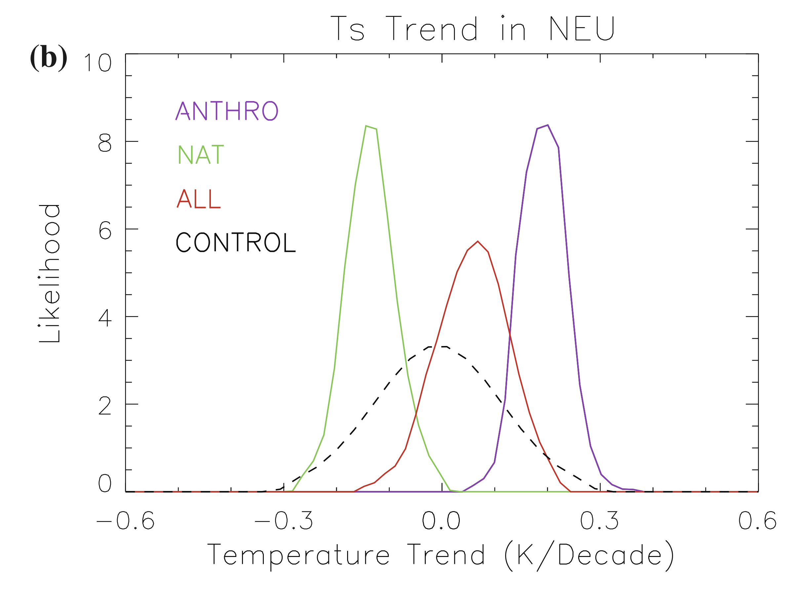
Figure 2: Attributable trends in near-surface temperature in northern Europe based on optimal fingerprint analysis using global constraints (reproduced from Christidis et al., 2010). The observed trend of 0.056 K per decade (not shown) is consistent with the all-forcings signal (red line).
Min and Hense (2007a) investigate evidence for competing forcing hypotheses in a Bayesian framework and conclude that the combination of anthropogenic and natural forcings outperforms any of the forcings separately. They find strong evidence for a forced change over natural internal variability alone (detection). Their analysis further allows to investigate the influence of prior beliefs in a given forcing combination and in their framework, a strong prior belief that recent climate change is due to natural internal variability would favor this hypothesis over others. Compared to other continental-scale regions, the observational evidence of a man-made warming in Europe is less decisive. Furthermore, Min and Hense (2007b) conclude that the combination of anthropogenic and natural forcings provides a better explanation of the observed warming in northern Europe than anthropogenic forcing alone, especially in the first half of the twentieth century.
Another source of evidence for an anthropogenic warming in northern Europe stems from paleorecords. Hegerl et al. (2011) investigate the effect of external forcings on European temperature using reconstructed temperature back to 1500 AD. They detect external influences – the combination of both natural and anthropogenic forcings – in all seasons, with the response to external forcing explaining about 30% of the interdecadal variance.
Furthermore, Gillett et al. (2008) find a detectable anthropogenic influence on Arctic warming. Their region encompasses the very northern part of the Baltic Sea catchment but includes land temperature measurements on all continents and islands north of N. Christidis et al. (2007) find a detectable change in growing season length, the onset of spring and a marginally detectable change in the end of the growing season in autumn for Europe using regional constraints.

Changes in temperature extremes
Climate change not only affects the mean climate but all properties of the distribution including the frequency, intensity, and spatio-temporal pattern of extreme events. Extreme events are rare and thus fewer data are available to make inference about extreme events and their changes. Attributing causes to changes in extreme events is thus generally more difficult than for changes in mean climate. Methods involving very large ensembles of climate model simulations are being developed to quantify the human contribution to individual extreme events such as the autumn 2000 floods in the UK (Pall et al., 2011). In contrast, changes in moderately extreme events such as the coldest night or warmest day in any given year, can be attributed using standard approaches.
Kiktev et al. (2003) find positive trends in warm nights and frost days for the Baltic sea area, however, significant only for parts of the area. They further find better agreement with simulated trends in those temperature extreme indices when atmosphere-only GCM simulations include anthropogenic forcing. Morak et al. (2011) find mixed results for detectability of the observed change in warm nights in northern Europe, whereas this change is robustly detectable in other regions. These findings are corroborated by Zwiers et al. (2010) who find a detectable anthropogenic signal on changes in long return period extremes of daily temperature in northern Europe. A combined anthropogenic and natural influence is only detectable for the warmest night per year (see figure 3). Formal attribution of the changes in temperature extremes to natural and anthropogenic causes has not been achieved yet, however, the consistency of observed changes with both all-forcings and anthropogenic only simulations points towards attribution of changes in extremes to human influence. Zwiers et al. (2010) further estimate the attributable change in waiting times for the different temperature extremes. They find that waiting times for a day as cold as a one in twenty years event in the 1960s have increased approximately by a factor of two by the 1990s due to human influence. Similarly, waiting times for hot extremes are approximately halved, that is an extremely hot day that would on average occur every 20 years in the 1960s is expected to occur every 10 years in the 1990s.

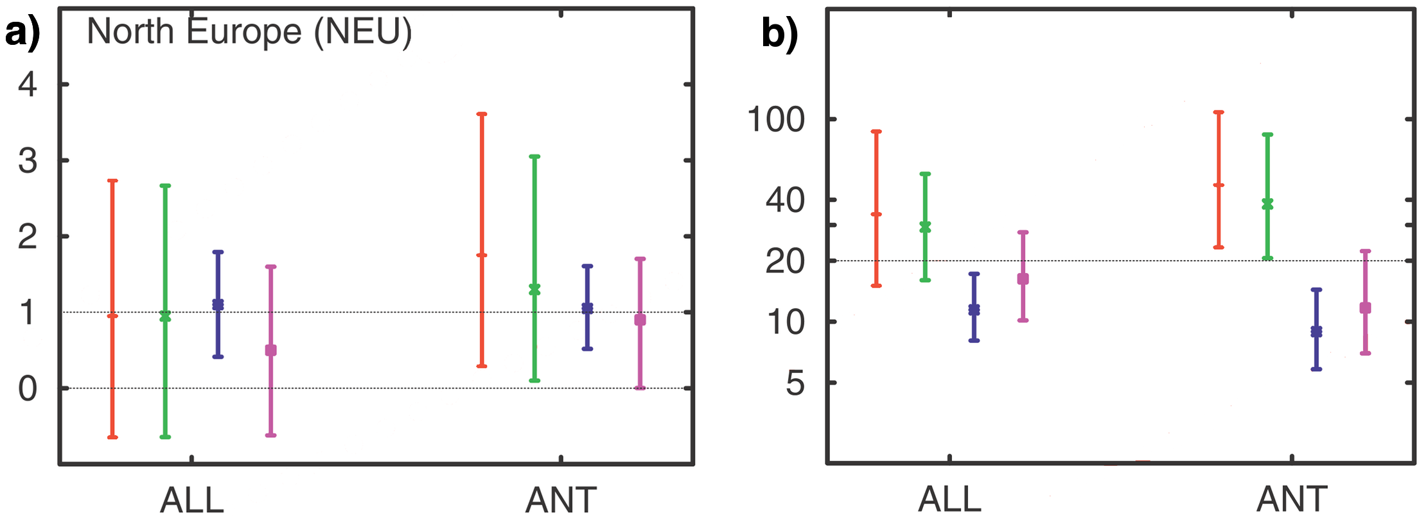
Figure 3: a) Scaling factors for annual temperature extremes, b) estimated waiting times of 1960s 20-year return values by 1990. The colours refer to extreme value distributions fitted to different annual temperature extremes, namely the the coldest night per year in red, the coldest day in green, the warmest night in blue, and the hottest day in purple. The symbols indicate the central estimate and the bars denote the 90% confidence interval. Detection of an external influence is claimed at the 10% level if the confidence interval around the scaling in a) does not include zero (reproduced from Zwiers et al., 2010, see text for further discussion).
Christidis et al. (2005) find detectable changes in warm nights and cold nights and days globally. Regional detail on the changes in warm nights is given in Christidis et al. (2010), their analysis, however, identifies a strong dependence of the anthropogenic signal in the Baltic Sea area on the model used. According to one of the models used (the HadCM3 model), human influence leads to an increase in warm nights from 1950-1997, whereas the second model used (the MIROC model), suggests a decrease in response to anthropogenic forcing. Similar discrepancies are also identified for the response to natural forcings. This illustrates the importance of taking model biases – and thus model inter-model differences – into account in regional detection and attribution analyses.

Potential influence of circulation changes on the detectability of warming
A major caveat of attributing causes for the observed warming in northern Europe comes from the fact that changes in northern hemisphere circulation are not well understood (Gillett, 2005) and it is known that modes of natural variability such as the North Atlantic Oscillation have a strong influence on temperature in the Baltic Sea region (e.g. Hurrell et al., 2003, see discussion below). Woollings (2010) argues that uncertainties in simulated circulation and lack of understanding in key processes provides a major challenge for predictions in Europe.
Gillett et al. (2000) investigate the effect of changes in the Arctic Oscillation (AO) on detection results and find that for northern hemisphere temperature, exclusion of the AO related temperature variability has a negligible effect on the outcome of an optimal detection analysis. These findings are corroborated by the analyses of Wu and Karoly (2007), who find that changes in major modes of atmospheric variability are not expected to affect trends in near-surface temperature at the grid-box scale. The follow-up study of Wu (2010), however, illustrates that while the above findings may hold daily mean temperatures, modes of atmospheric variability have a strong influence on trends in maximum and minimum daily temperature in winter in northern Europe. After removing the influence of the major modes of variability, these quantities show a cooling in the period from 1951 to 2000 as opposed to the strong warming without removing the influence of the major modes of variability.

6.2.4 Circulation and the hydrological cycle
Circulation
Northern European climate is strongly related to the North Atlantic Oscillation (NAO Hurrell et al., 2003). Changes in this mode of atmospheric variability have been shown to be not well simulated by present-day climate models (Gillett, 2005, Miller et al., 2006). The simulated changes are generally of correct sign but underestimate the magnitude of the observed change, thus giving rise to the speculation that changes in other parameters dependent on changes in circulation might be underestimated by models as well.
Gillett et al. (2005) detect an external influence on the observed global SLP changes in winter (DJF). The fingerprint used in their analysis features positive trends in the southern North Atlantic and negative trends around Iceland thus representing an increase in the NAO index. In a more recent study, Gillett and Stott (2009) are able to attribute zonally averaged SLP changes to anthropogenic influence, however, detection and attribution using northern mid- to high-latitude data alone fails. In contrast to earlier work, the authors find that the magnitude of observed global SLP changes is consistent with the model simulated response. So far, it remains unclear to what extent changes in this major mode of atmospheric variability are consistent with simulated anthropogenic signals.
Apart from inference on large-scale patterns of atmospheric variability, surface pressure readings can also be used to analyze wind speed and storm activity (see Krueger and von Storch 2011 for an evaluation of the approach). Such an approach is superior to using direct wind speed measurements in that it relies on fairly robust measurements of sea-level pressure. In contrast, wind speed measurements often suffer from inhomogeneities in the records related to site and instrument changes and build-up of surrounding areas (Trenberth et al., 2007). Wang et al. (2009) analyze geostrophic wind speed (derived from nearby pressure readings) and ocean wave height across the northern hemisphere in a formal detection and attribution assessment and find a detectable anthropogenic influence in winter. The anthropogenic fingerprint includes increasing wind speeds in northwestern Europe. The models are able to reproduce the basic pattern, however, simulated changes are smaller than the observed changes and most of the models tend to underestimate variability compared with observations. Looking at historic changes in storminess derived from pressure reading, Matulla et al. (2008) and Wang et al. (2011) find increasing storminess in northern Europe in the second half of the 20th century. Putting the recent increase in storminess in northern Europe in the historical context, Bärring and von Storch (2004), Matulla et al. (2008), and Bärring and Fortuniak (2009) find little evidence of an emerging anthropogenic signal in the Baltic Sea area as similar increases have been observed in the past.

Hydrological cycle
Changes in the hydrological cycle are much more complex than changes to thermal quantities, as both thermodynamics as well as circulation changes play an important part in shaping changes in the hydrological cycle. Characteristics of the global response of the hydrological cycle can be characterized as follows. We expect an absolute humidity increase of 7% per K, as a consequence of the increased water holding capacity of the atmosphere with increasing temperature and given relative humidity patterns stay approximately constant (Allen and Ingram, 2002, Held and Soden, 2006). The observed increase in global surface humidity has been attributed to human influence (Willett et al., 2007). In the last decade, however, the surface humidity has not increased further in concert with global temperature (Simmons et al., 2010) but leveled-off aftern the 1997-98 El Niño. The authors speculate that surface humidity is thus rather dominated by ocean temperatures.
In contrast to absolute humidity, precipitation increases only by 1-3% per K (Wentz et al., 2007). This apparent discrepancy is resolved in models by decreasing convective mass flux and a slow-down of atmospheric circulation mainly in the tropics. Further consequences include an increase in the pattern of evaporation minus precipitation - that is, wet regions get wetter, dry regions get drier (Held and Soden, 2006). From theoretical considerations, it is also clear that the precipitation response will depend on the nature of the forcing, that is, precipitation will more strongly respond to short-term forcings such as volcanic eruptions or solar irradiance changes than to the long-term increase in greenhouse gases (Allen and Ingram, 2002, Lambert et al., 2004, 2005).
Globally there is both evidence for a detectable influence of short-term forcings and long-term forcing on the observed precipitation change. Zhang et al. (2007) find a detectable anthropogenic influence on recent observed changes in zonal mean precipitation. Their anthropogenic fingerprint features the well-known pattern of moistening in the Tropics and high latitudes and drying in the subtropics. The climate models, however, significantly underestimate the observed changes. The authors conclude that anthropogenic forcing contributed about 50-85% to the observed increase in precipitation in the northern midlatitudes of 6.2 mm per decade. Lambert et al. (2004) and Lambert et al. (2005) suggest that short-wave forcings such as changes in volcanic aerosols should be easier to detect in global precipitation. They indeed detect an influence of the combined natural and anthropogenic forcings and conclude that most of the forced signal in global mean precipitation is due to natural forcing. These findings have been corroborated by Gillett et al. (2004) by detecting the influence of volcanic eruptions on the observed global land precipitation change over the 20th century. In contrast to global temperature changes, precipitation changes cannot be attributed to individual forcings yet.
No regional detection and attribution analysis for precipitation changes in northern Europe is available so far. Bhend and von Storch (2008) find that the pattern of recent observed changes in winter precipitation is consistent with the anthropogenic signal derived from regional climate model simulations. The magnitude of the change, however, is much smaller in the simulations compared with the observations in line with other studies and the discussion about understanding regional circulation changes. van Haren et al. (2011) also identify significant discrepancies between observed and simulated precipitation changes in Europe. They further identify discrepancies in SST and circulation changes in the models compared to observed changes as the main causes of the inconsistencies between simulated and observed changes in regional precipitation.

< Include graph from Haren2011? , can we pull together simulated and observed precipitation changes from ENSEMBLES? >

Min et al. (2008a) find a detectable human influence on arctic moistening. Their analysis indicates that anthropogenic forcing has lead to an increase in precipitation in the northern Baltic Sea area, whereas natural forcing has lead to a decrease in precipitation from 1950 to 1999. Their analysis further suggests that the simulated changes underestimate the observed moistening considerably and namely their best guess anthropogenic signal has to be scaled up significantly to match the observed change and simulated internal variability is not consistent with the observed residual variability – indicating that the models underestimate both forced and internal variability in precipiation. If AO-related variability is removed from the observations, the correspondence between observed and simulated changes in precipitation improves considerably.
Min et al. (2009) investigate potential detectability of change in extreme precipitation in a perfect model framework. They find that detectability of changes in extreme precipitation in Europe is low for the twentieth century. Recently, Min et al. (2011) detected an anthropogenic influence on northern midlatitude annual maximum 1-day and maximum 5-day precipitation changes from 1951 to 1999. As with mean precipitation, their results suggest that models underestimate the observed change. Furthermore, they fail to detect a combined anthropogenic and natural response, indicating either missing skill in the subset of models used to determine the combined signal or large inter-model differences in the response to natural forcings.
Stahl et al. (2010) and Wilson et al. (2010) conclude that streamflow changes in near-natural catchments in northern Europe are congruent with expected streamflow changes due to human influence in winter and spring. Furthermore, Wilson et al. (2010) find that recent streamflow changes are in line with future expected changes in seasons when the temperature signal dominates (winter and spring), whereas the expected increase in summer and autumn streamflow that is due to increasing precipitation and the spatial characteristics of the human signal in streamflow do not manifest itself in past changes. While these studies highlight the potential for attribution of streamflow changes to different causes, a formal assessment has not been attempted so far. In addition, Hansson et al. (2011) conclude that recent changes in river runoff into the Baltic Sea are not exceptional compared to changes over the past 500 years according to their reconstruction of river runoff.
< Changes in snow still missing >

6.2.5 Causes of changes in the Baltic Sea
The human influence on ocean heat content has been detected (Barnett et al., 2001) and changes in all of the major ocean basins are found to be different from internal variability (Pierce et al., 2006, Palmer et al., 2009). Due to the complex and small-scale bathymetry of the Baltic Sea, however, the available AOGCM simulations cannot be used for detection and attribution studies in this area. Therefore, no formal detection and attribution assessment for the Baltic Sea is available as of yet.
Hansson and Omstedt (2008) investigate maximum ice extent and horizontally and vertically integrated temperature in the Baltic sea using the PROBE-Baltic model. They conclude that the recent warming and recent rate of warming does not stand out in the light of the past 500 years and thus cannot be detected. Furthermore, they do not recommend using GCM data as boundary condition for their ocean model, thus inhibiting a formal detection and attribution approach.
Salinity in major ocean basins has been used to infer changes in freshwater runoff and precipitation (Hegerl et al., 2007b). Temporal variability of the salinity in the Baltic Sea, however, is strongly dependent on Major Baltic Inflow events of highly saline water from the North Sea (Matthäus et al., 2008). These events in turn depend on the large-scale circulation and on the salinity of the Baltic Sea (among other factors). Nevertheless, Meier and Kauker (2003) find based on hindcasts of Baltic salinity, that salinity changes in the Baltic Sea are linked partly to changes in freshwater influx and precipitation and partly to changes in the large-scale atmospheric circulation. Due to the coupling of Baltic salinity with the salinity of the North Sea and the dependence of the exchange on properties in both Basins, attribution of changes in Baltic salinity may only be achieved partially.
Together with the change in ocean heat content, global sea-level changes as the density of water decreases with increasing temperature (and thus the volume increases). Global sea-level changes since 1960 agree well with simulations including anthropogenic and volcanic forcings (Domingues et al., 2008). The regional pattern of sea-level rise, however, is only partly understood. Baltic sea level changes have been shown to vary in concert with circulation and precipitation changes (Hünicke and Zorita, 2006). The contribution of these regional effects to Baltic sea level are of the same order of magnitude as the global sea level rise (Hünicke, 2010) and thus have to be accounted for in future detection and attribution studies.
Finally, changes in sea ice are to be expected with global warming. Arctic sea ice changes have been attributed to human influences (Min et al., 2008b) and are in fact attributable since 1992. Sea ice formation in the Baltic Sea, however, is hardly comparable to arctic sea ice, as the brackish water, the complex bathymetry and the limited extent of the Baltic Sea lead to distinct features of Baltic sea ice formation. The maximum ice extent is decreasing and from 1987 to 2009, all winters have been average or below average with regard to maximum ice extent (Vihma and Haapala, 2009). The general tendency towards milder winters is masked by considerable interannual variability; the most recent winters of 2009/2010 and 2010/2011 for example have been judged as severe winters by the SMHI. The long time series of ice extent and break-up dates available across the Baltic Sea would lend itself for attribution assessments. A formal detection and attribution assessment of Baltic Sea ice, however, is not available so far.

6.2.6 Causes of climate change impacts
Attributing causes to climate change impacts is often complicated by the multitude of confounding factors acting on the system. For example changes in marine biodiversity have been linked to climate (Hiddink and Coleby, 2011), and ecosystem changes have been linked to atmospheric and direct human interference with the system (Moellmann et al., 2009). As in other attribution assessments, these linkages are based on multivariate linear regression and thus can be strongly dependent on the number of potential drivers included in the analysis. Selection of potential drivers has to be purely based on physical (biological, etc.) reasoning and not on statistical power in explaining the observed changes in the system under examination. Quantification of the respective contributions and their uncertainties of all potential causes is crucial to avoid misattribution.
So far, there is a multitude of approaches to attributing causes to observed changes in climate change impacts. The “IPCC Expert Meeting on Detection and Attribution Related to Anthropogenic Climate Change” suggests to make the distinction between four different approaches as follows:
1. Single-step attribution to external forcings: These methods assess the influence of external forcings onto an observed quantity with an integrated modelling system that explicitly simulates the effect of all plausible drivers on the respective variable.
2. Multi-step attribution to external forcings consist of several independent but linked attribution assessments. The first step usually involves the attribution of changes in large-scale meteorologic quantities to changes in external forcings and the second step involves attributing changes in impacts or changes in a biological system to changes in climatic conditions. The two independent assessments and their respective uncertainties are then combined to describe the resulting effect of the external forcings on the target quantity.
3. Associative pattern attribution to external forcings is a ‘meta-analysis’ to characterize the sensitivity of systems to changes in external forcings based on correspondence or disagreement in the relative response across a large number of studies (in different regions and/or systems).
4. Attribution to a change in climatic conditions (but not explicitly to changes in external forcings) can be the last step in a multi-step attribution analysis but is more often found as a stand-alone analysis.
An example of an associative pattern attribution analysis is the study of Rosenzweig et al. (2008). Based on a compilation of significant findings for a wide range of studies analyzing change in physical and biological systems, the authors compute the fraction of the findings that are consistent with the local warming. For Europe, they find that 94% of the studies investigating change in the physical systems and 90% of the studies on changes in the biological systems find changes that are consistent with the observed warming. While such an approach is valuable in providing an overview of findings across systems, there is the potential danger of sampling issues influencing the results.
If process models of the system are available, the uncertainties in the response to changes in the various drivers (climate and other) can be fully explored. Such a end-to-end attribution analysis, however, is so far not available for the Baltic Sea area.
References
Allen, M. R. and Ingram, W. J. (2002). Constraints on future changes in climate and the hydrologic cycle. Nature, 419(6903):224–+.
Barnett, T. P., Pierce, D. W., and Schnur, R. (2001). Detection of anthropogenic climate change in the world’s oceans. Science, 292(5515):270–274.
Bärring, L. and Fortuniak, K. (2009). Multi-indices analysis of southern scandinavian storminess 1780-2005 and links to interdecadal variations in the nw europe-north sea region. Int. J. Climatol., 29(3):373–384.
Bhend, J. and von Storch, H. (2008). Consistency of observed winter precipitation trends in northern europe with regional climate change projections. Climate Dynamics, 31(1):17–28.
Bhend, J. and von Storch, H. (2009). Is greenhouse gas forcing a plausible explanation for the observed warming in the baltic sea catchment area? Boreal Environment Research, 14(1):81–88.
Bärring, L. and von Storch, H. (2004). Scandinavian storminess since about 1800. Geophys. Res. Lett., 31(20):L20202–.
Christidis, N., Stott, P. A., Brown, S., Hegerl, G. C., and Caesar, J. (2005). Detection of changes in temperature extremes during the second half of the 20th century. Geophysical Research Letters, 32(20).
Christidis, N., Stott, P. A., Brown, S., Karoly, D. J., and Caesar, J. (2007). Human contribution to the lengthening of the growing season during 1950-99. Journal of Climate, 20:5441–5454.
Christidis, N., Stott, P. A., and Brown, S. J. (2011). The role of human activity in the recent warming of extremely warm daytime temperatures. J. Climate, 24(7):1922–1930.
Christidis, N., Stott, P. A., Zwiers, F. W., Shiogama, H., and Nozawa, T. (2010). Probabilistic estimates of recent changes in temperature: a multi-scale attribution analysis. Climate Dynamics, 34(7-8):1139–1156.
Domingues, C. M., Church, J. A., White, N. J., Gleckler, P. J., Wijffels, S. E., Barker, P. M., and Dunn, J. R. (2008). Improved estimates of upper-ocean warming and multi-decadal sea-level rise. Nature, 453(7198):1090–1093.
Forster, P., Ramaswamy, V., Artaxo, P., Berntsen, T., Betts, R., Fahey, D., Haywood, J., Lean, J., Lowe, D., Myhre, G., Nganga, J., Prinn, R., Raga, G., Schulz, M., and Dorland, R. V. (2007). Climate Change 2007: The Physical Science Basis. Contribution of Working Group I to the Fourth Assessment Report of the Intergovernmental Panel on Climate Change, chapter Changes in Atmospheric Constituents and in Radiative Forcing, pages 129–234. Cambridge University Press, Cambridge, United Kingdom and New York, NY, USA.
Gillett, N. P. (2005). Northern hemisphere circulation. Nature, 437(7058):496–496.
Gillett, N. P., Allan, R. J., and Ansell, T. J. (2005). Detection of external influence on sea level pressure with a multi-model ensemble. Geophys. Res. Lett., 32(19):L19714–.
Gillett, N. P., Hegerl, G. C., Allen, M. R., and Stott, P. A. (2000). Implications of changes in the northern hemisphere circulation for the detection of anthropogenic climate change. Geophysical Research Letters, 27(7):993–996.
Gillett, N. P. and Stott, P. A. (2009). Attribution of anthropogenic influence on seasonal sea level pressure. Geophysical Research Letters, 36(23):L23709.
Gillett, N. P., Stott, P. A., and Santer, B. D. (2008). Attribution of cyclogenesis region sea surface temperature change to anthropogenic influence. Geophysical Research Letters, 35(9).
Gillett, N. P., Weaver, A. J., Zwiers, F. W., and Wehner, M. F. (2004). Detection of volcanic influence on global precipitation. Geophysical Research Letters, 31(12):L12217.
Hansson, D., Eriksson, C., Omstedt, A., and Chen, D. (2011). Reconstruction of river runoff to the baltic sea, ad 1500â“1995. International Journal of Climatology, 31(5):696–703.
Hansson, D. and Omstedt, A. (2008). Modelling the baltic sea ocean climate on centennial time scale: temperature and sea ice. Climate Dynamics, 30:763–778. 10.1007/s00382-007-0321-2.
Hegerl, G., Luterbacher, J., Gonzalez-Rouco, F., Tett, S. F. B., Crowley, T., and Xoplaki, E. (2011). Influence of human and natural forcing on european seasonal temperatures. Nature Geoscience, 4(2):99–103.
Hegerl, G. and Zwiers, F. (2011). Use of models in detection and attribution of climate change. Wiley Interdisciplinary Reviews: Climate Change, 2(4):570–591.
Hegerl, G., Zwiers, F. W., Braconnot, P., Gillett, N., Luo, Y., Orsini, J. M., N. Nicholls, J. P., and Stott, P. (2007a). Climate Change 2007: The Physical Science Basis. Contribution of Working Group I to the Fourth Assessment Report of the Intergovernmental Panel on Climate Change, chapter Understanding and Attributing Climate Change, pages 663–745. Cambridge University Press, Cambridge, United Kingdom and New York, NY, USA.
Hegerl, G. C., Crowley, T. J., Allen, M., Hyde, W. T., Pollack, H. N., Smerdon, J., and Zorita, E. (2007b). Detection of human influence on a new, validated 1500-year temperature reconstruction. Journal of Climate, 20(4):650–666.
Hegerl, G. C., Hasselmann, K., Cubasch, U., Mitchell, J. F. B., Roeckner, E., Voss, R., and Waszkewitz, J. (1997). Multi-fingerprint detection and attribution analysis of greenhouse gas, greenhouse gas-plus-aerosol and solar forced climate change. Climate Dynamics, 13(9):613–634.
Held, I. M. and Soden, B. J. (2006). Robust responses of the hydrological cycle to global warming. J. Clim., 19:5686–5699.
Hiddink, J. G. and Coleby, C. (2011). What is the effect of climate change on marine fish biodiversity in an area of low connectivity, the baltic sea? Global Ecology and Biogeography, pages no–no.
Hünicke, B. (2010). Contribution of regional climate drivers to future winter sea-level changes in the baltic sea estimated by statistical methods and simulations of climate models. International Journal of Earth Sciences, 99:1721–1730. 10.1007/s00531-009-0470-0.
Hünicke, B. and Zorita, E. (2006). Influence of temperature and precipitation on decadal baltic sea level variations in the 20th century. Tellus A, 58(1):141–153.
Huntingford, C., Stott, P. A., Allen, M. R., and Lambert, F. H. (2006). Incorporating model uncertainty into attribution of observed temperature change. Geophysical Research Letters, 33(5):L05710.
Hurrell, J., Kushnir, Y., Ottersen, G., and Visbeck, M. (2003). The North Atlantic Oscillation: Climatic Significance and Environmental Impact, chapter An overview of the North Atlantic Oscillation, pages 1–35. American Geophysical Union, Washington, DC.
IPCC (2007). Summary for policymakers. In Climate Change 2007: The Scientific Basis.
Jones, G. S., Stott, P. A., and Christidis, N. (2008). Human contribution to rapidly increasing frequency of very warm northern hemisphere summers. Journal of Geophysical Research-atmospheres, 113(D2).
Karoly, D. J. and Wu, Q. G. (2005). Detection of regional surface temperature trends. Journal of Climate, 18(21):4337–4343.
Kiktev, D., Sexton, D., Alexander, L., and Folland, C. (2003). Comparison of modeled and observed trends in indices of daily climate extremes (vol 16, pg 3560, 2003). Journal of Climate, 16:3560–3571.
Krueger, O. and von Storch, H. (2011). Evaluation of an air pressureâ“based proxy for storm activity. J. Climate, 24(10):2612–2619.
Lambert, F. H., Gillett, N. P., Stone, D. A., and Huntingford, C. (2005). Attribution studies of observed land precipitation changes with nine coupled models. Geophysical Research Letters, 32(18):L18704.
Lambert, F. H., Stott, P. A., Allen, M. R., and Palmer, M. A. (2004). Detection and attribution of changes in 20th century land precipitation. Geophysical Research Letters, 31(10):L10203.
Masson, D. and Knutti, R. (2011). Spatial-scale dependence of climate model performance in the cmip3 ensemble. J. Climate, 24(11):2680–2692.
Matthäus, W., Nehring, D., Feistel, R., Nausch, G., Mohrholz, V., and Lass, H.-U. (2008). The Inflow of Highly Saline Water into the Baltic Sea, pages 265–309. John Wiley & Sons, Inc.
Matulla, C., Schoner, W., Alexandersson, H., von Storch, H., and Wang, X. L. (2008). European storminess: late nineteenth century to present. Climate Dynamics, 31(2-3):125–130.
Meier, H. E. M. and Kauker, F. (2003). Modeling decadal variability of the baltic sea: 2. role of freshwater inflow and large-scale atmospheric circulation for salinity. J. Geophys. Res., 108(C11):3368–.
Miller, R. L., Schmidt, G. A., and Shindell, D. T. (2006). Forced annular variations in the 20th century intergovernmental panel on climate change fourth assessment report models. Journal of Geophysical Research-Atmospheres, 111(D18):D18101.
Min, S. K. and Hense, A. (2007a). A bayesian assessment of climate change using multimodel ensembles. part ii: Regional and seasonal mean surface temperatures. Journal Of Climate, 20(12):2769–2790.
Min, S.-K. and Hense, A. (2007b). Hierarchical evaluation of ipcc ar4 coupled climate models with systematic consideration of model uncertainties. Climate Dynamics, 29:853–868. 10.1007/s00382-007-0269-2.
Min, S.-K., Zhang, X., Zwiers, F. W., and Hegerl, G. C. (2011). Human contribution to more-intense precipitation extremes. Nature, 470(7334):378–381.
Min, S. K., Zhang, X. B., and Zwiers, F. (2008a). Human-induced arctic moistening. Science, 320(5875):518–520.
Min, S. K., Zhang, X. B., Zwiers, F. W., and Agnew, T. (2008b). Human influence on arctic sea ice detectable from early 1990s onwards. Geophysical Research Letters, 35(21).
Min, S. K., Zhang, X. B., Zwiers, F. W., Friederichs, P., and Hense, A. (2009). Signal detectability in extreme precipitation changes assessed from twentieth century climate simulations. Climate Dynamics, 32(1):95–111.
Moellmann, C., Diekmann, R., Mueller-Karulis, B., Kornilovs, G., Plikshs, M., and Axe, P. (2009). Reorganization of a large marine ecosystem due to atmospheric and anthropogenic pressure: a discontinuous regime shift in the central baltic sea. Global Change Biology, 15(6):1377–1393.
Morak, S., Hegerl, G. C., and Kenyon, J. (2011). Detectable regional changes in the number of warm nights. Geophys. Res. Lett., 38(17):L17703–.
Pall, P., Aina, T., Stone, D. A., Stott, P. A., Nozawa, T., Hilberts, A. G. J., Lohmann, D., and Allen, M. R. (2011). Anthropogenic greenhouse gas contribution to flood risk in england and wales in autumn 2000. Nature, 470(7334):382–385.
Palmer, M. D., Good, S. A., Haines, K., Rayner, N. A., and Stott, P. A. (2009). A new perspective on warming of the global oceans. Geophysical Research Letters, 36(20):L20709.
Pierce, D. W., Barnett, T. P., AchutaRao, K. M., Gleckler, P. J., Gregory, J. M., and Washington, W. M. (2006). Anthropogenic warming of the oceans: Observations and model results. Journal of Climate, 19(10):1873–1900.
Rosenzweig, C., Karoly, D., Vicarelli, M., Neofotis, P., Wu, Q., Casassa, G., Menzel, A., Root, T. L., Estrella, N., Seguin, B., Tryjanowski, P., Liu, C., Rawlins, S., and Imeson, A. (2008). Attributing physical and biological impacts to anthropogenic climate change. Nature, 453(7193):353–357.
Simmons, A. J., Willett, K. M., Jones, P. D., Thorne, P. W., and Dee, D. P. (2010). Low-frequency variations in surface atmospheric humidity, temperature, and precipitation: Inferences from reanalyses and monthly gridded observational data sets. Journal of Geophysical Research-atmospheres, 115.
Stahl, K., Hisdal, H., Hannaford, J., Tallaksen, L. M., van Lanen, H. A. J., Sauquet, E., Demuth, S., Fendekova, M., and Jodar, J. (2010). Streamflow trends in europe: evidence from a dataset of near-natural catchments. Hydrology and Earth System Sciences, 14(12):2367–2382.
Stott, P. A. (2003). Attribution of regional-scale temperature changes to anthropogenic and natural causes. Geophysical Research Letters, 30(14):1728.
Stott, P. A., Gillett, N. P., Hegerl, G. C., Karoly, D. J., Stone, D. A., XueBin, Z., and Zwiers, F. (2010). Detection and attribution of climate change: a regional perspective. Interdisciplinary Reviews Climate Change, 1(2):192–211.
Stott, P. A., Jones, G. S., Christidis, N., Zwiers, F. W., Hegerl, G., and Shiogama, H. (2011). Single-step attribution of increasing frequencies of very warm regional temperatures to human influence. Atmospheric Science Letters, pages n/a–n/a.
the BACC author team (2008). Assessment of Climate Change in the Baltic Sea Basin. Springer Berlin, Heidelberg, New York. accepted.
Trenberth, K., Jones, P., Ambenje, P., Bojariu, R., Easterling, D., Tank, A. K., Parker, D., Rahimzadeh, F., Renwick, J., Rusticucci, M., Soden, B., and Zhai, P. (2007). Climate Change 2007: The Physical Science Basis, chapter Observations: Surface and Atmospheric Climate Change, pages 235–336. Cambridge University Press, Cambridge, United Kingdom and New York, NY, USA.
van Haren, R., van Oldenborgh, G. J., Lenderink, G., Collins, M., and Hazeleger, W. (2011). Sst and circulation trend biases cause an underestimation of european precipitation trends. submitted.
van Oldenborgh, G. J., Drijfhout, S., van Ulden, A., Haarsma, R., Sterl, A., Severijns, C., Hazeleger, W., and Dijkstra, H. (2009). Western Europe is warming much faster than expected. Climate of the Past, 5:1–12.
Vihma, T. and Haapala, J. (2009). Geophysics of sea ice in the baltic sea: A review. Progress in Oceanography, 80:129–148.
Wang, X., Wan, H., Zwiers, F., Swail, V., Compo, G., Allan, R., Vose, R., Jourdain, S., and Yin, X. (2011). Trends and low-frequency variability of storminess over western europe, 1878-2007. Climate Dynamics, pages 1–17. 10.1007/s00382-011-1107-0.
Wang, X. L. L., Swail, V. R., Zwiers, F. W., Zhang, X. B., and Feng, Y. (2009). Detection of external influence on trends of atmospheric storminess and northern oceans wave heights. Climate Dynamics, 32(2-3):189–203.
Wentz, F. J., Ricciardulli, L., Hilburn, K., and Mears, C. (2007). How much more rain will global warming bring? Science, 317(5835):233–235.
Willett, K. M., Gillett, N. P., Jones, P. D., and Thorne, P. W. (2007). Attribution of observed surface humidity changes to human influence. Nature, 449(7163):710–712.
Wilson, D., Hisdal, H., and Lawrence, D. (2010). Has streamflow changed in the nordic countries? - recent trends and comparisons to hydrological projections. Journal of Hydrology, 394(3-4):334–346.
Woollings, T. (2010). Dynamical influences on european climate: an uncertain future. Philosophical Transactions of the Royal Society A: Mathematical,Physical and Engineering Sciences, 368(1924):3733–3756.
Wu, Q. (2010). Associations of diurnal temperature range change with the leading climate variability modes during the northern hemisphere wintertime and their implication on the detection of regional climate trends. J. Geophys. Res., 115(D19):D19101–.
Wu, Q. and Karoly, D. J. (2007). Implications of changes in the atmospheric circulation on the detection of regional surface air temperature trends. Geophys. Res. Lett., 34(8):L08703–.
Zhang, X. B., Zwiers, F. W., Hegerl, G. C., Lambert, F. H., Gillett, N. P., Solomon, S., Stott, P. A., and Nozawa, T. (2007). Detection of human influence on twentieth-century precipitation trends. Nature, 448(7152):461–U4.
Zorita, E., Stocker, T. F., and von Storch, H. (2008). How unusual is the recent series of warm years? Geophys. Res. Lett., 35(24):L24706–.
Zwiers, F. W., Zhang, X., and Feng, Y. (2010). Anthropogenic influence on long return period daily temperature extremes at regional scales. J. Climate, 24(3):881–892.
Zwiers, F. W. and Zhang, X. B. (2003). Toward regional-scale climate change detection. Journal of Climate, 16(5):793–797.

